Constructor:
In Java, a constructor is a special method that is automatically called when you create an object. Its main purpose is to initialize the object's data.
Key Features of a Constructor
- It has the same name as the class.
- It does not have a return type (not even void).
- It is called automatically when you create an object using the new keyword.
- A class can have multiple constructors (constructor overloading).

Types of Constructor:
1)Default Constructor
A default constructor is a constructor that the Java compiler automatically provides when a class does not contain any constructor. It has no parameters and implicitly calls the superclass constructor using super().

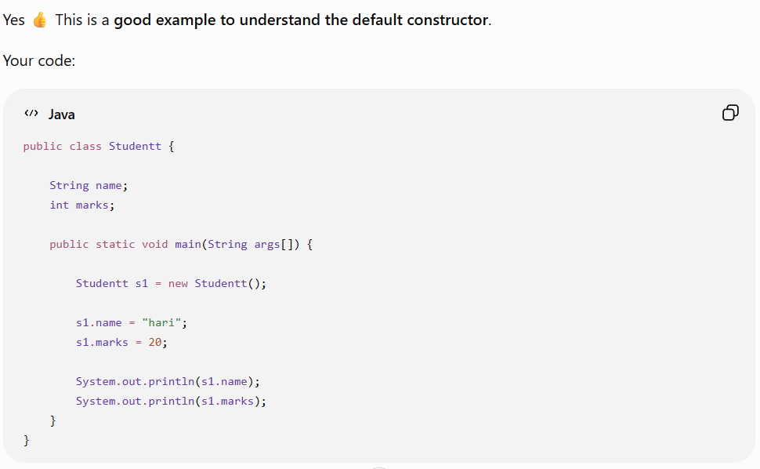
What happens here?
When you write:
Studentt s1 = new Studentt();
You didn't define any constructor in the Studentt class.
Therefore, Java automatically provides a default constructor, conceptually:
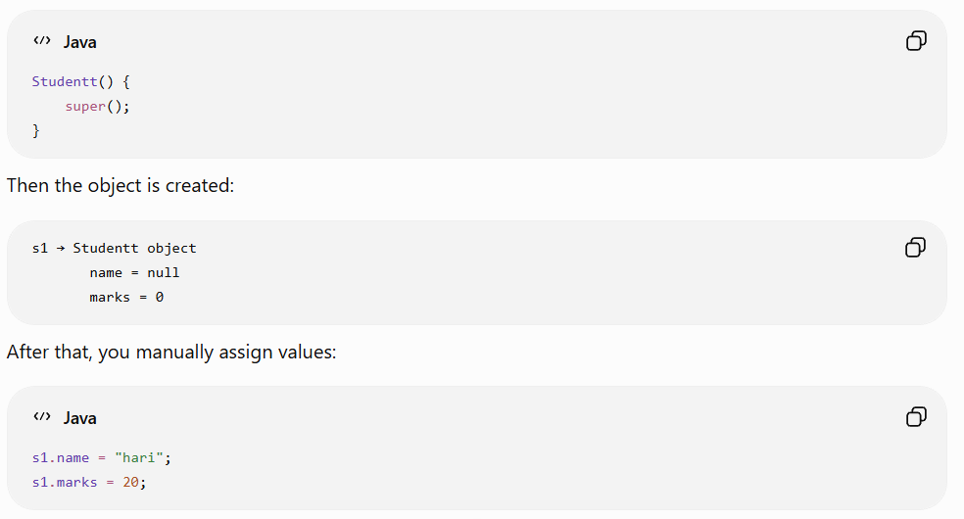
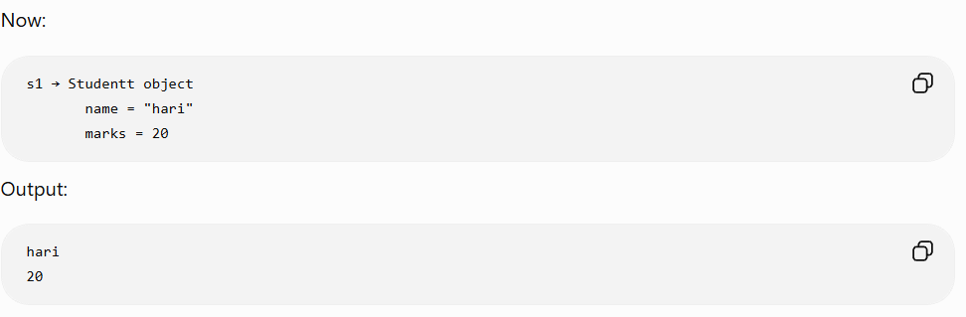
2) parameterized constructor
A parameterized constructor is a constructor that is explicitly defined by the programmer and accepts one or more parameters to initialize an object's instance variables when the object is created.
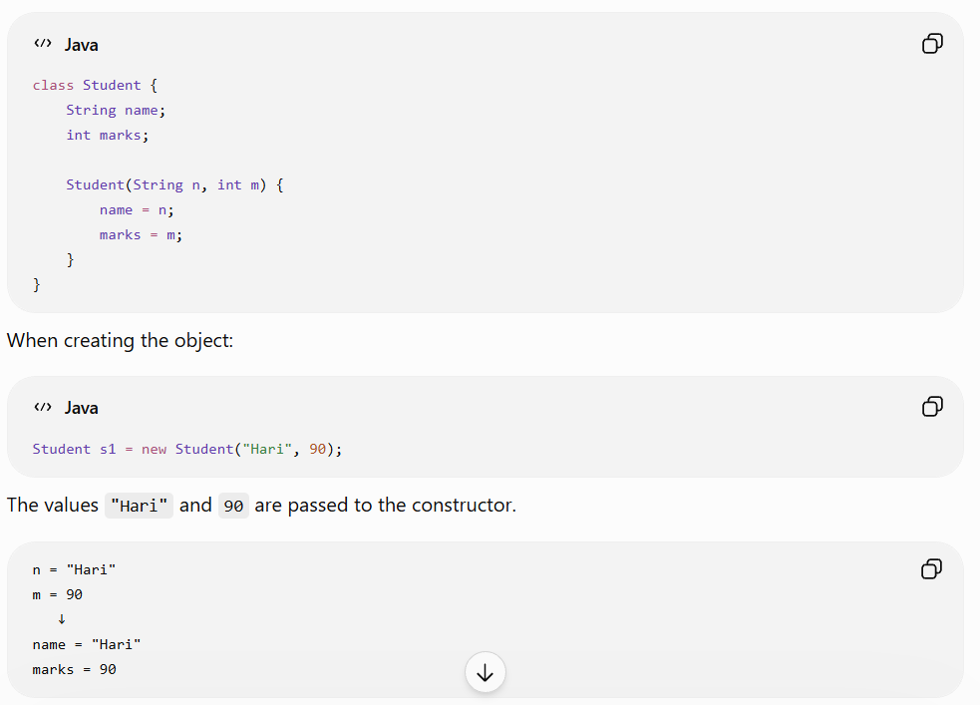
3)No-argument constructor
A no-argument constructor is a constructor that takes no parameters and is used to initialize an object when it is created.
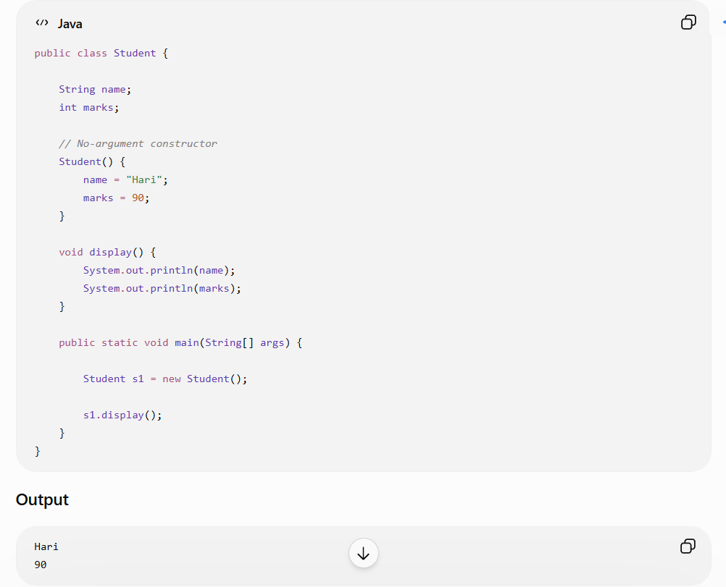
4)Copy Constructor
A copy constructor is a constructor that creates a new object by copying the values of an existing object of the same class.
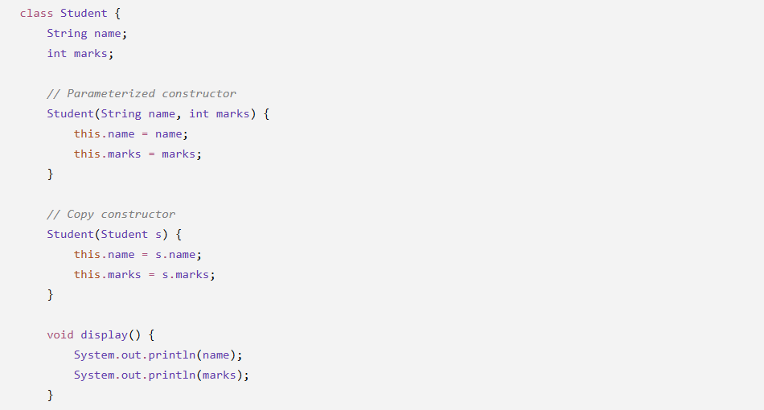

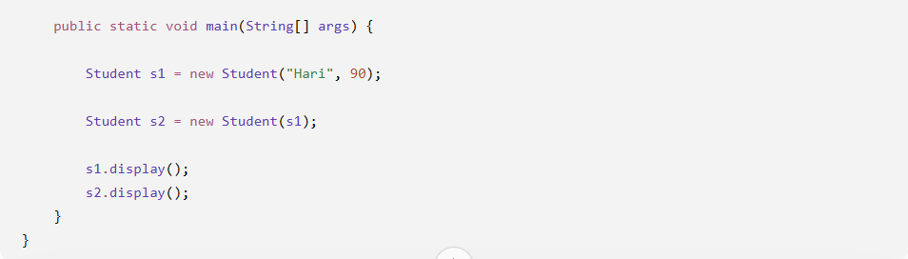
Output:
Hari
90
Hari
90
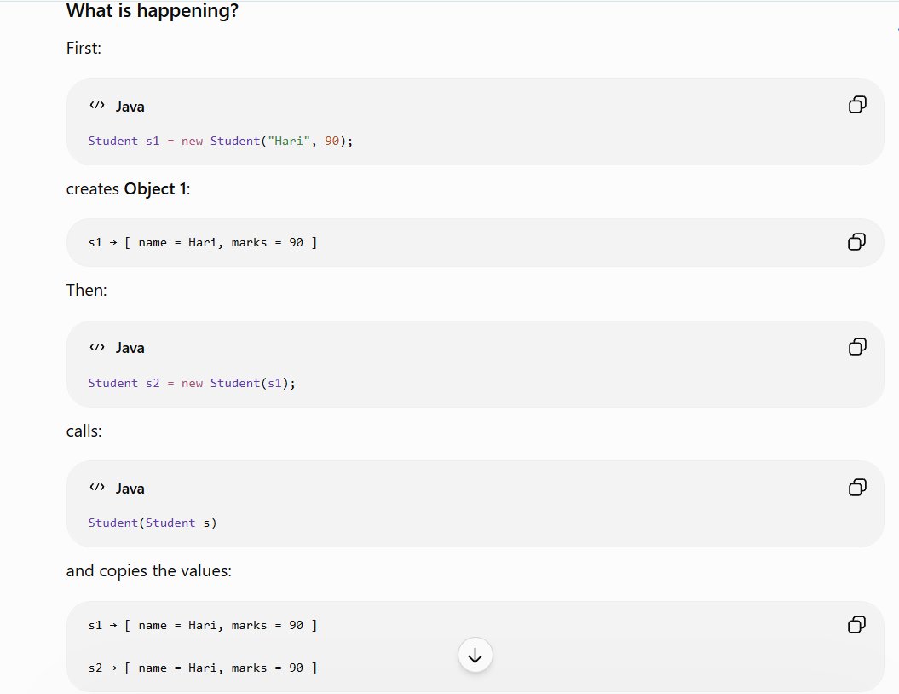
⚠️ Important: s1 and s2 are two different objects. The copy constructor copies the data; it does not make both variables refer to the same object.

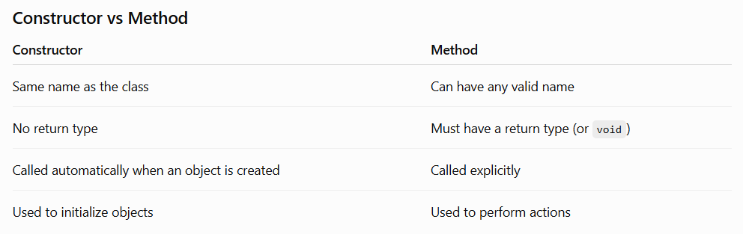
This and Super Method in java:

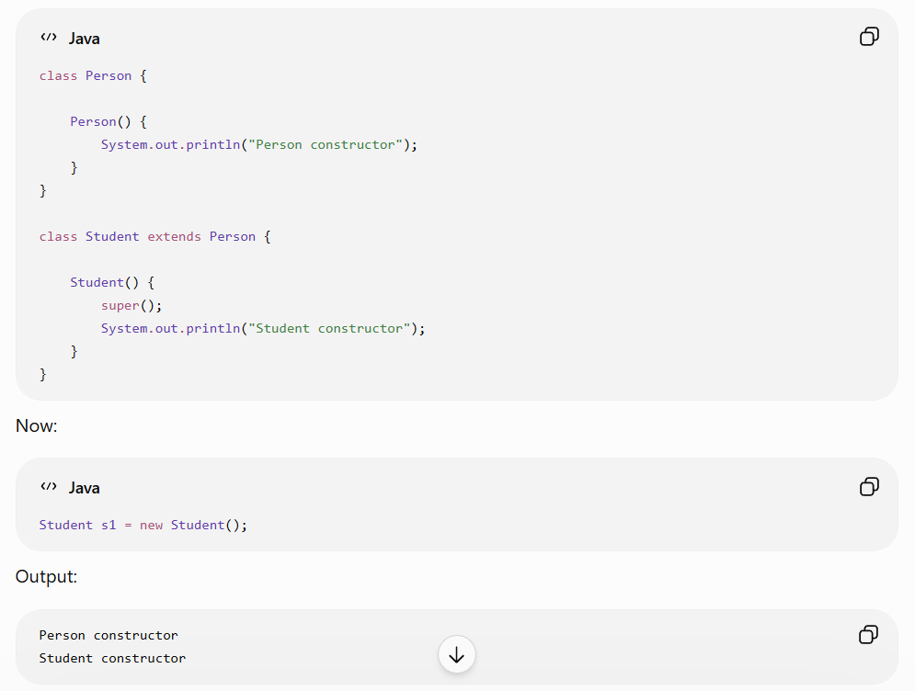

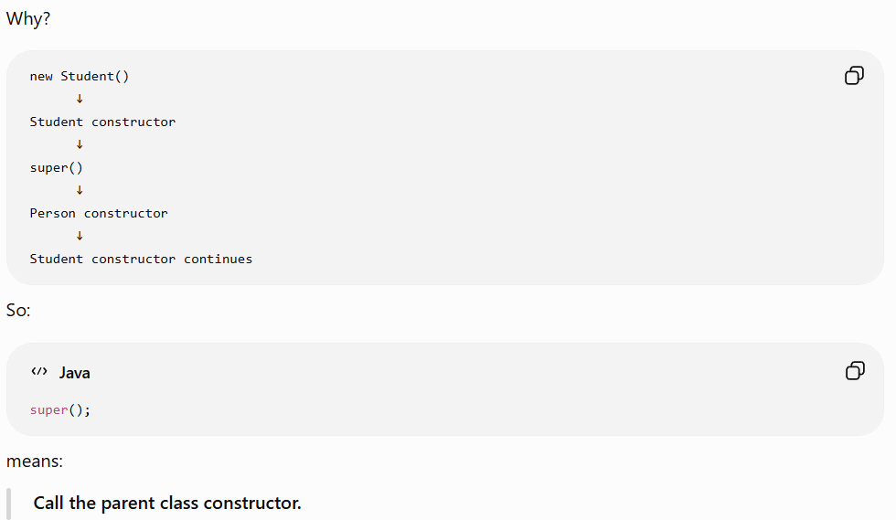

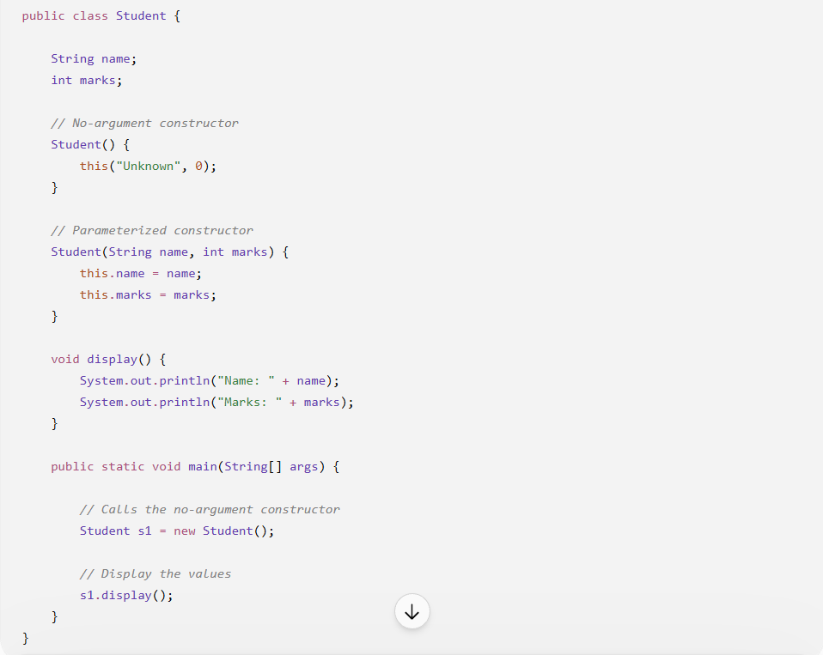
Output
Name: Unknown
Marks: 0
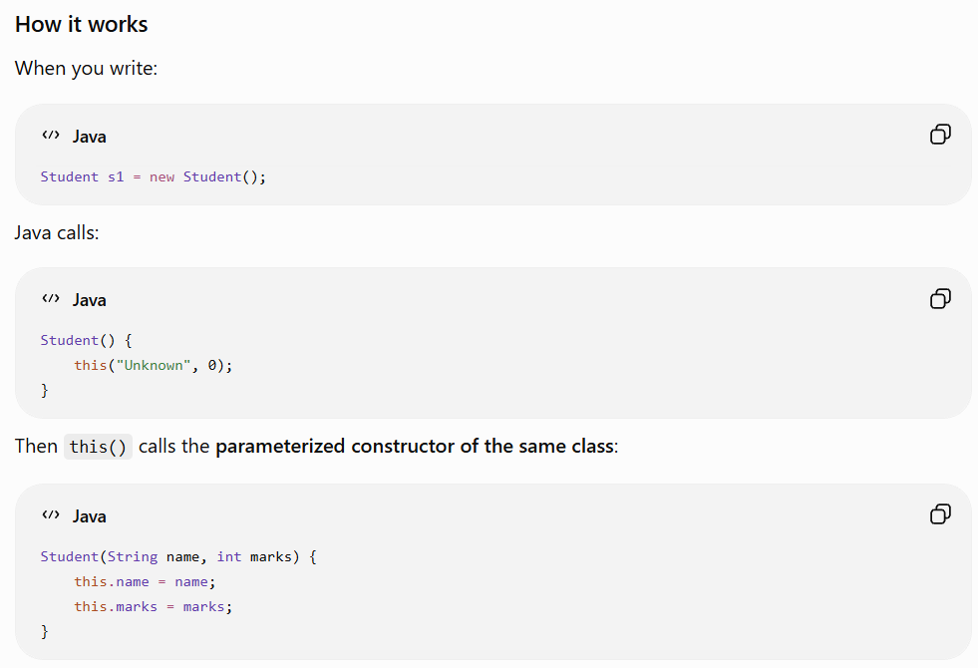
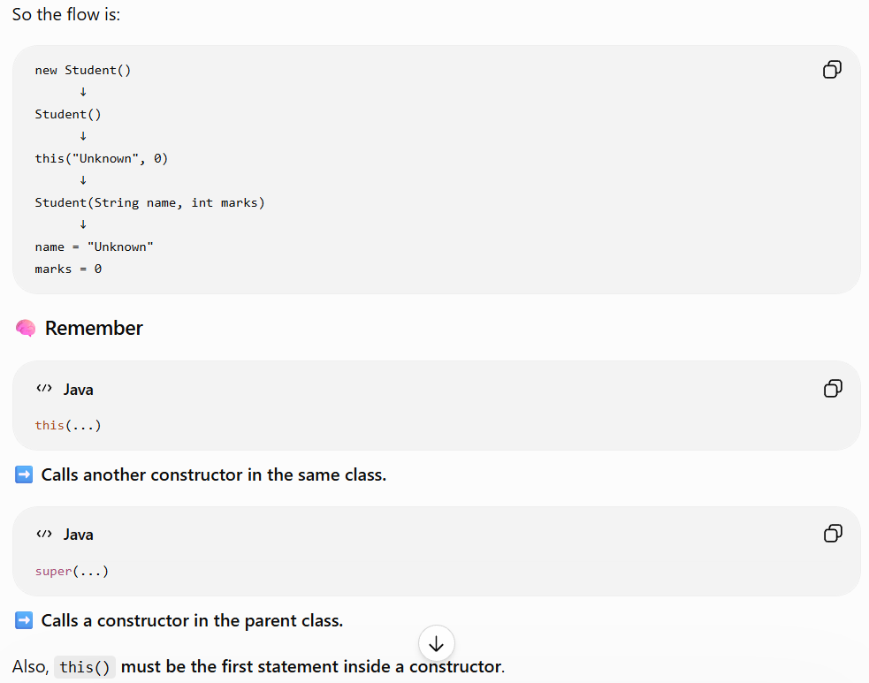

Method Overriding
Method overriding occurs when a child class provides its own implementation of a method that is already defined in its parent class.

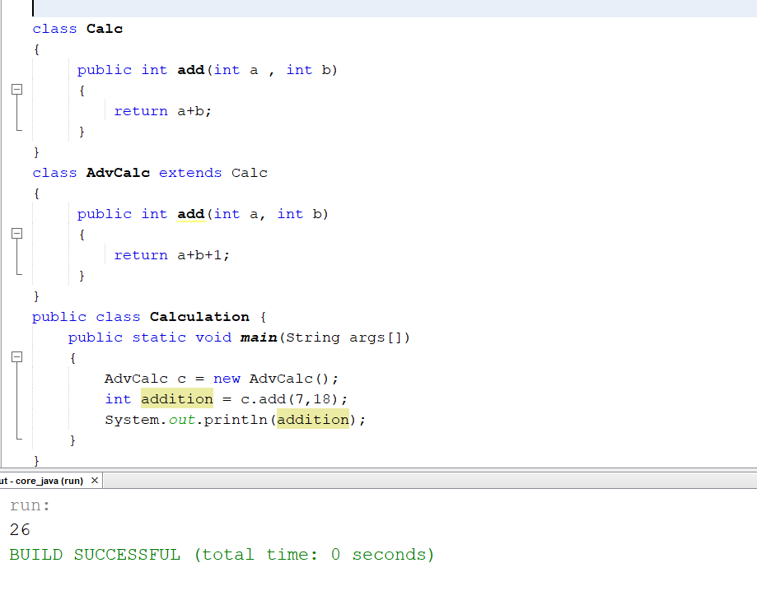
Method overriding means a child class provides its own implementation of a method that already exists in the parent class.
In your example:
Calc → add() → a + b
AdvCalc → add() → a + b + 1
So, AdvCalc changes the behavior of the add() method inherited from Calc.

Package in Java
A package is a way of grouping related Java classes, interfaces, and other components together.
Think of a package like a folder on your computer.
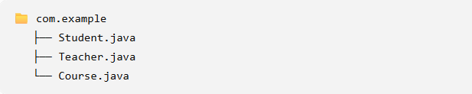
All these related classes can be placed inside the same package.
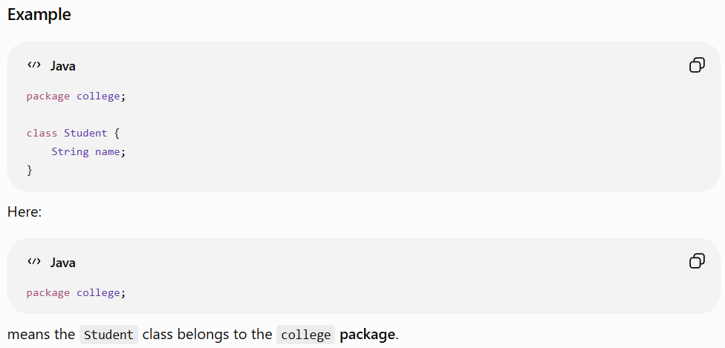
Why do we use packages?
Mainly to:
- Organize code
- Avoid naming conflicts
- Control access between classes
- Make large projects easier to manage

Real-world example
A large application might have:

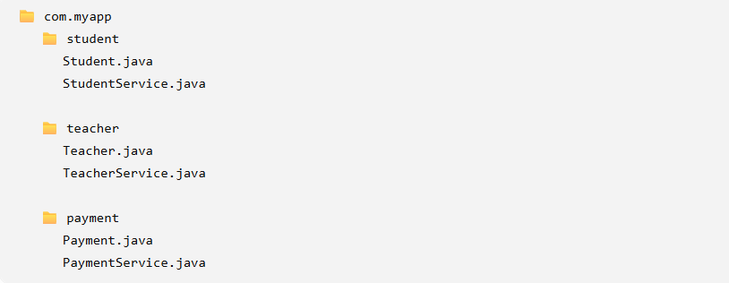
So you can think:
Package = a folder used to organize related Java classes.

Access Modifiers:
Access modifiers are keywords used to control where a class, variable, method, or constructor can be accessed from.
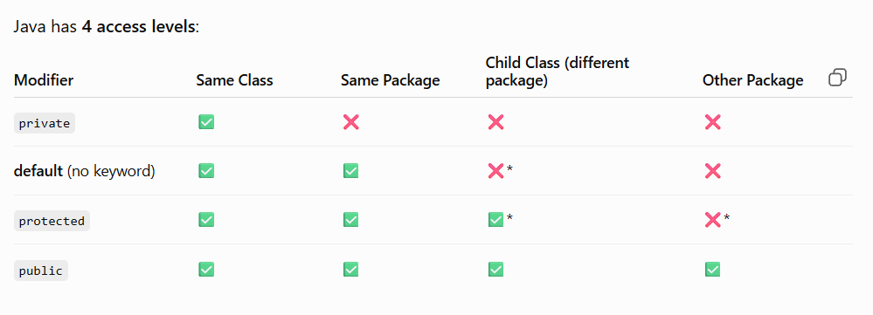

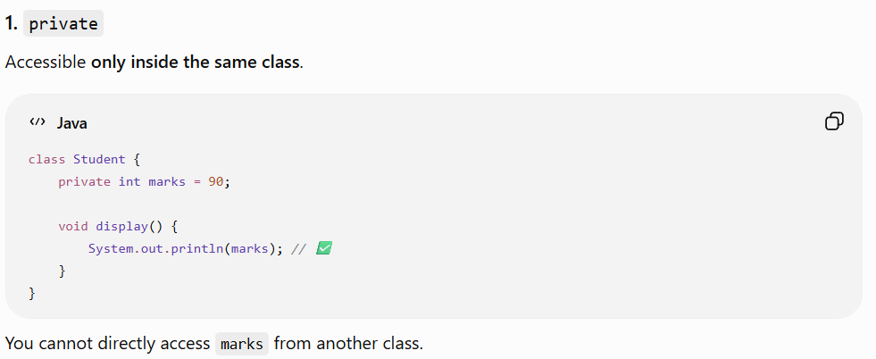
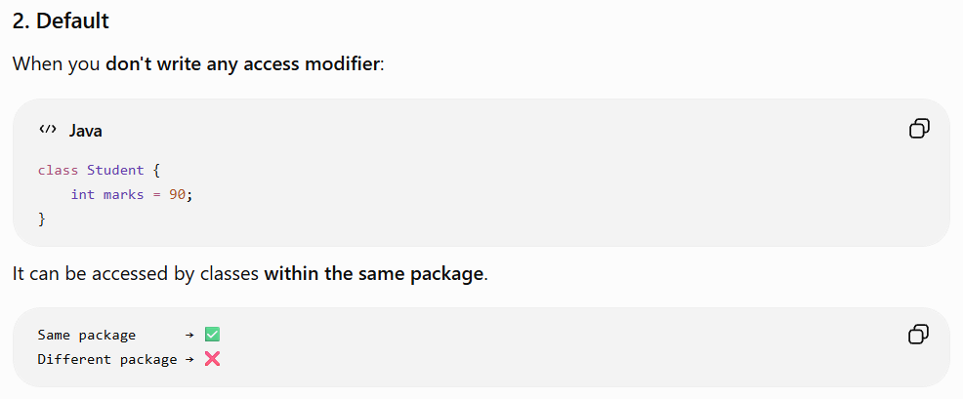
3) Protected
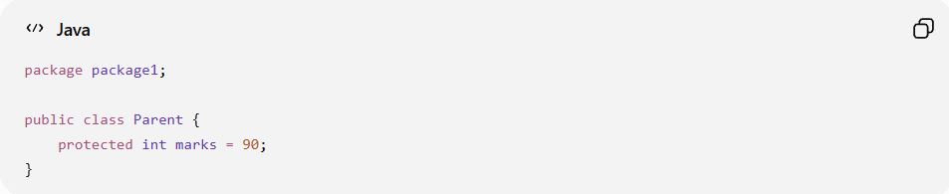
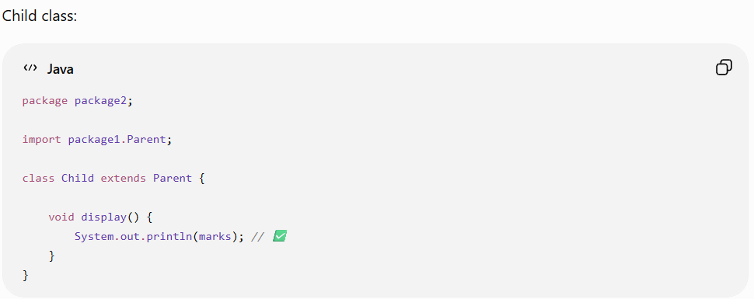
Child can access marks because it inherits from Parent.
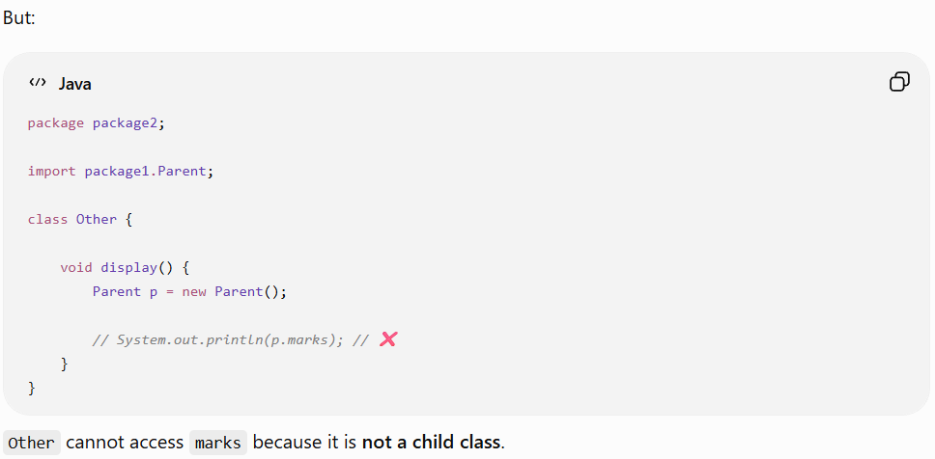
4)Public
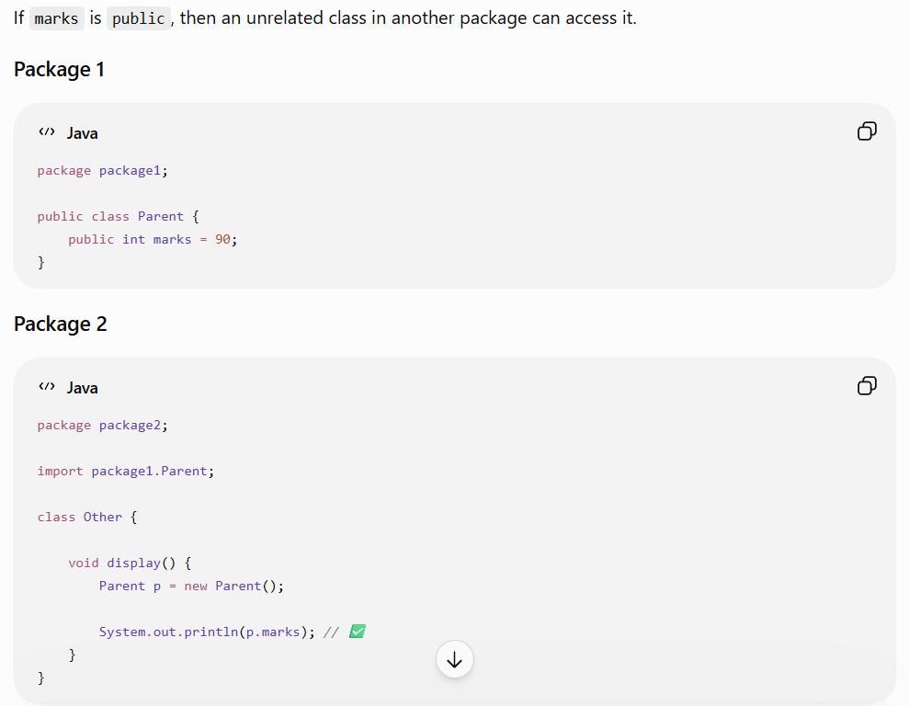
The most important thing to understand first is:
private = most restricted
default = package level
protected = package + inheritance
public = least restricted

Polymorphism
Polymorphism means "one thing having many forms." In Java, it allows the same method name or reference to behave differently depending on the situation.

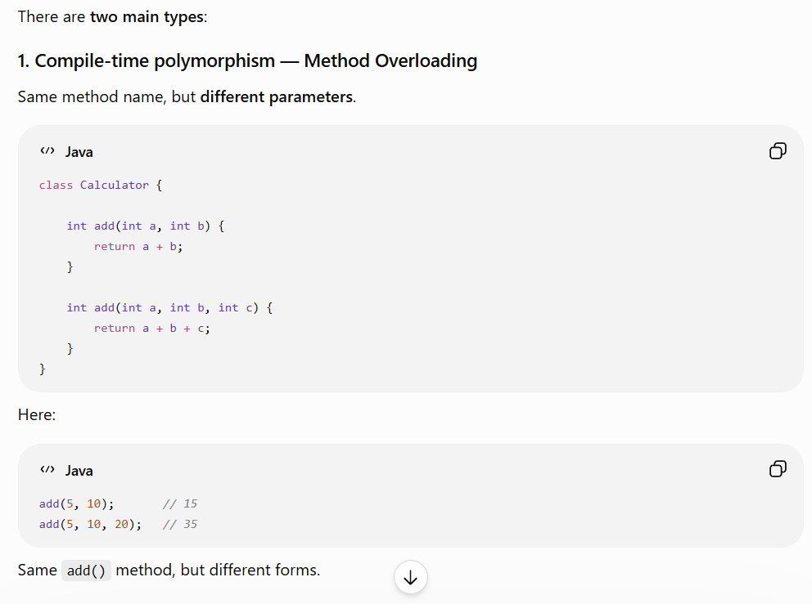
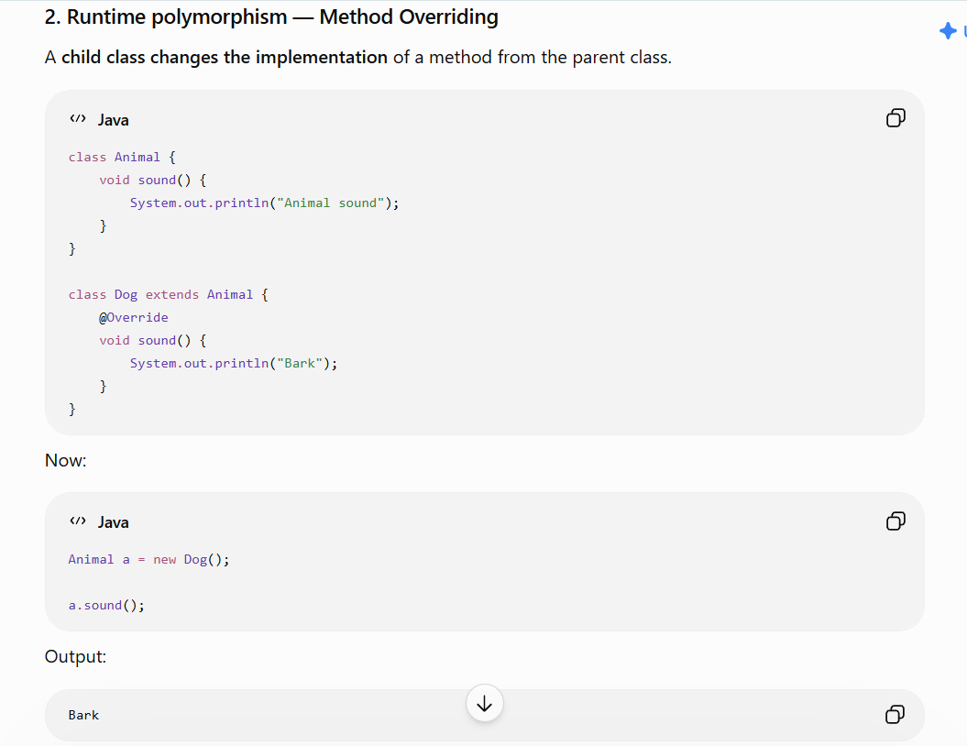
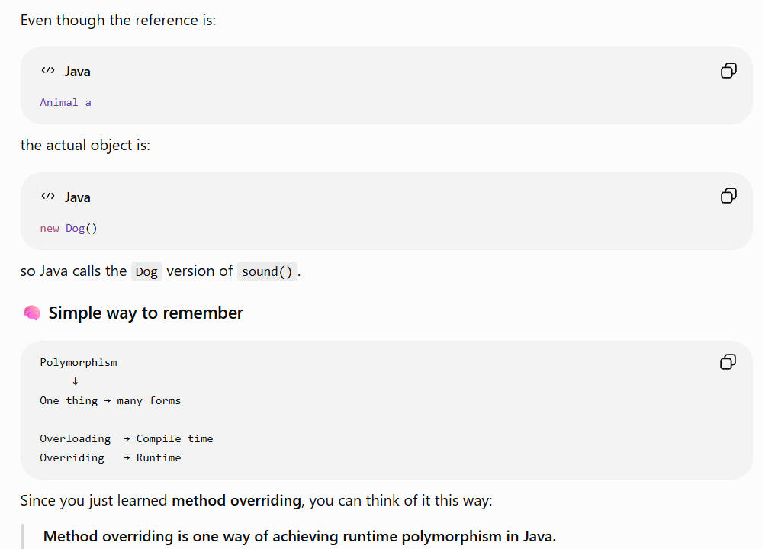
Dynamic Method Dispatch:
Dynamic Method Dispatch is the process where Java decides at runtime which overridden method to call based on the actual object, not the reference type.
It is the mechanism behind runtime polymorphism

Why it was Useful in Real-world ?
1) It allows the same code to work with different child objects.
2) You can add new types without changing much of the existing code.
3) This makes real-world applications more flexible and easier to maintain.

The real-time use of Dynamic Method Dispatch is that it lets you write code that works with a general parent type, while Java automatically chooses the correct child implementation at runtime.
Simple real-world example: Payment
Imagine an application supports different payment methods:

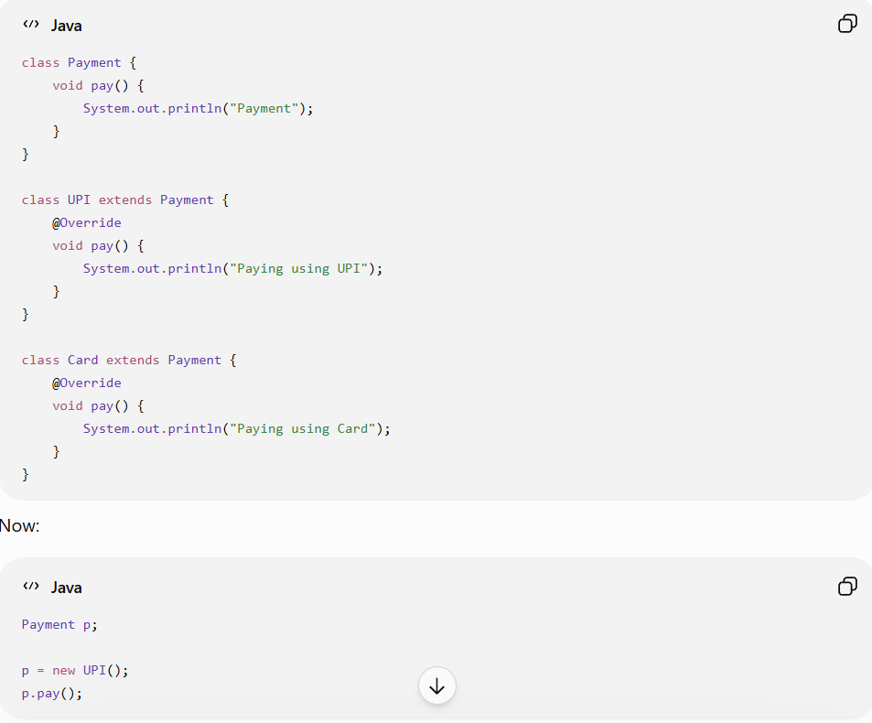
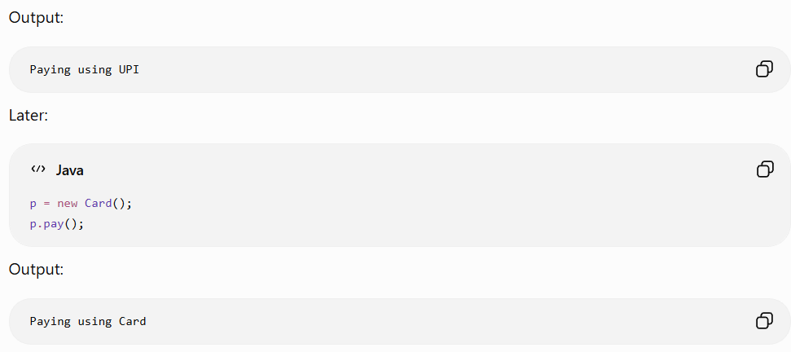

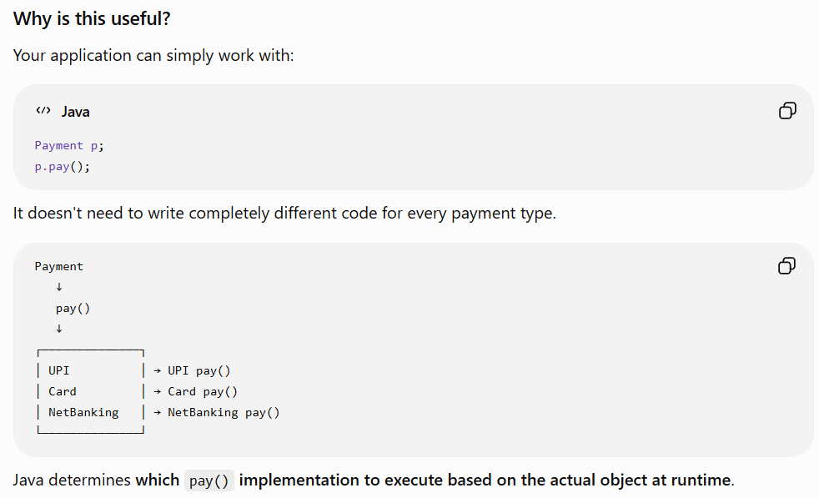
Final Keyword :
The final keyword is used to prevent something from being changed.
It can be used with variables, methods, and classes.
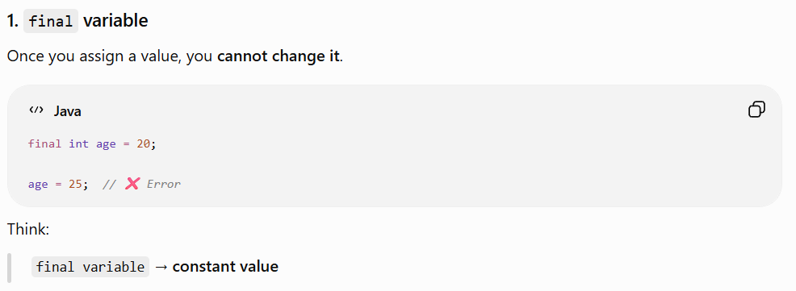
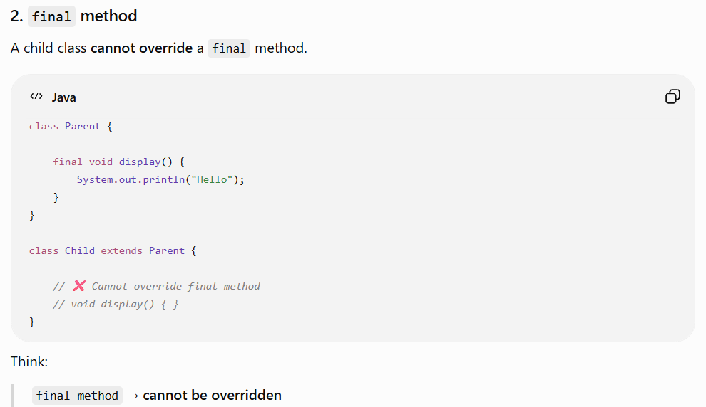
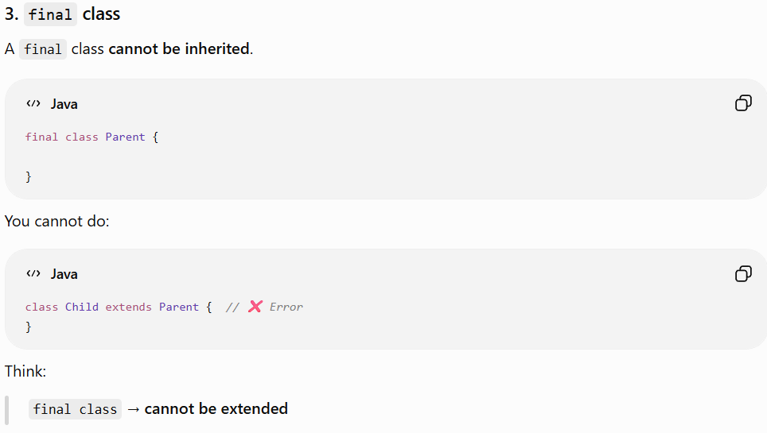
Object Class:
These four concepts are related because every Java class ultimately inherits from the Object class.
Object
├── equals()
├── toString()
└── hashCode()
1. Object
Object is the root/parent class of all Java classes.
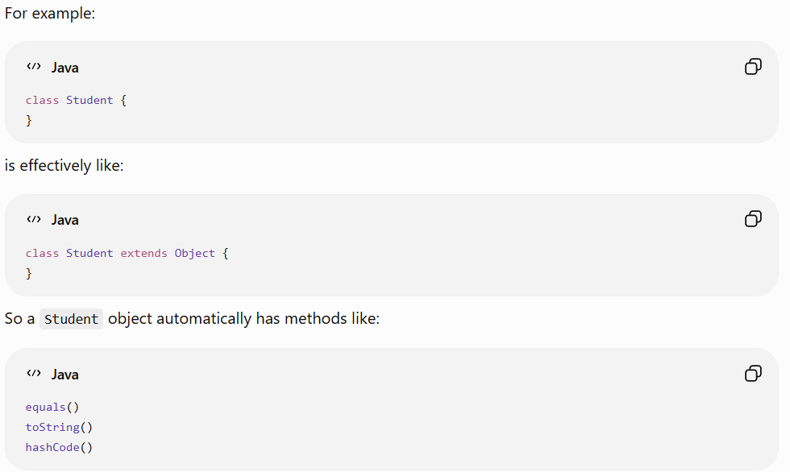
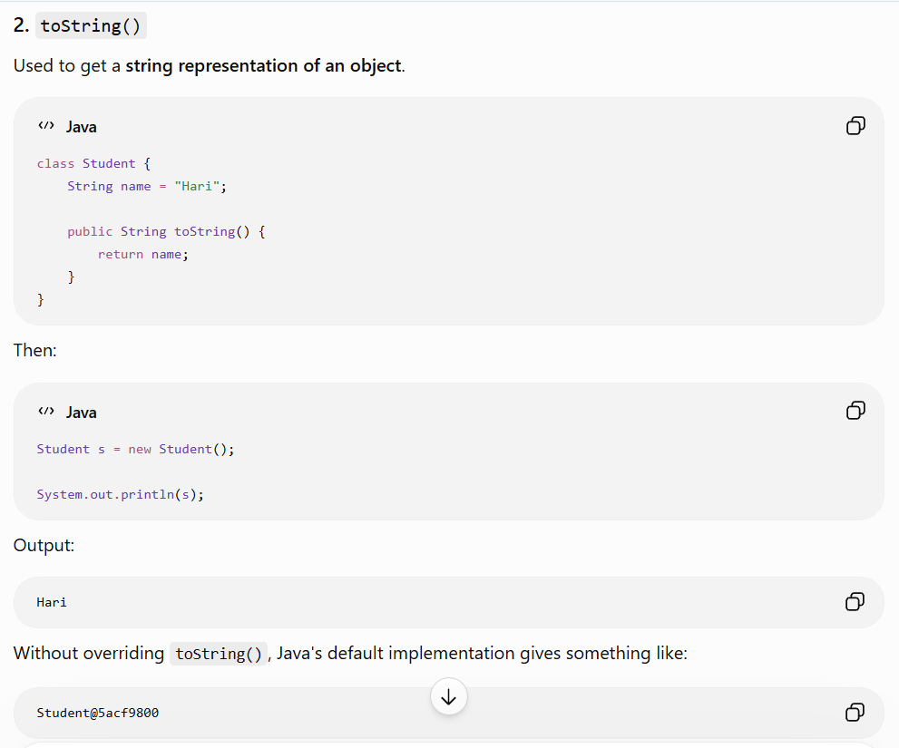
So:
toString() → gives a readable representation of an object.
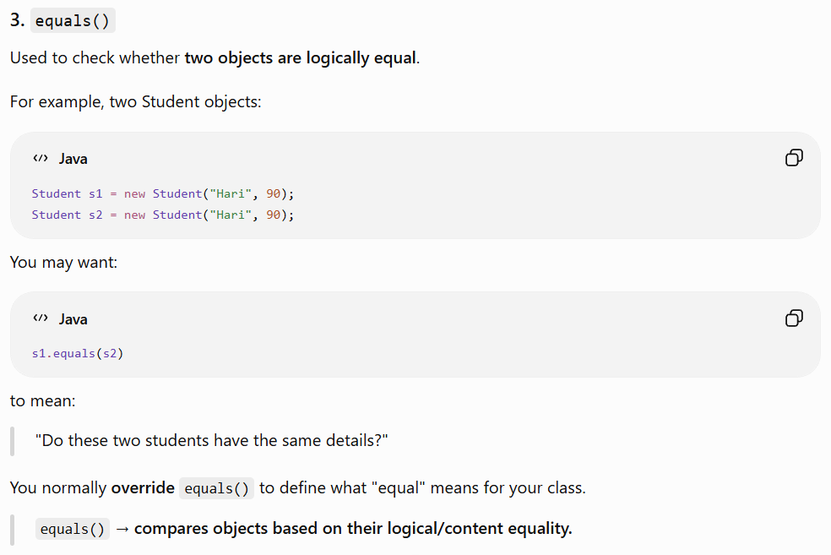

4. hashCode()
hashCode() produces an integer value representing the object's hash.
int value = s1.hashCode();
It is especially important when using collections such as:
HashMap
HashSet
Hashtable
For example, if you override equals(), you generally should also override hashCode() consistently.
hashCode() → provides a hash value used by hash-based collections to organize and find objects efficiently.

UpCasting:
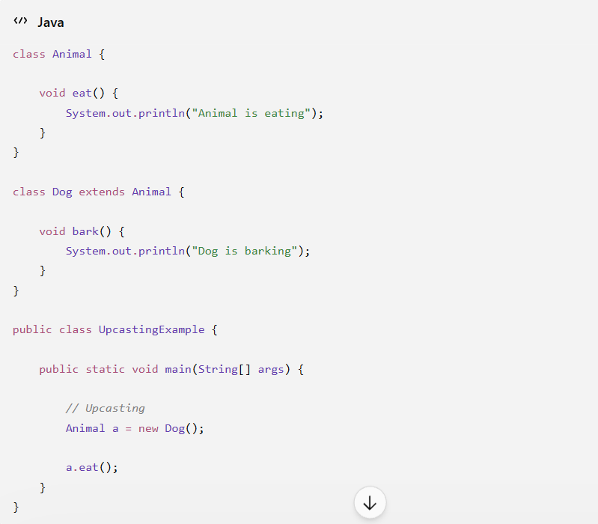
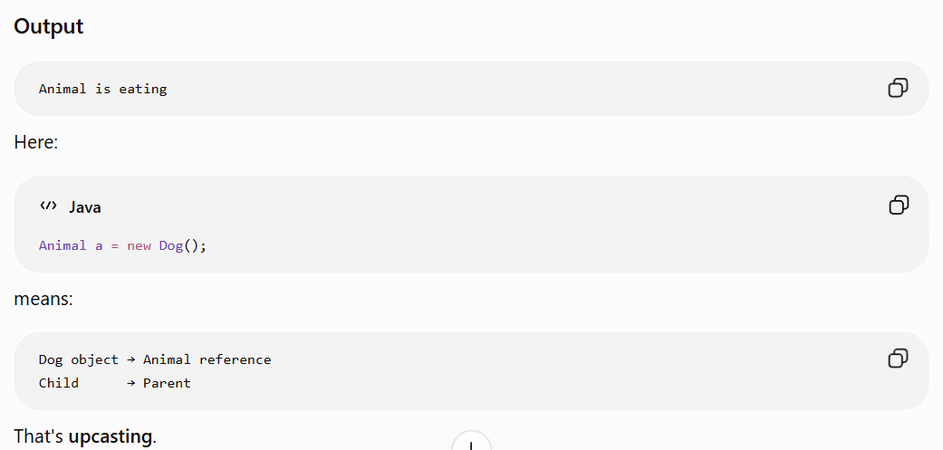
2. Downcasting Program
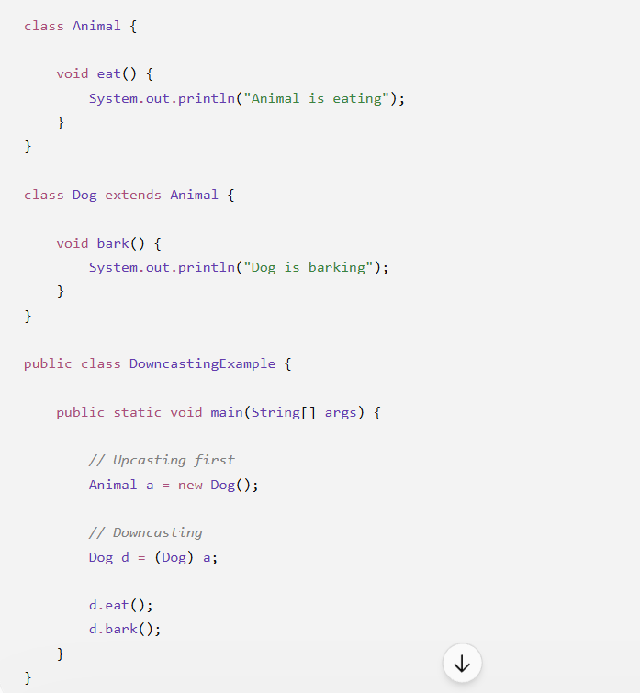

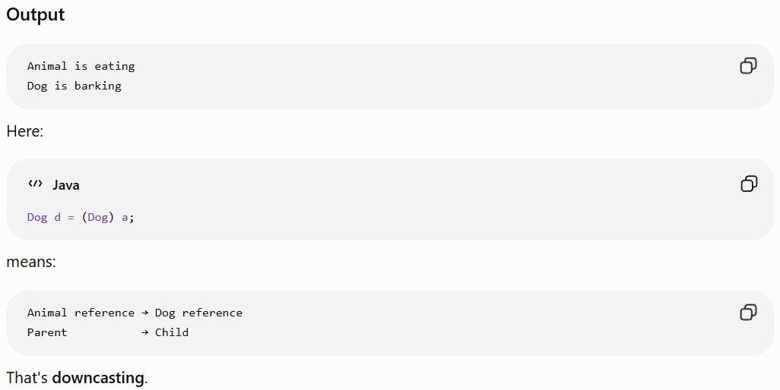
Wrapper Class in Java
A wrapper class is a class that converts a primitive data type into an object.
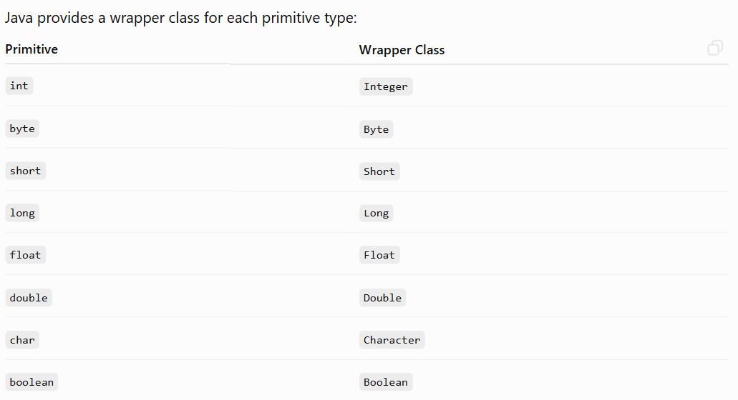
Simple example
int a = 10; // primitive
Integer b = 10; // wrapper object
Here:
int → primitive
Integer → object

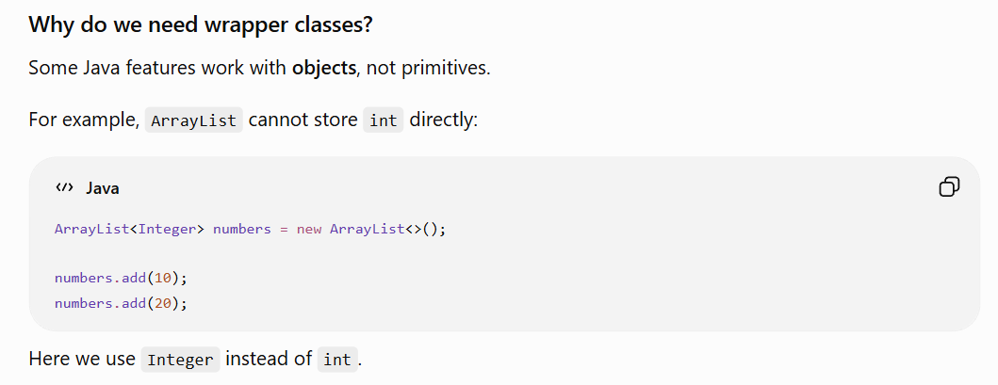
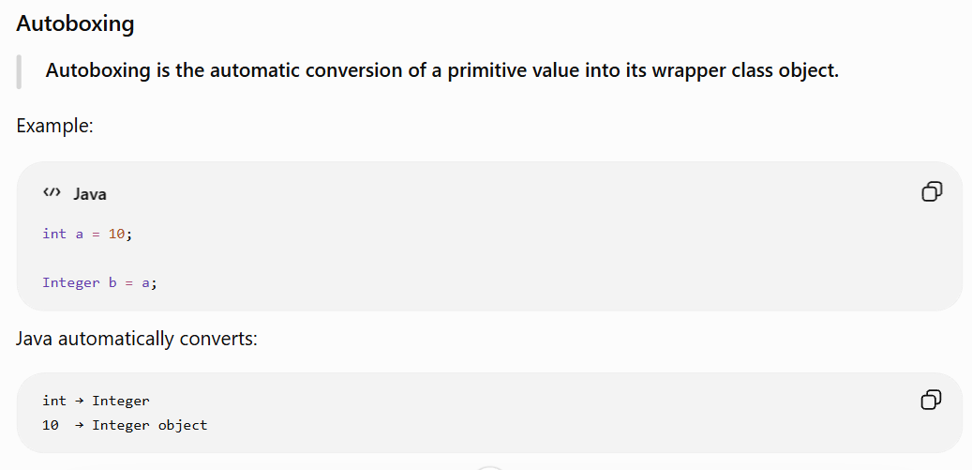
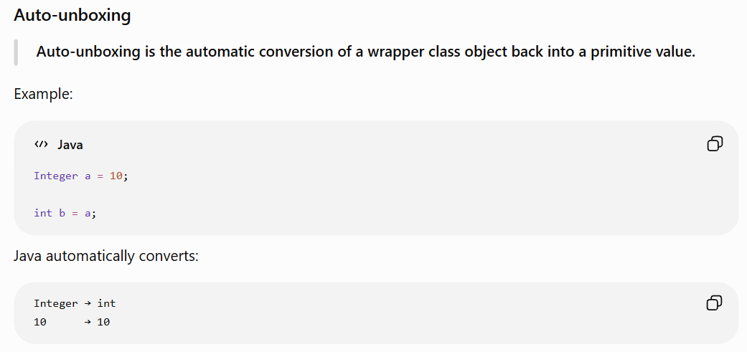

Abstract Keyword:
An abstract class is a class that cannot be instantiated and can contain both abstract methods (without implementation) and concrete methods (with implementation).
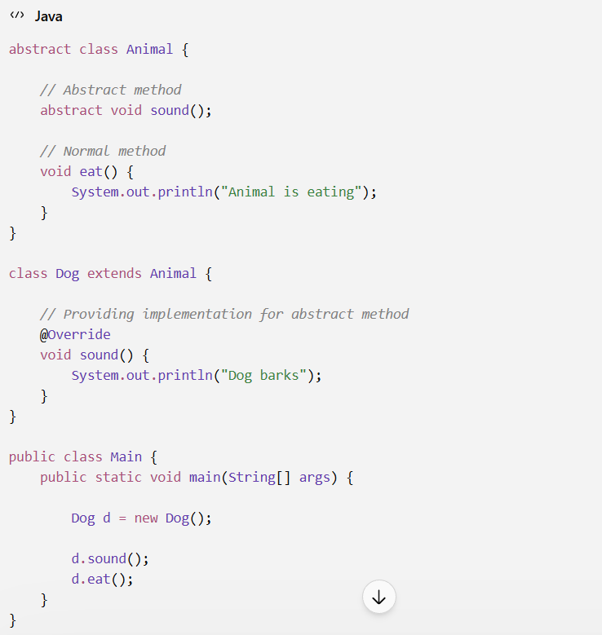
Output
Dog barks
Animal is eating
Abstract method = a method declared without a body, forcing the child class to provide the implementation.

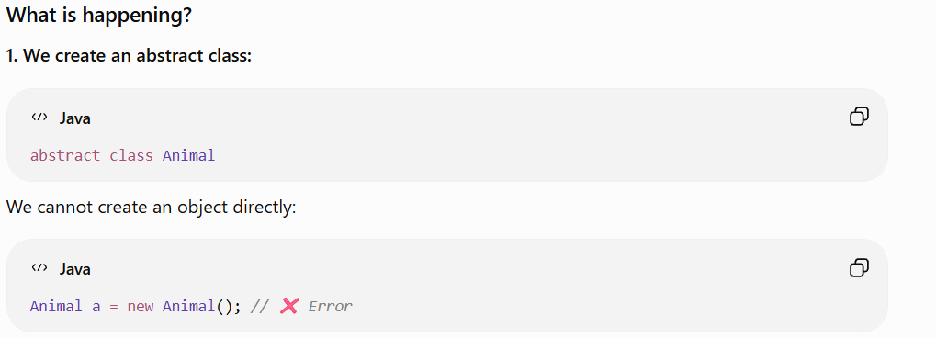
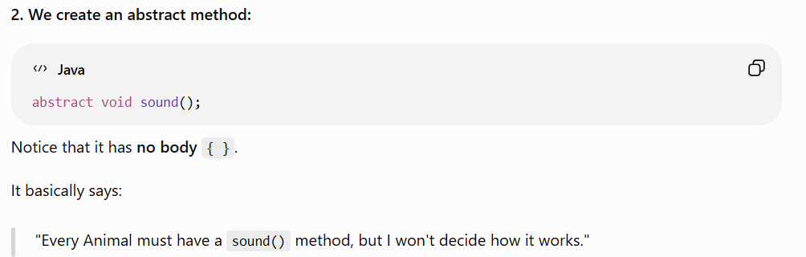
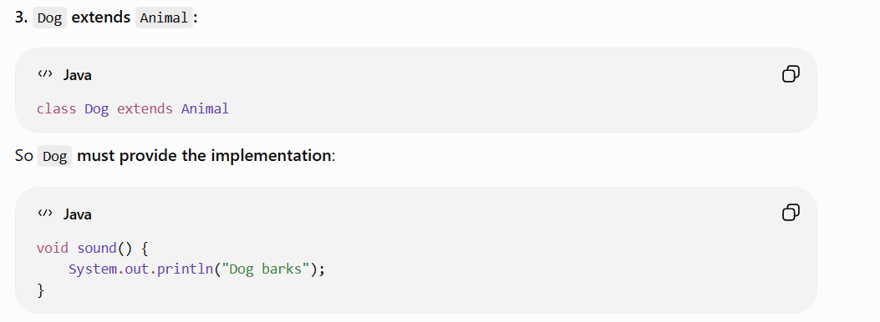
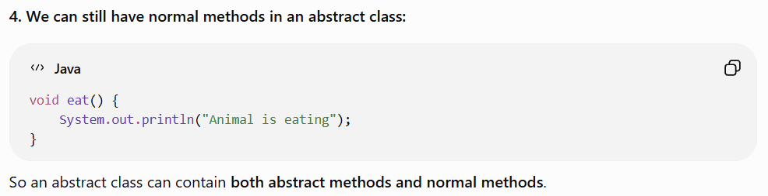

Inner Class Definition
An inner class is a non-static class that is declared inside another class and is associated with an object of the outer class.

Two Types:
Non-static inner class → belongs to an object → outer object required.
Static nested class → belongs to the class → outer object not required.
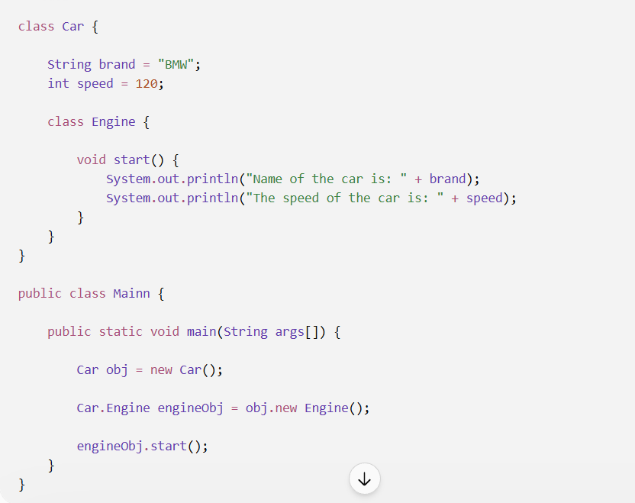
Output
Name of the car is: BMW
The speed of the car is: 120

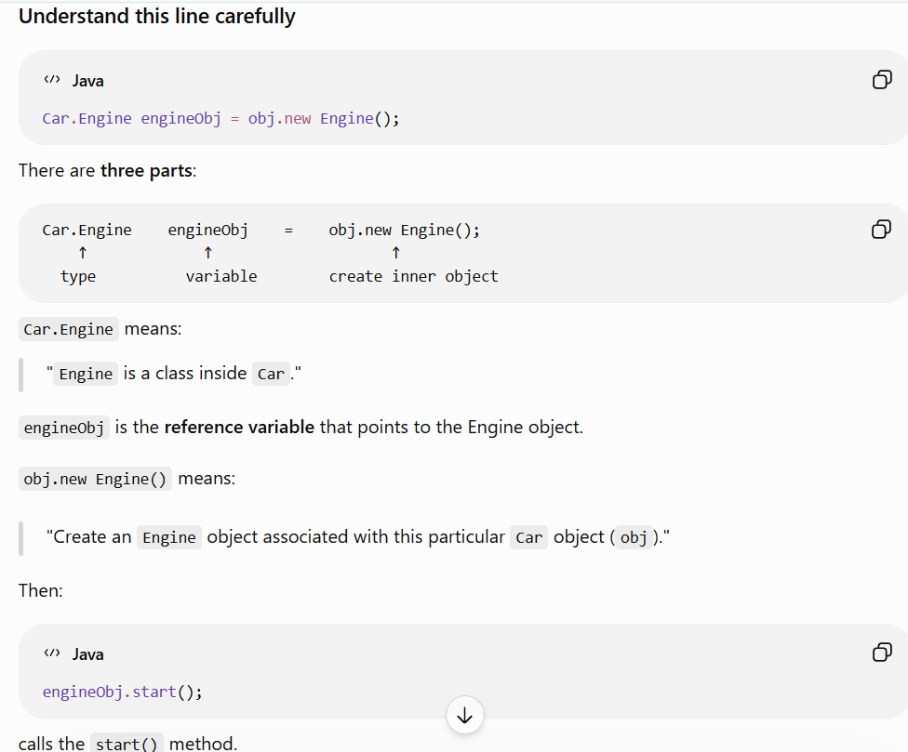
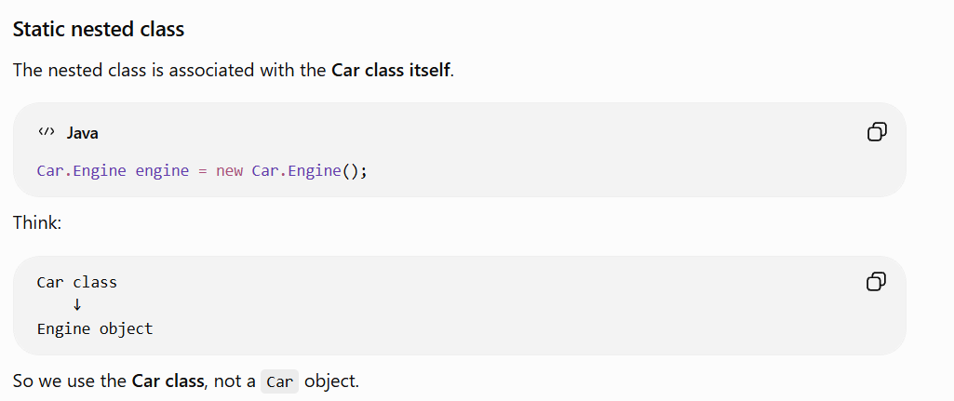
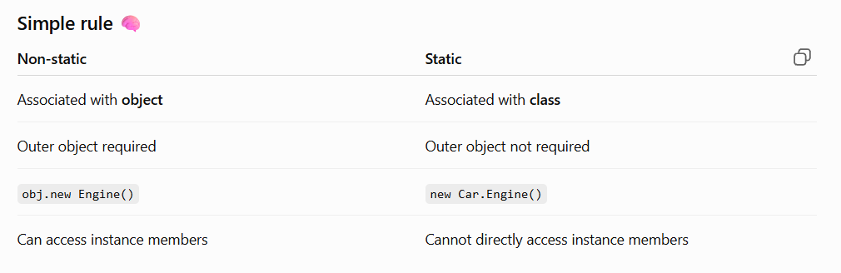
anonymous inner class:
An anonymous inner class is used to provide a one-time implementation of an interface or abstract class without creating a separate named class.

Important point
Anonymous inner classes are especially useful when:
- ✅ Implementation is needed only once
- ✅ You don't want to create a separate class
- ✅ You need to implement an interface
- ✅ You need to extend an abstract class

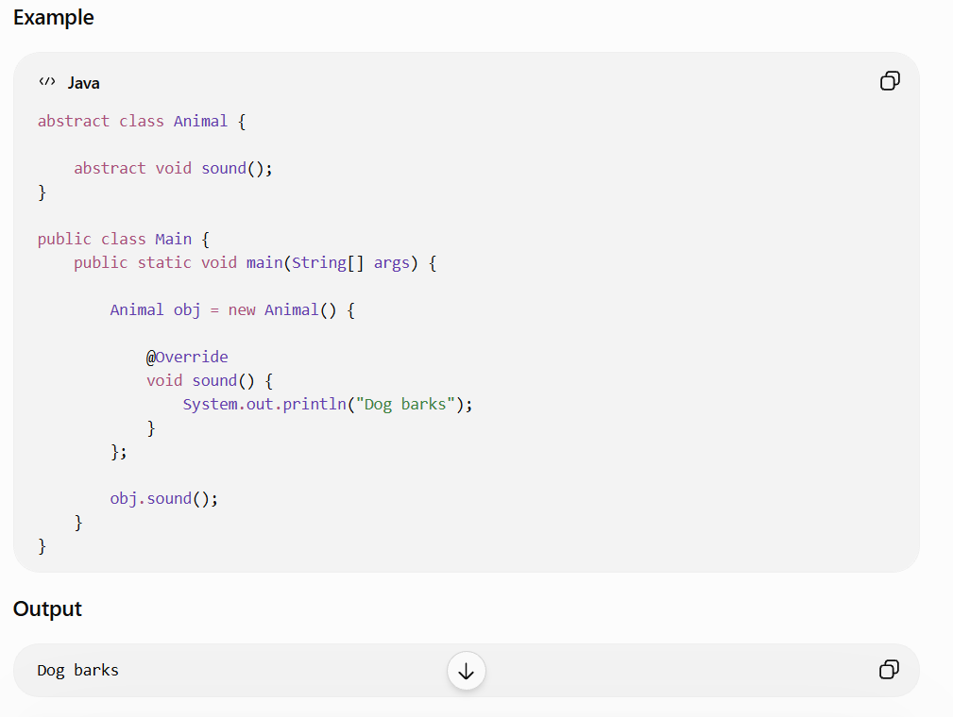

What is Interface?
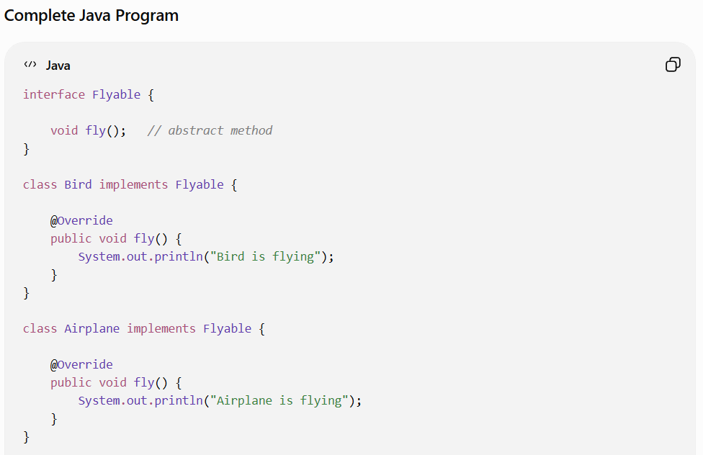
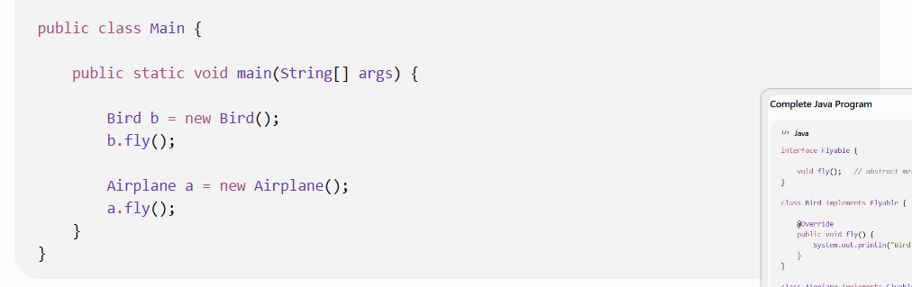
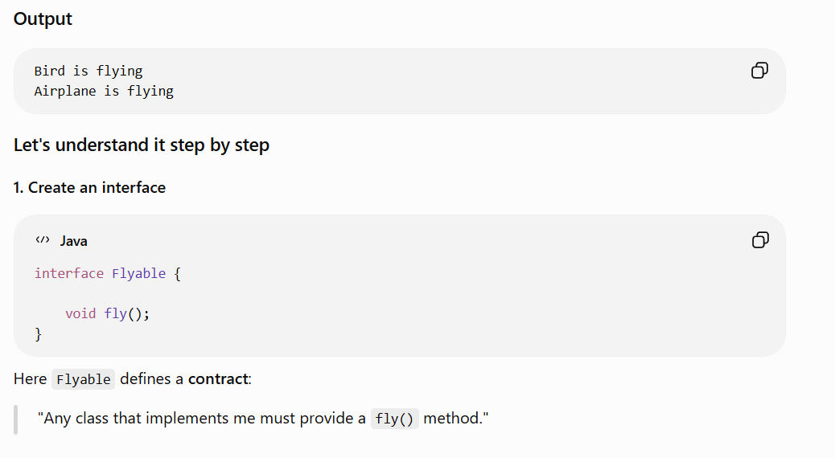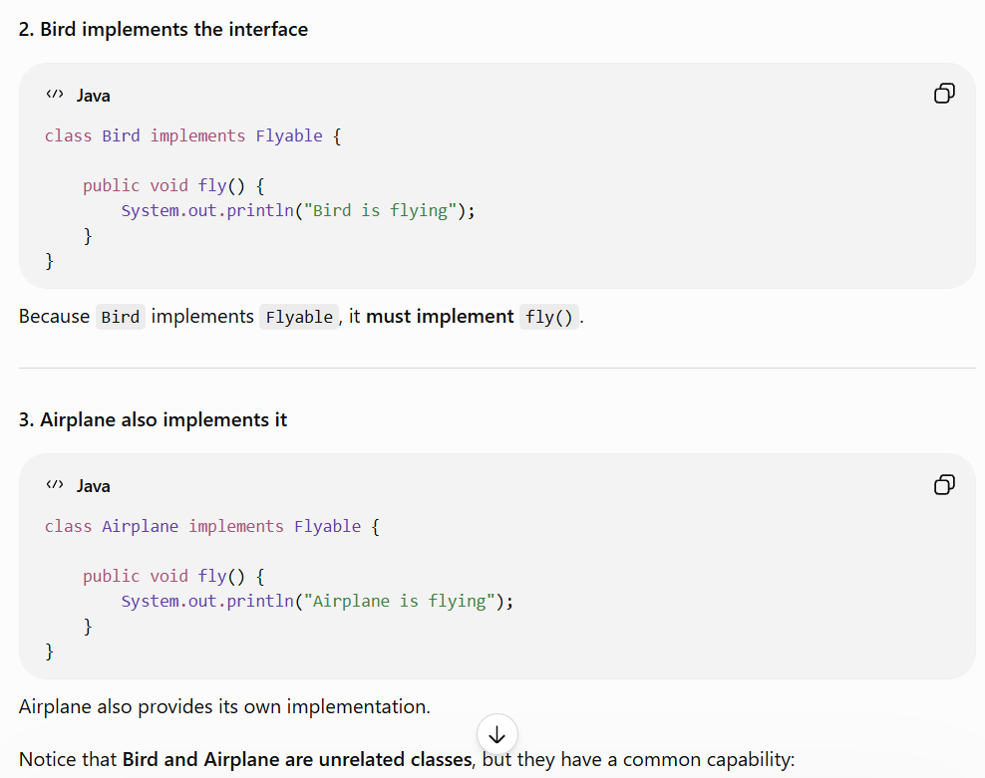

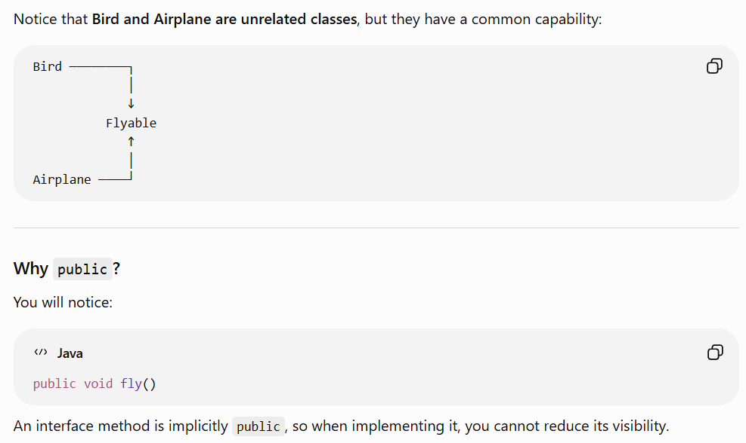
Interface → can bring unrelated classes together based on a common capability/behavior.
Abstract class → brings closely related classes together based on common characteristics and behavior.
Interface:
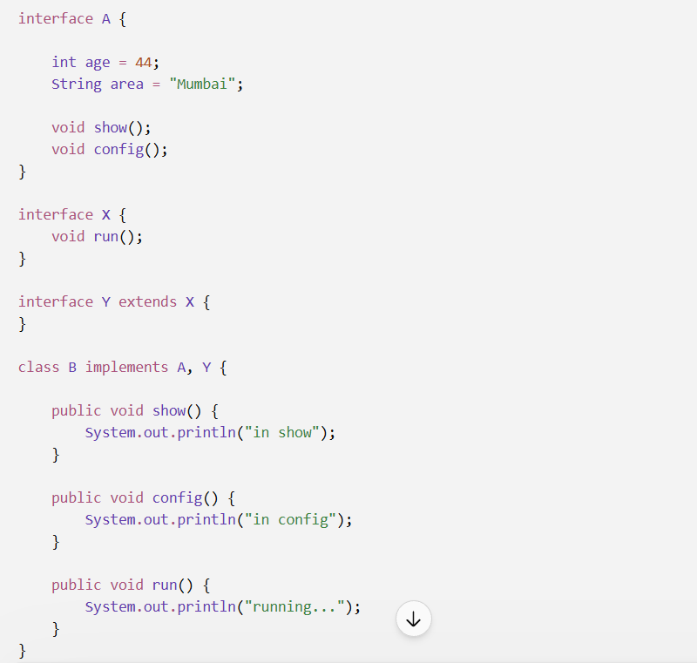
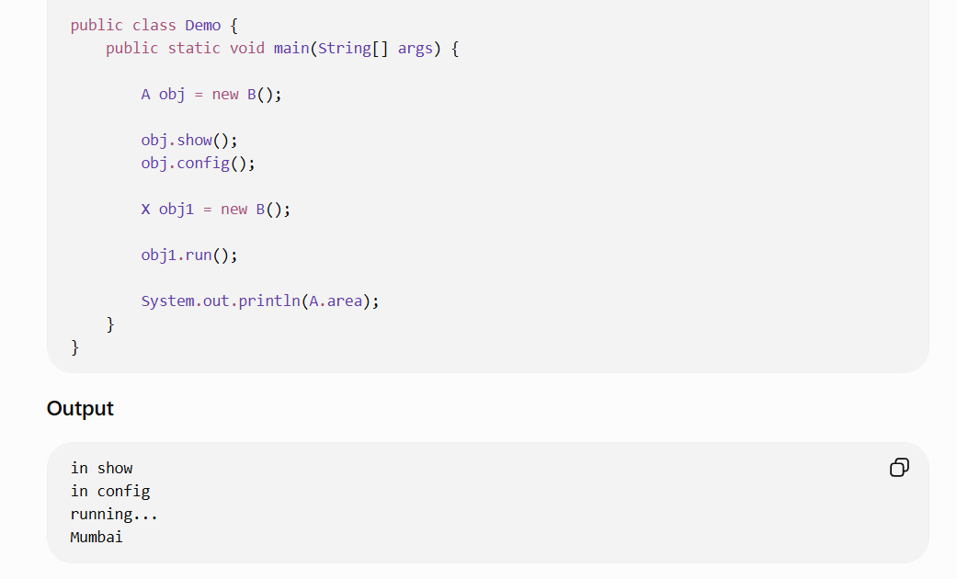
The 5 things you should remember:
1. class → class
extends
2. class → interface
implements
3. interface → interface
extends
4. Interface variables
public static final
5. A class can implement multiple interfaces
implements A, B, C

What is enum in Java?
enum stands for enumeration.
It is used when you have a fixed set of values that a variable is allowed to have

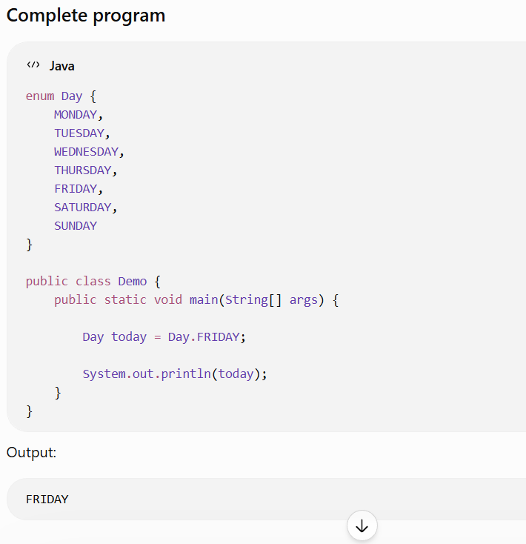

enum is very commonly used with switch.
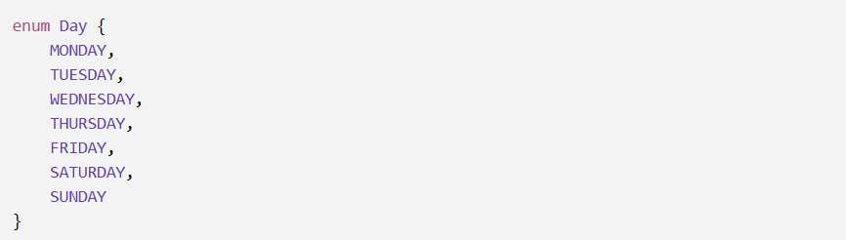

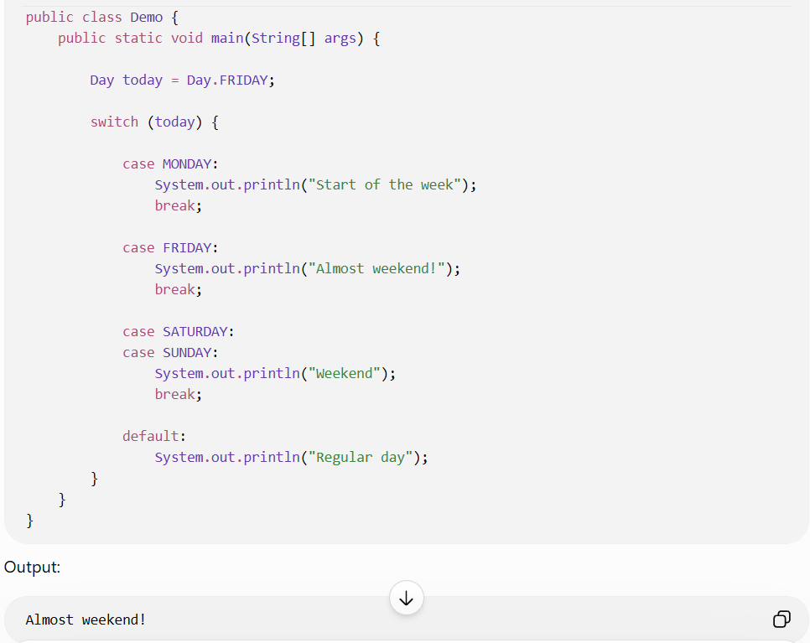
Enum Example Program:
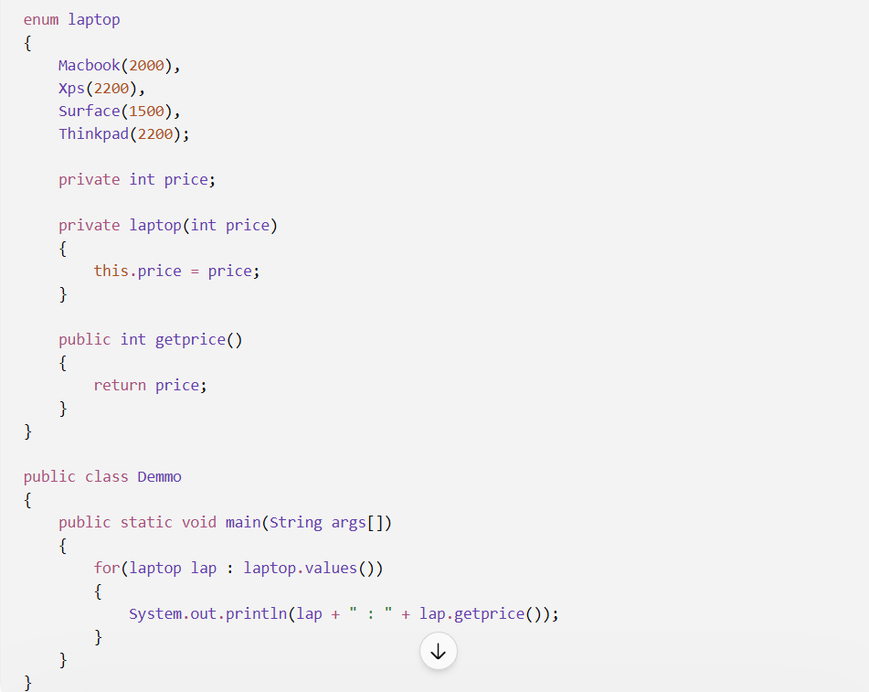
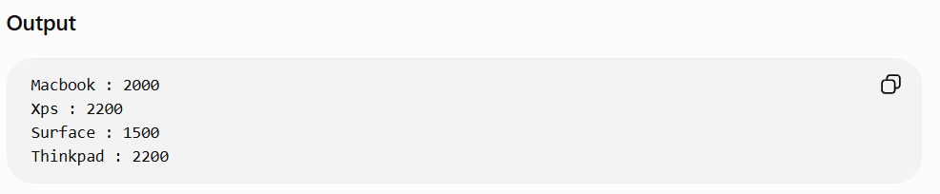
What is Annotation ?
An annotation in Java is metadata added to source code using @, which provides additional information to the compiler, JVM, or frameworks about program elements such as classes, methods, and variables.
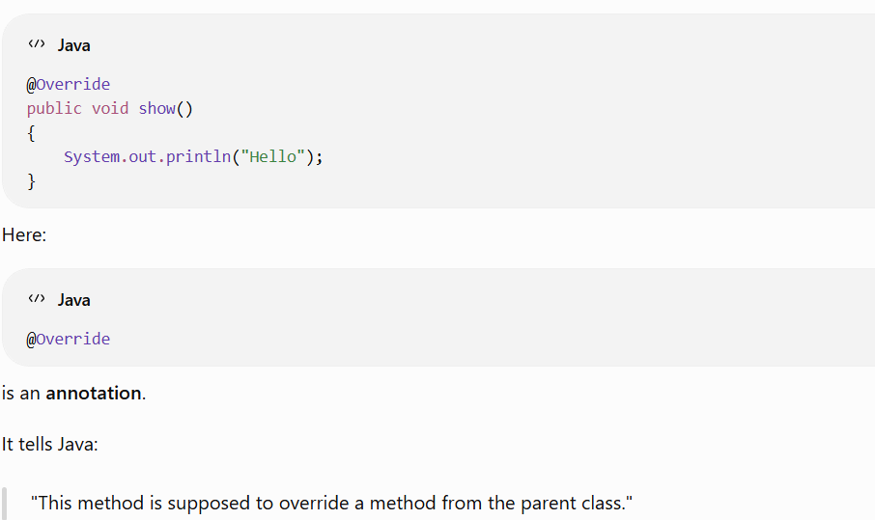
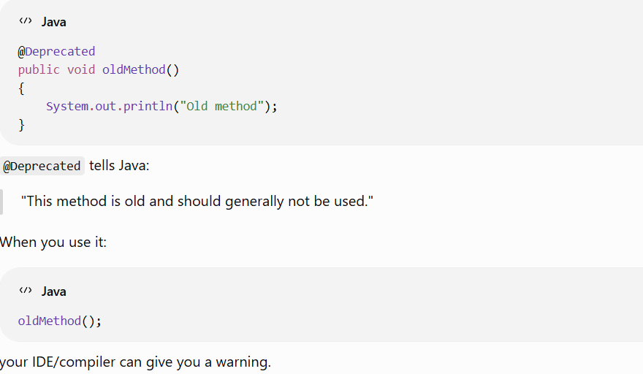
Why do we need annotations?
Annotations are commonly used to:
- Give instructions to the compiler
- Provide information to the JVM
- Configure frameworks
- Reduce configuration/code

What are the types of Interface?
1. Normal Interface
An interface that contains two or more abstract methods.
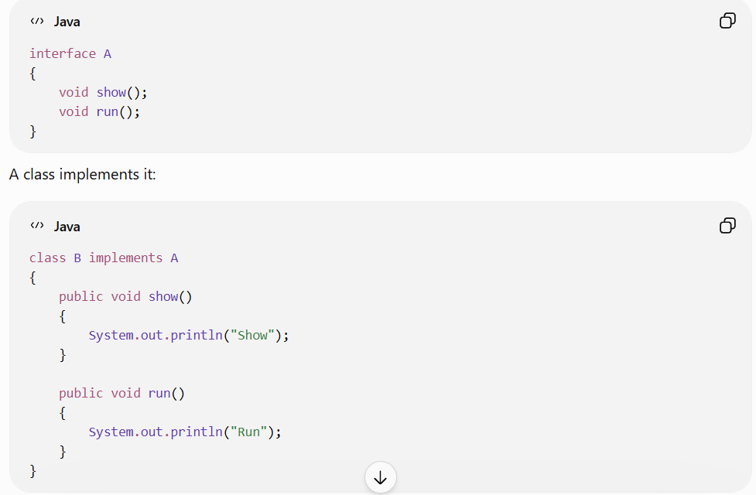
2. Functional Interface
An interface that contains exactly one abstract method.
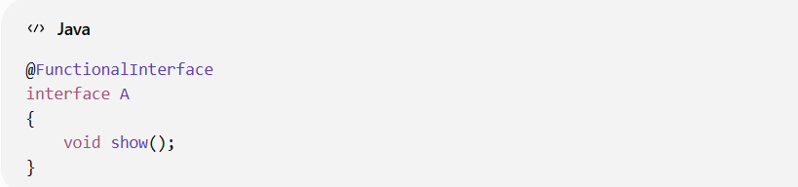
It is commonly used with lambda expressions:
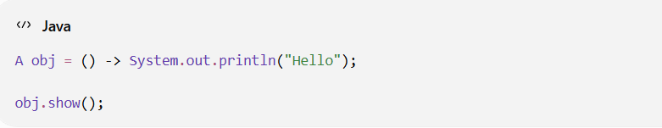
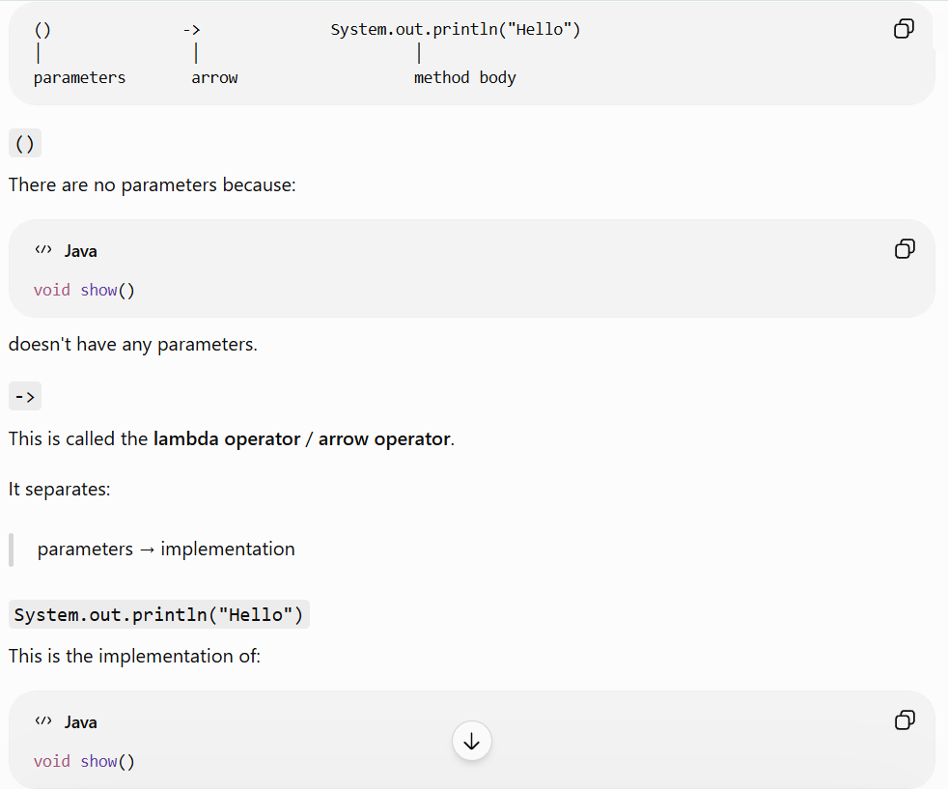
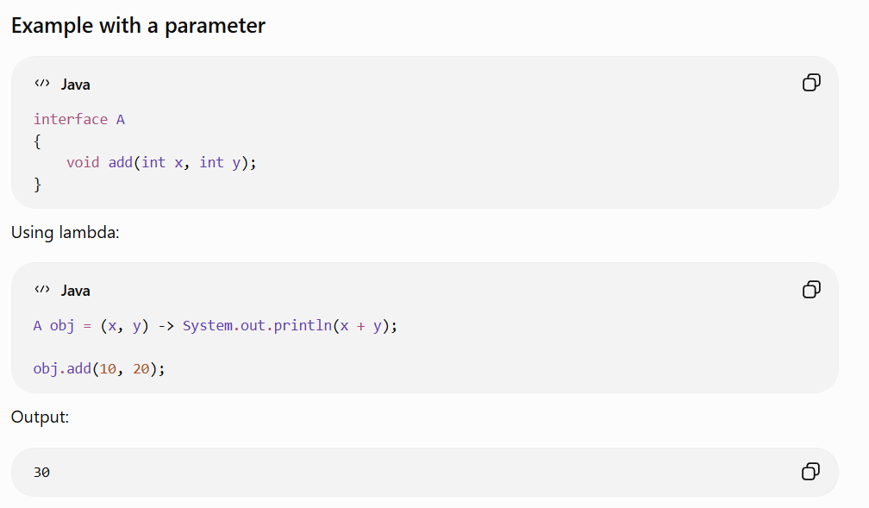
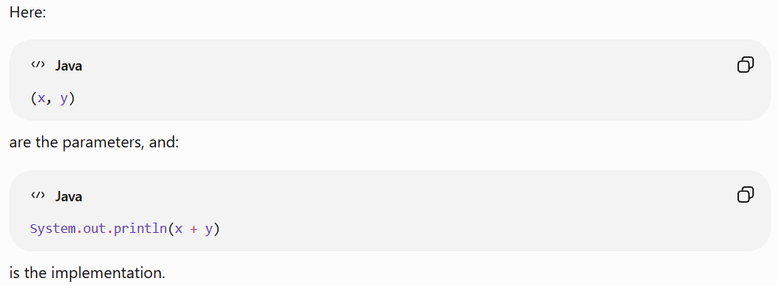
Return type in Lambda Expression:
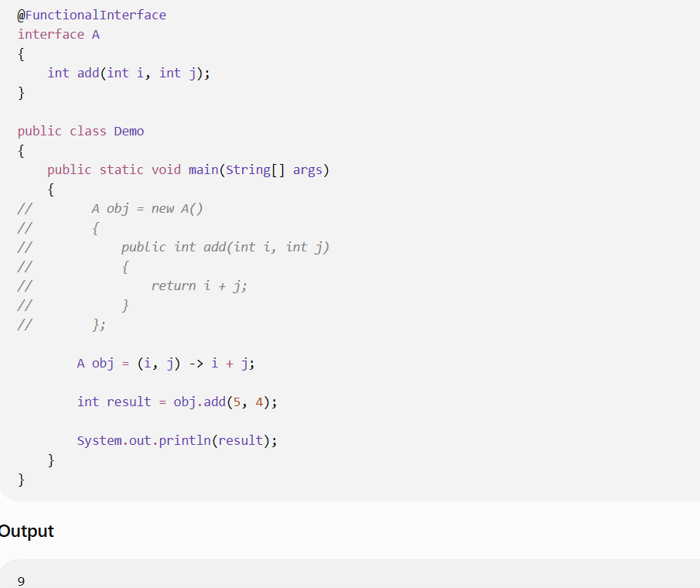
Lambda doesn't explicitly declare a return type; the return type is inferred from the functional interface's abstract method.

What is Exception?
An exception is an event that occurs during program execution that disrupts the normal flow of the program.
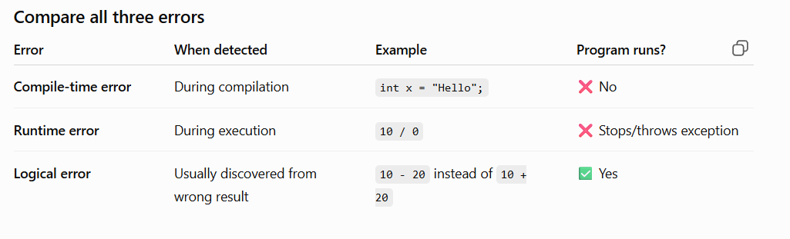
Why do we use try and catch in Java?
try and catch are used to handle exceptions so that your program doesn't terminate unexpectedly when an error occurs.
try → "Try to execute this code"
catch → "If an exception occurs, handle it here"
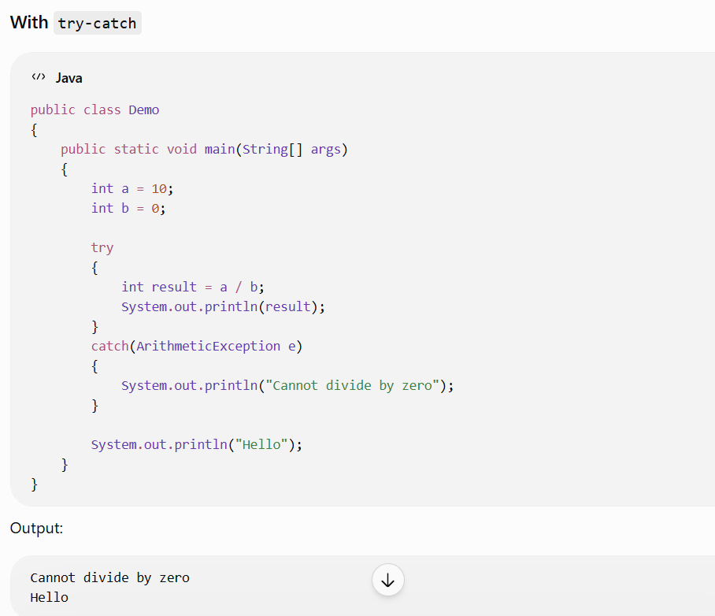
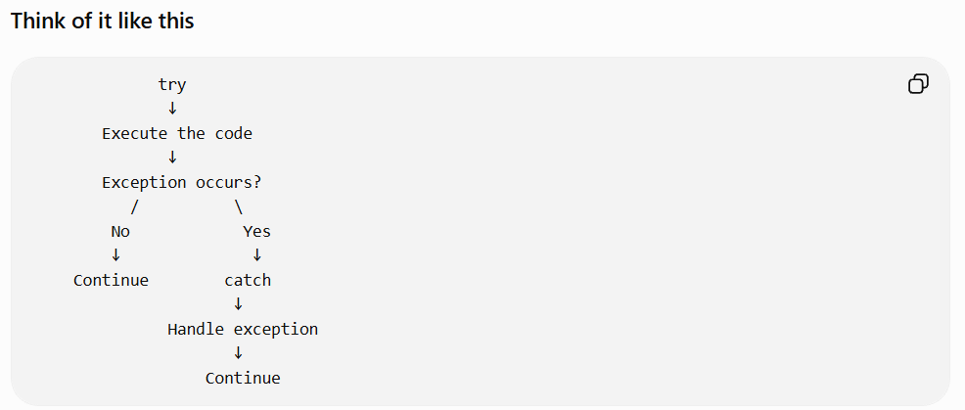
In real-world applications, try-catch is used to handle expected or possible failures—such as database errors, file errors, invalid input, and API/network failures—so the application can respond gracefully instead of terminating unexpectedly.

try with Multiple catch in Java:
Sometimes the code inside a try block can produce different types of exceptions.
In that situation, we can use multiple catch blocks to handle each exception differently.
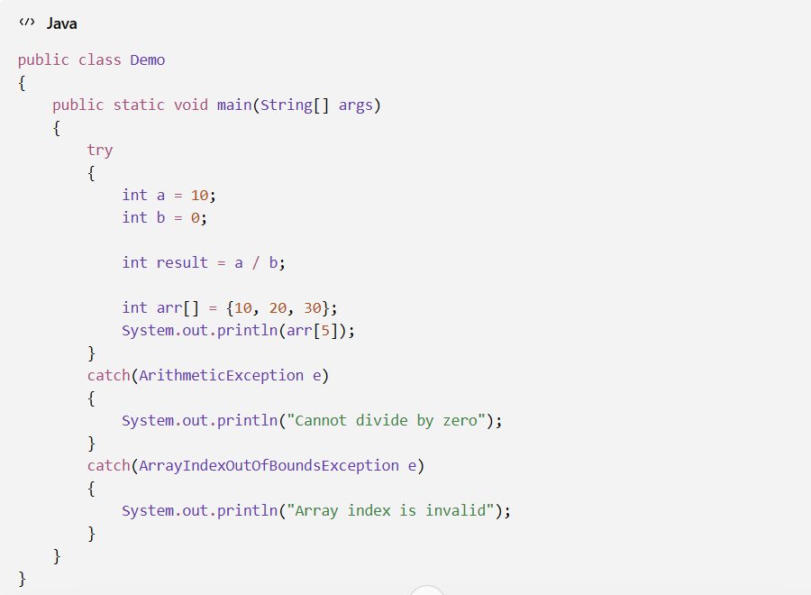

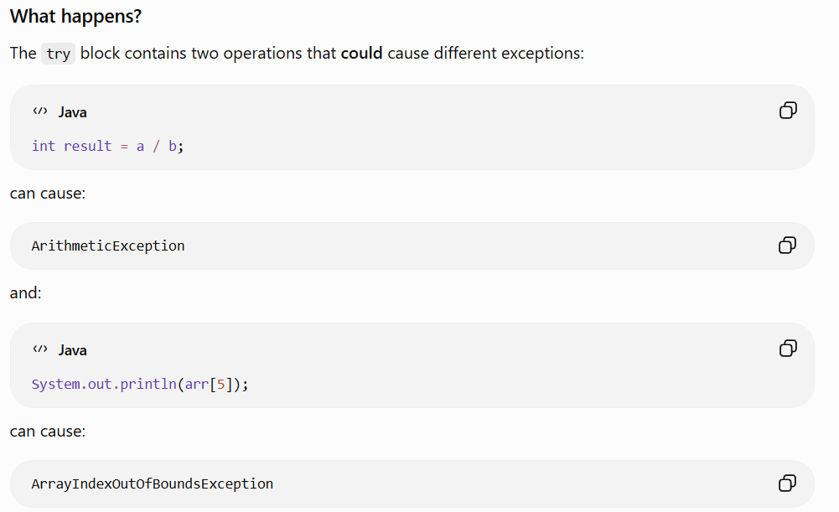
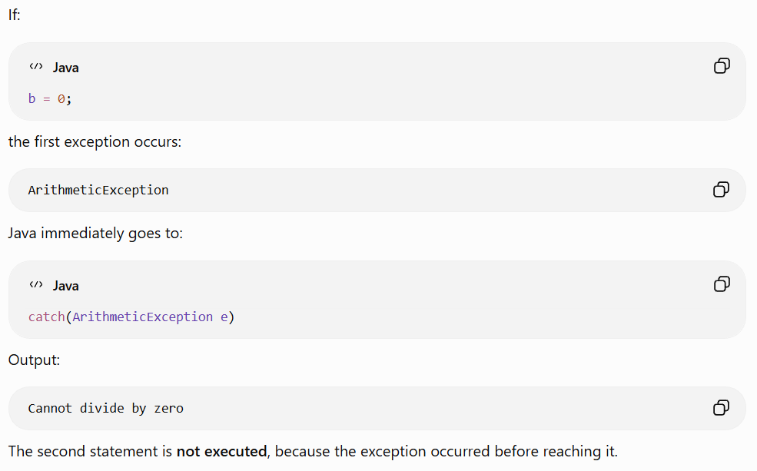
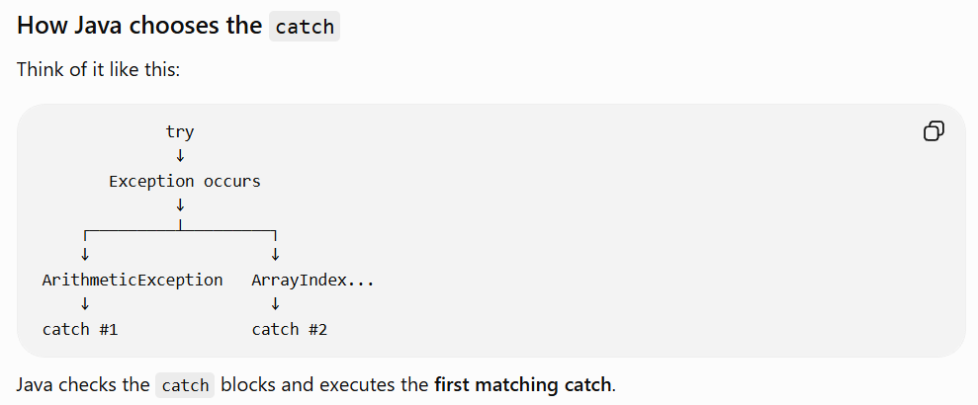
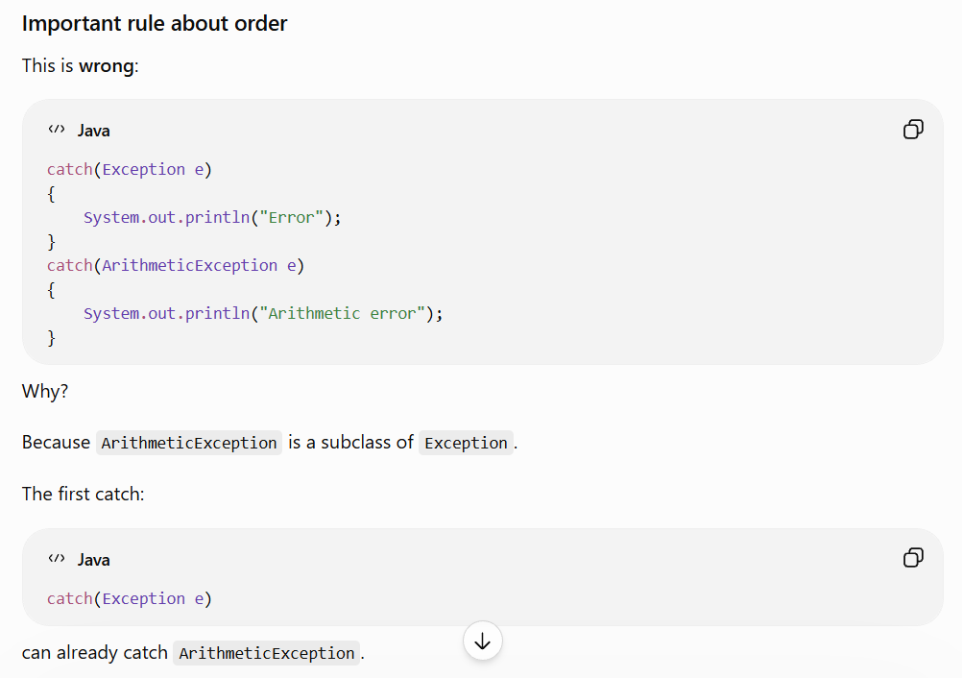
Therefore the second catch becomes unreachable.
Instead:
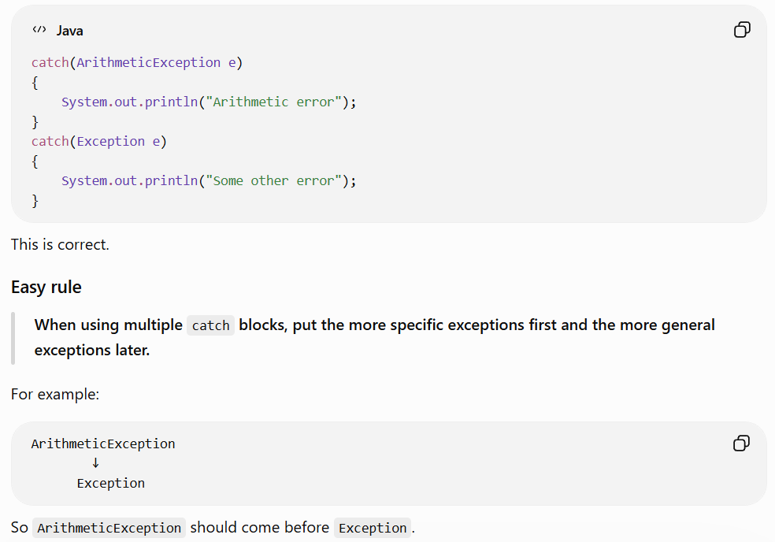
Exception Hierarchy in Java
Exception hierarchy means the way Java organizes exceptions using inheritance.
The main hierarchy looks like this:
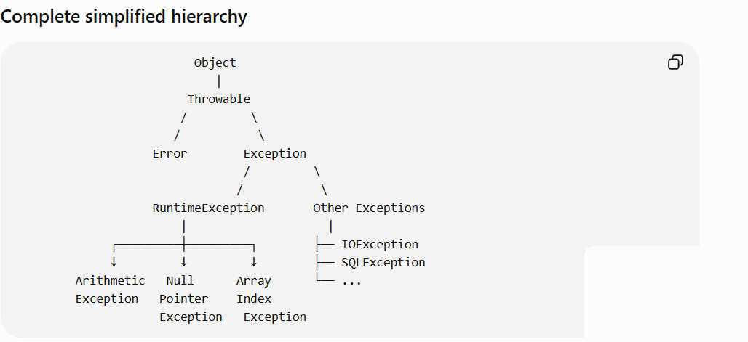
1. Throwable
Throwable is the top-level class for things that can be thrown by Java.
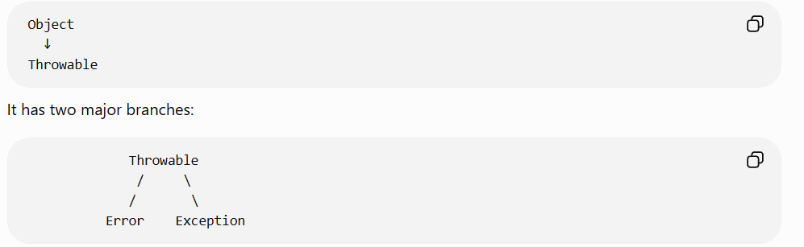
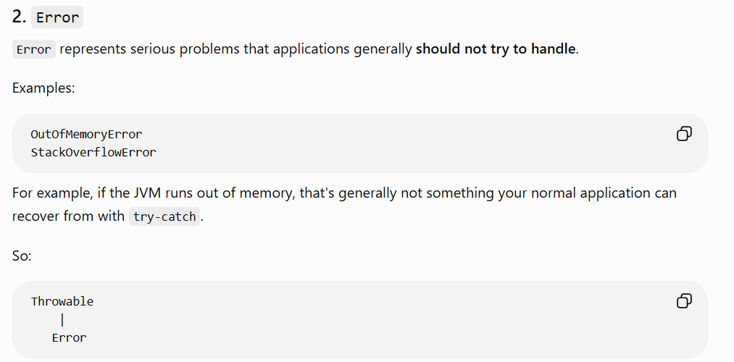
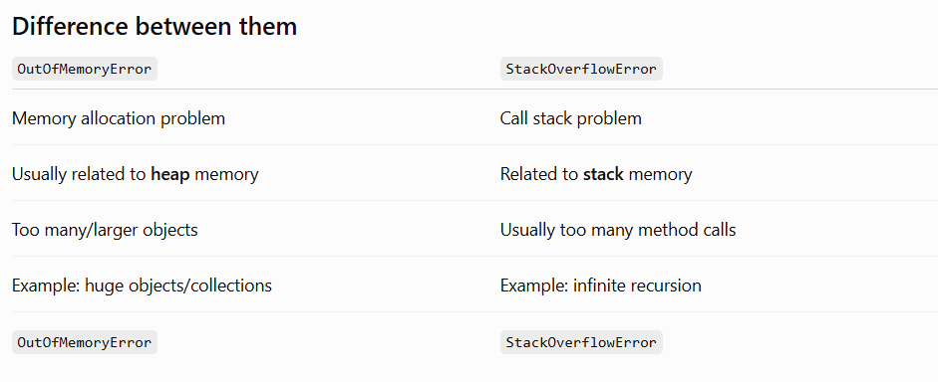
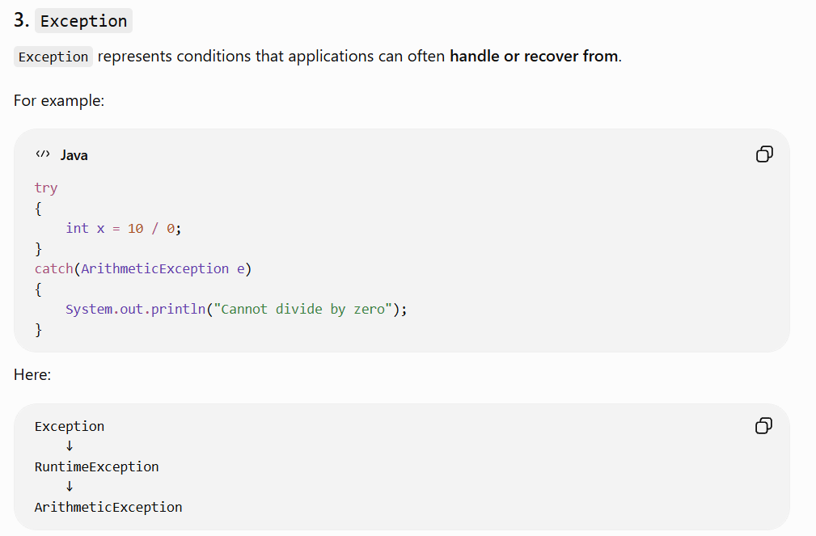
4. RuntimeException
RuntimeException is an important subclass of Exception.
These exceptions generally occur because of problems during program execution.
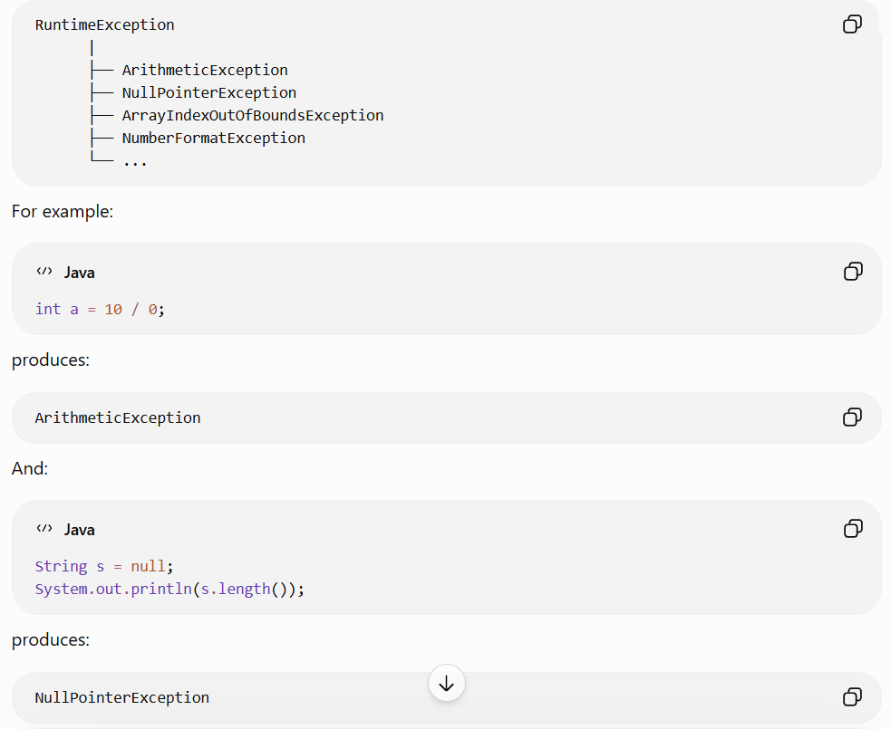
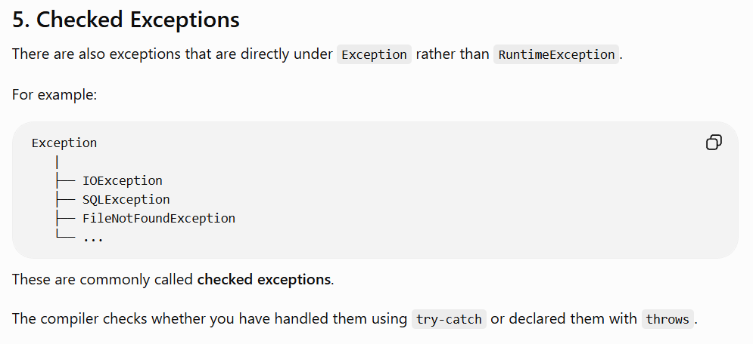

throw
throw is used to explicitly throw an exception when we want to indicate that an error has occurred.
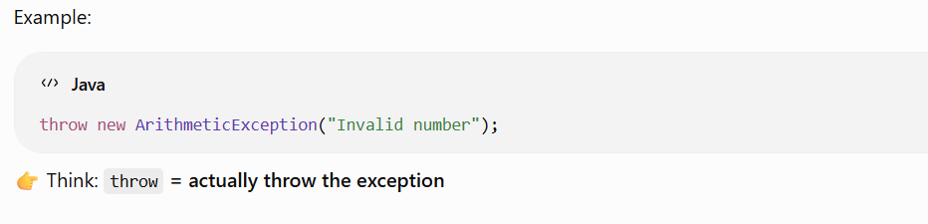
throws
throws is used in a method declaration to tell the caller that the method may throw an exception.
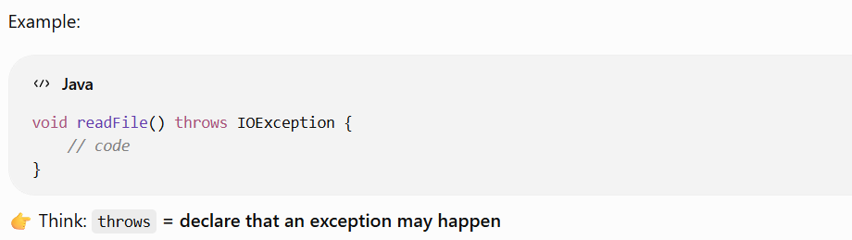
Easy way to remember
throw → Throw the exception
throws → Tell/declare that exception may occur
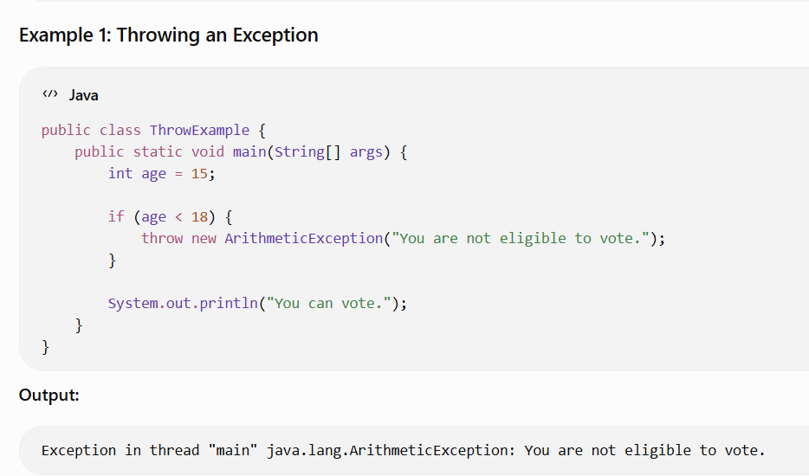
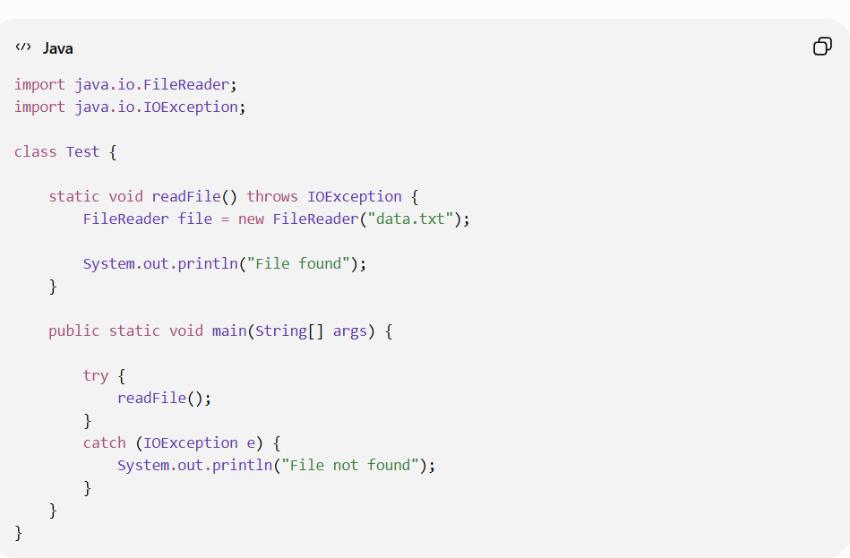
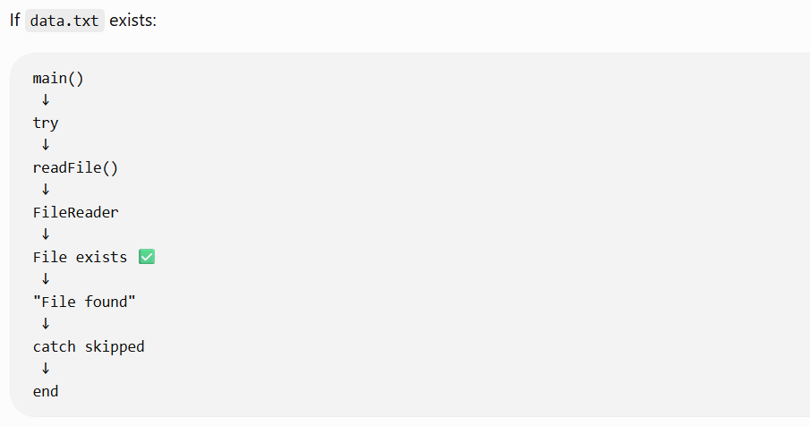
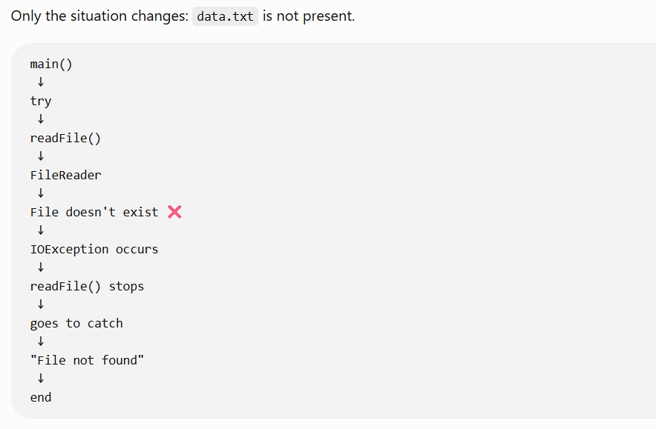
What is a Custom Exception in Java?
A custom exception is an exception that we create ourselves to represent a specific error or situation in our application.
Java already provides exceptions like:
ArithmeticException
NullPointerException
IOException
But sometimes our application has its own specific errors.
For example:
- Bank account → Insufficient Balance
- Login → Invalid User
- Banking → Invalid Account
- Shopping → Product Out of Stock
For these situations, we can create our own exception class.

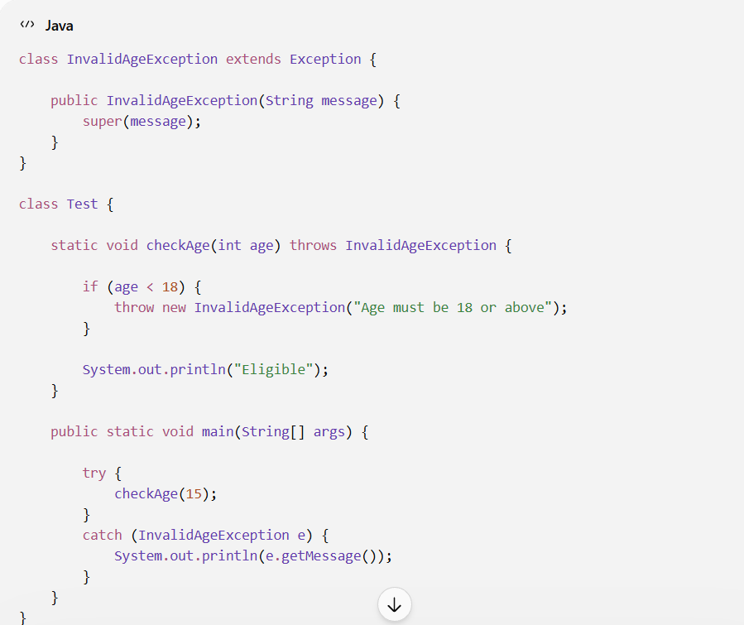
Flow of execution:
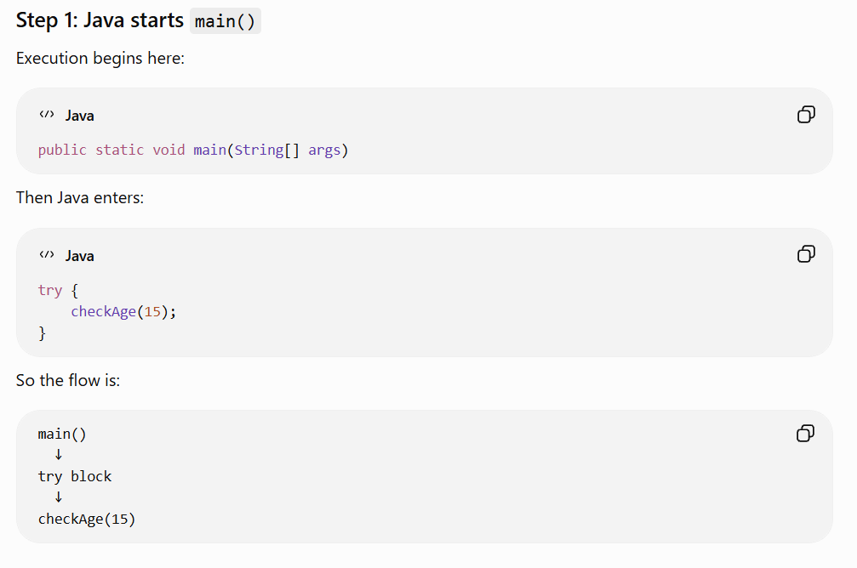

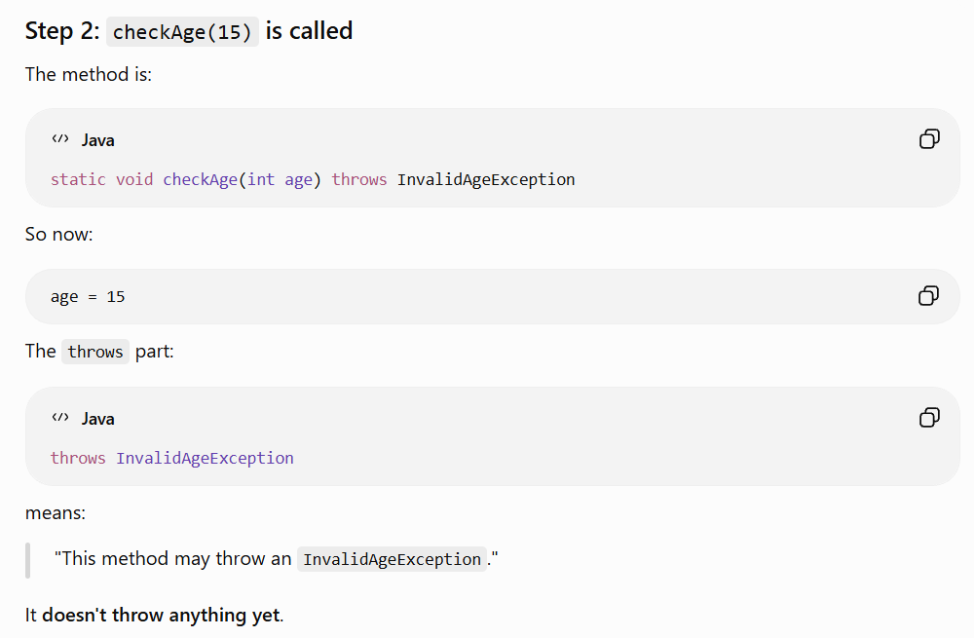
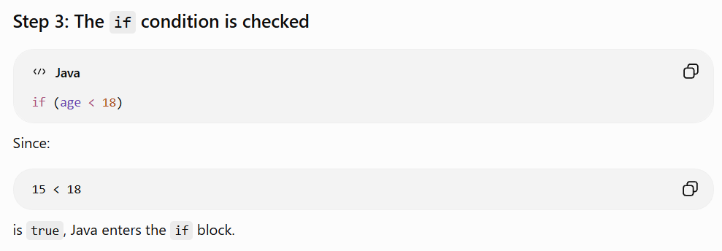
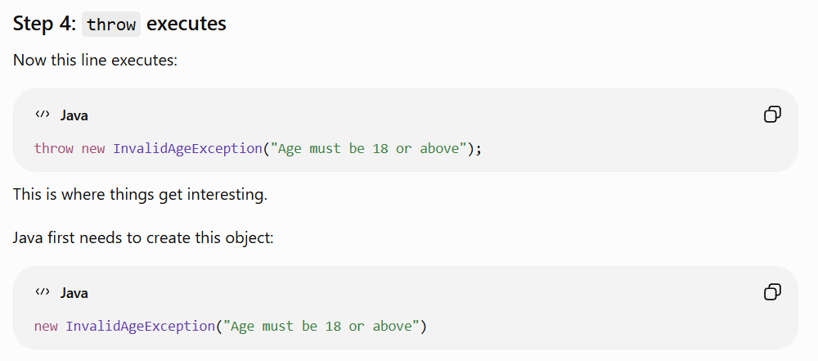

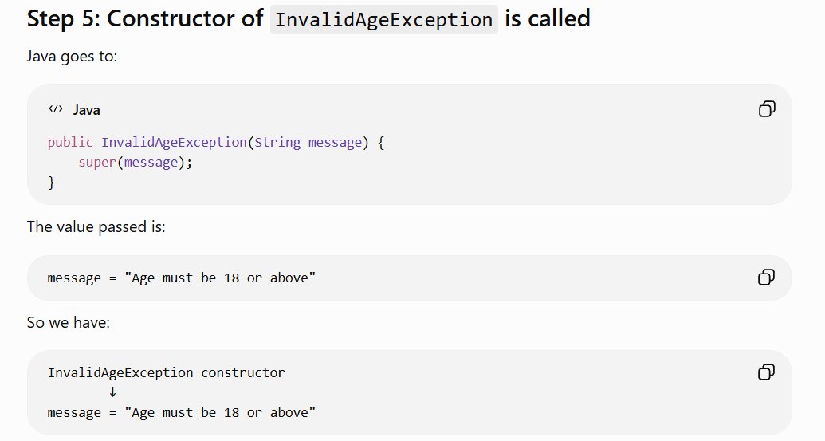
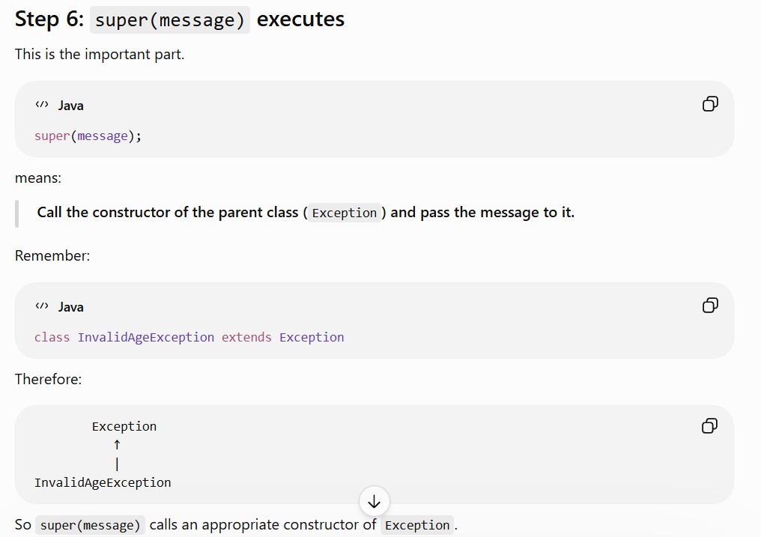
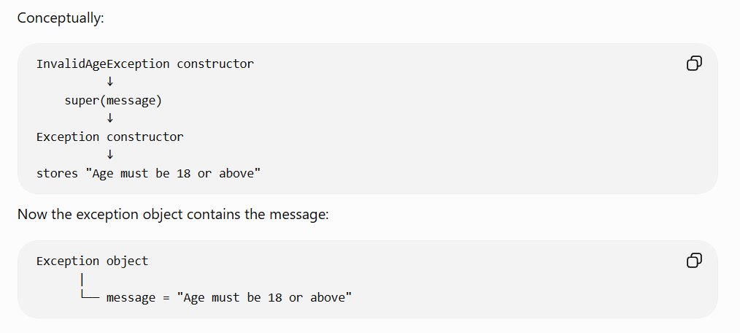
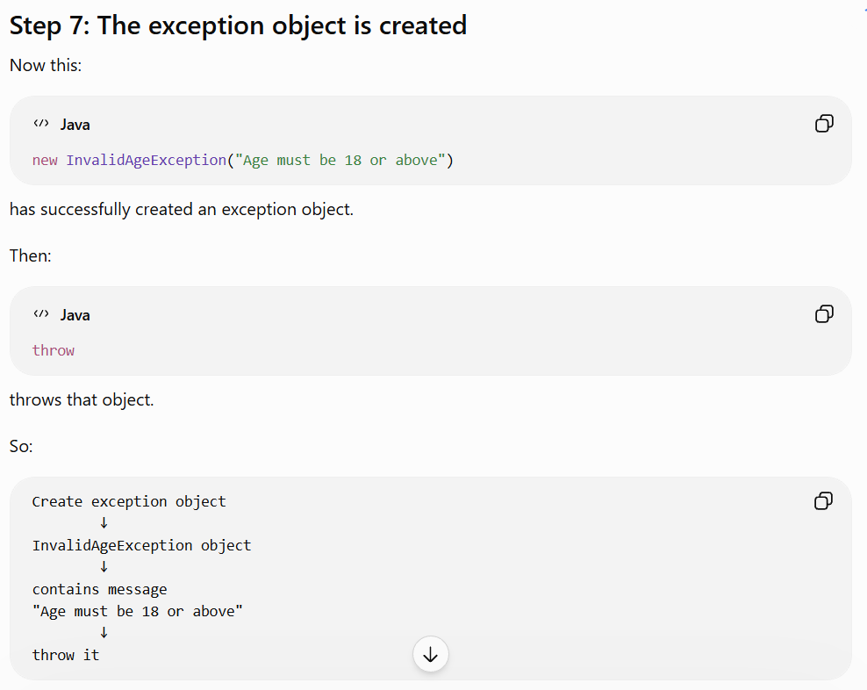
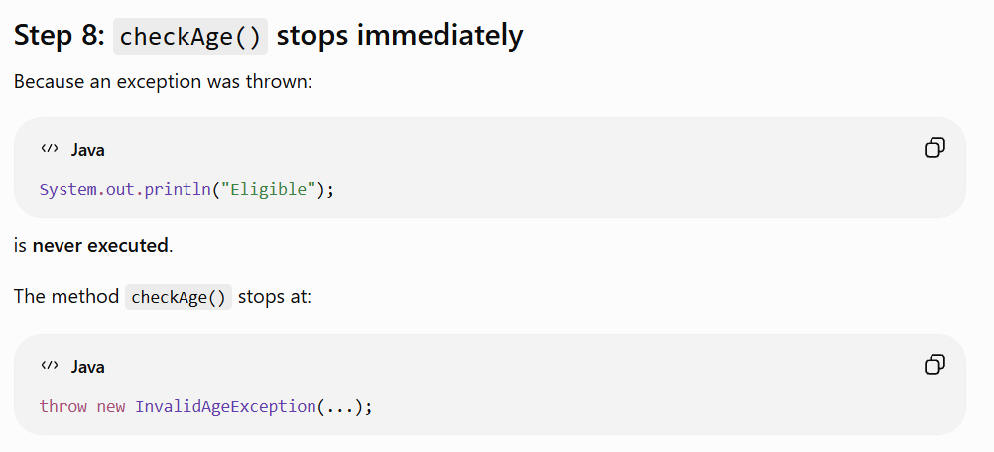
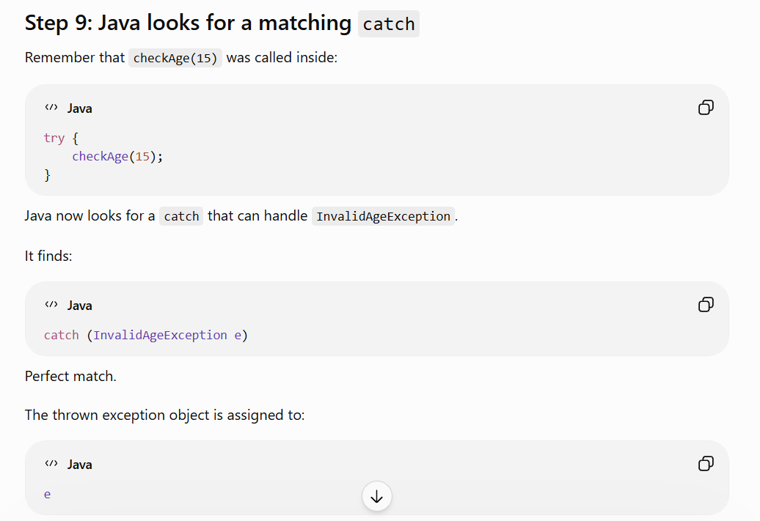
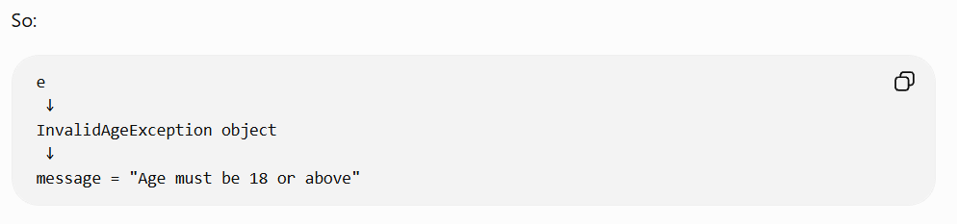
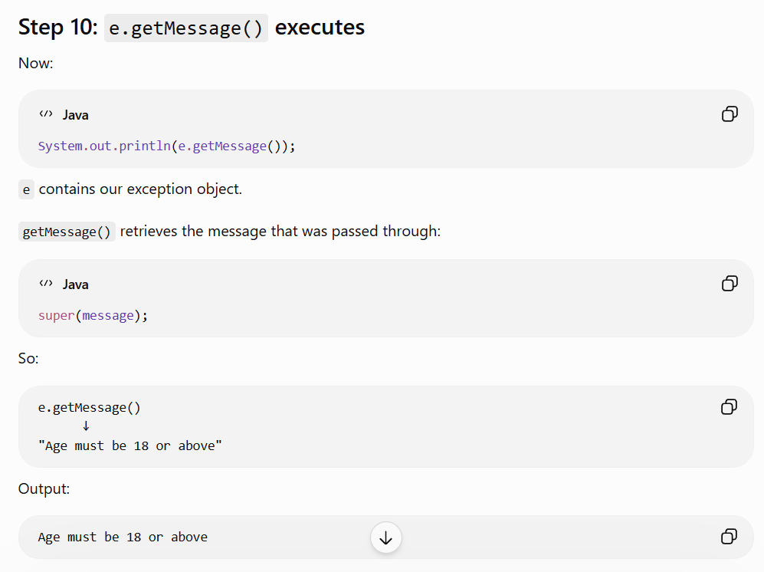

-------------------------------------------------------------------------------------------------------------------------

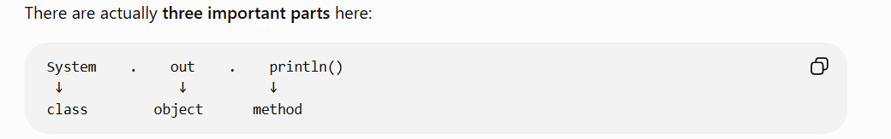
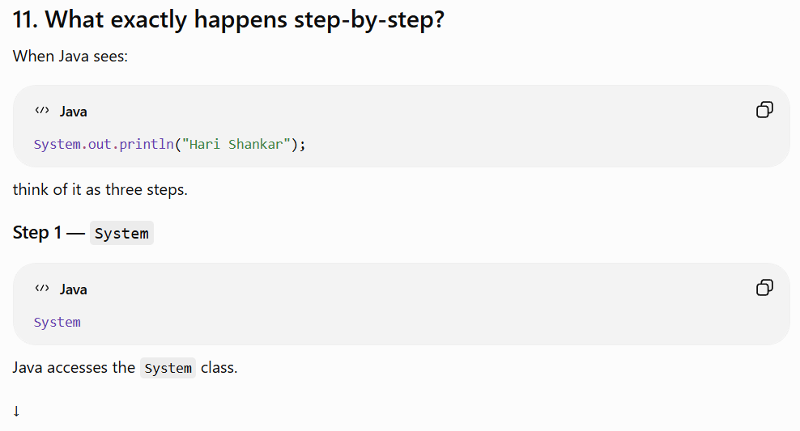
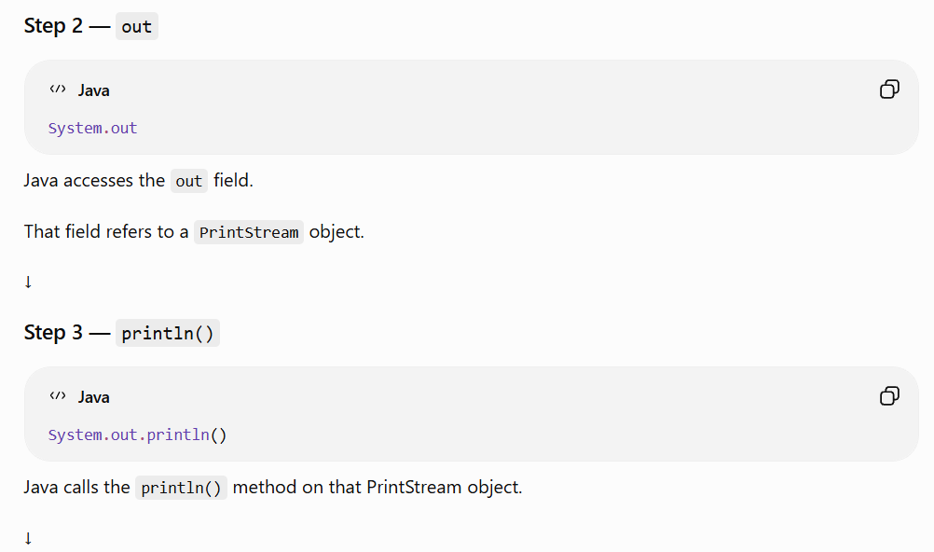
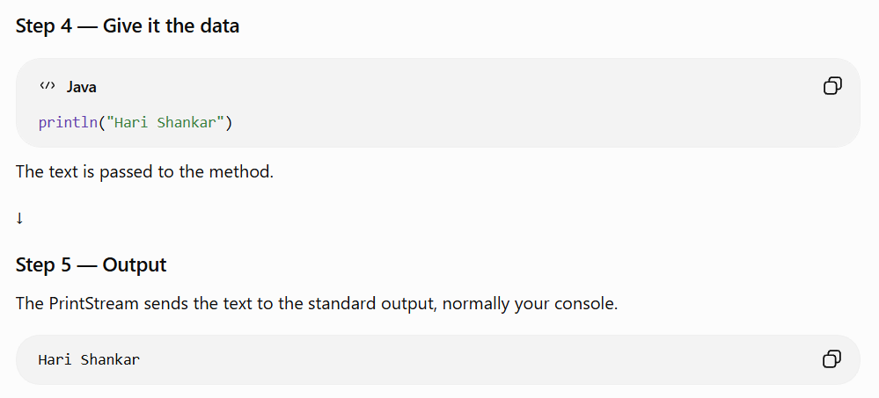
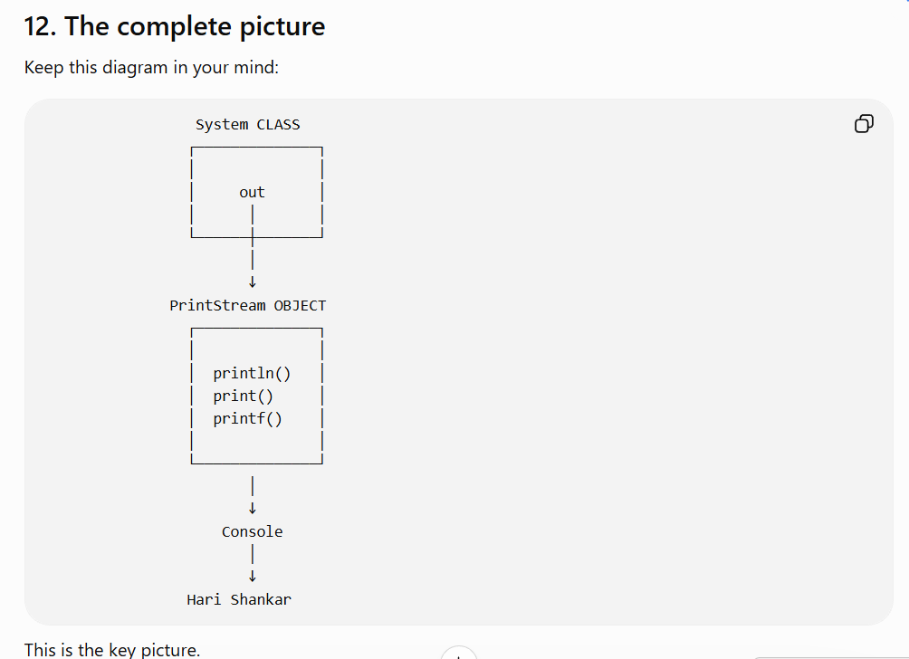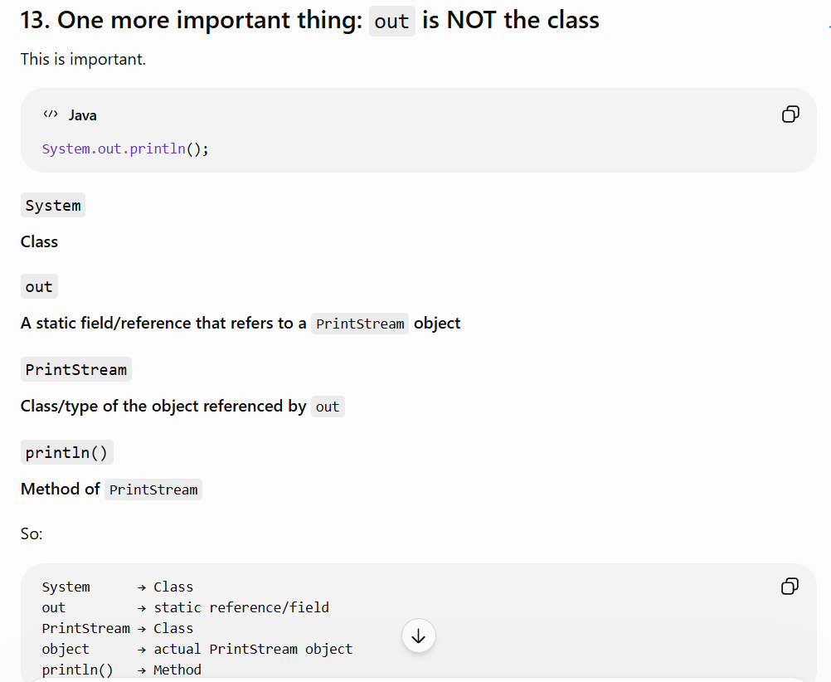

Definition of Thread in Java
A thread is a small unit of execution within a program that allows a task to run independently.
In simple words:
A thread is a path of execution through which a program performs a task.
Example
Imagine a music app:
- Thread 1 → plays music 🎵
- Thread 2 → downloads a song 📥
- Thread 3 → responds to your button clicks 🖱️
All these tasks can run concurrently using threads.
One-line definition for interviews:
A thread is an independent path of execution within a program used to perform tasks concurrently.
What are Multiple Threads in Java?
Multiple threads means having more than one thread executing tasks within the same program.
In simple words:
Multiple threads = multiple independent paths of execution running concurrently in one program.
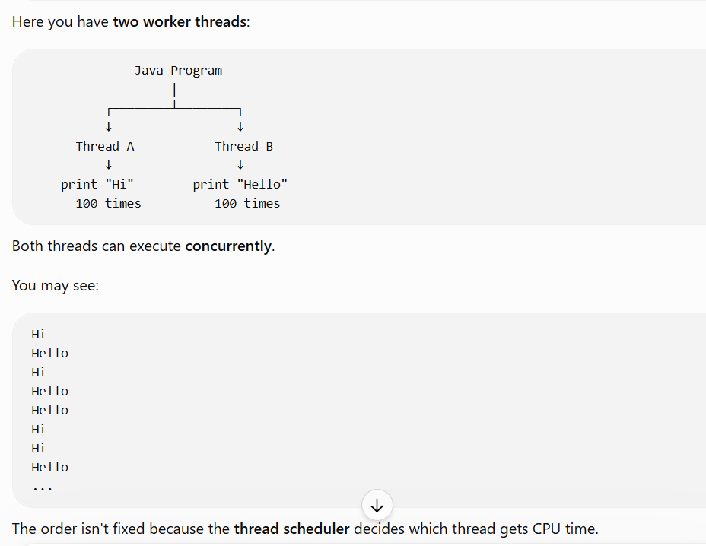
Why use multiple threads?
Suppose a backend application needs to:
Task 1 → Handle user request
Task 2 → Download a file
Task 3 → Process data
Task 4 → Send an email
Instead of making everything wait for one task to finish, different threads can handle different tasks.

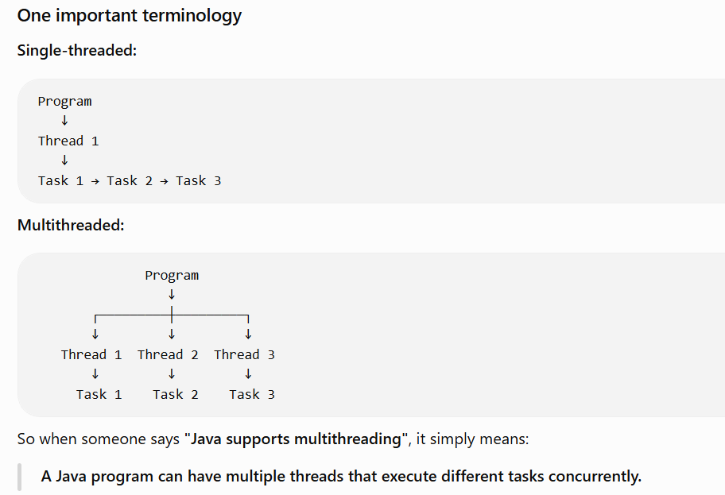
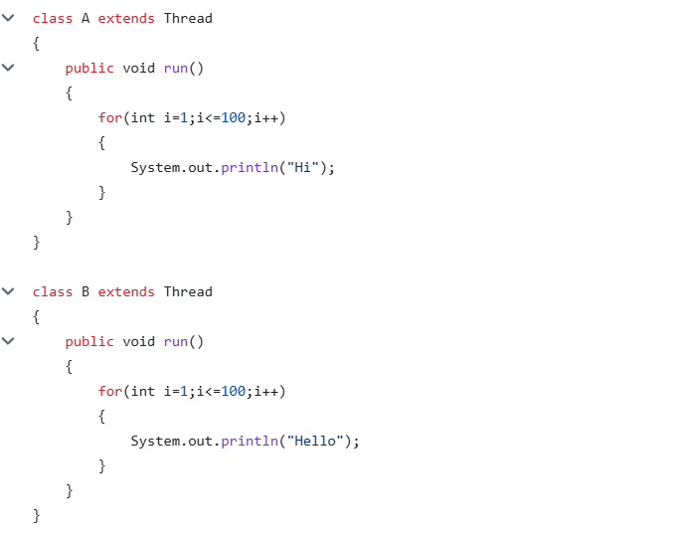
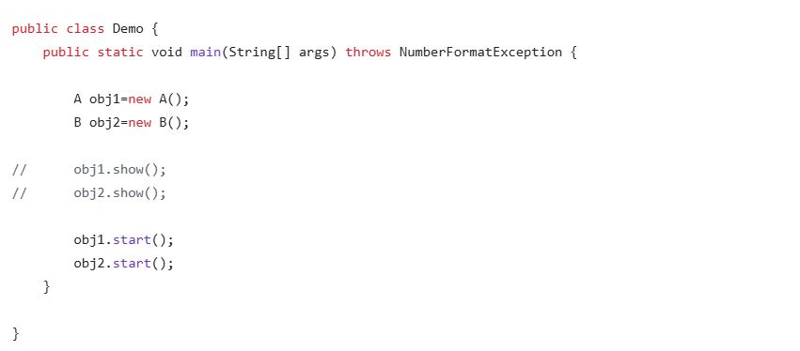
start() is a special method of the Thread class that starts a new thread, and that new thread executes run().
start() → special method → starts a new thread → run() executes

Definition of Thread Priority
Thread priority is a value assigned to a thread that indicates its relative importance to the thread scheduler when deciding which thread should get CPU time.
In Java, priority ranges from 1 to 10:
1 → Lowest priority
5 → Normal priority (default)
10 → Highest priority
Important: Higher priority does not guarantee that the thread will execute first or finish first.
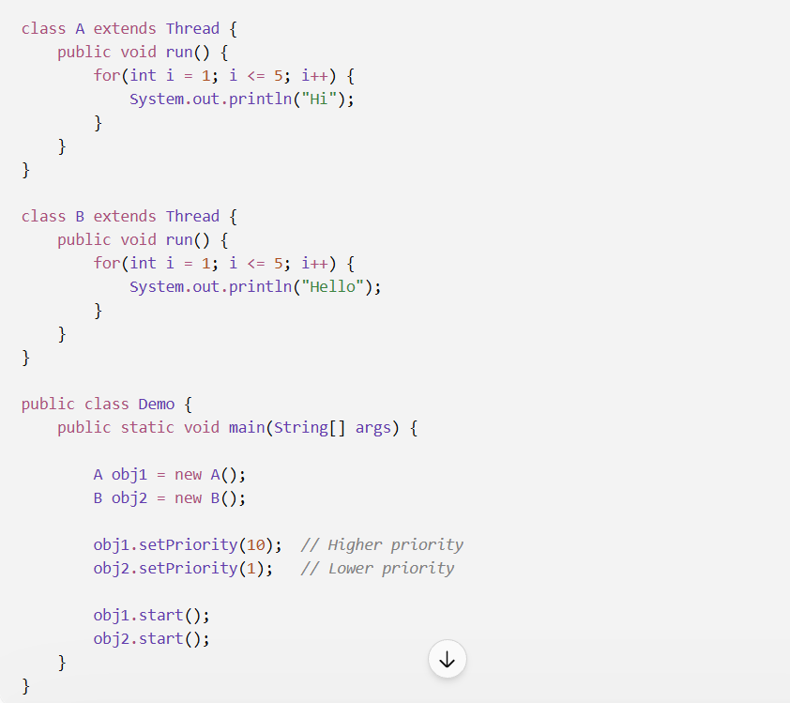
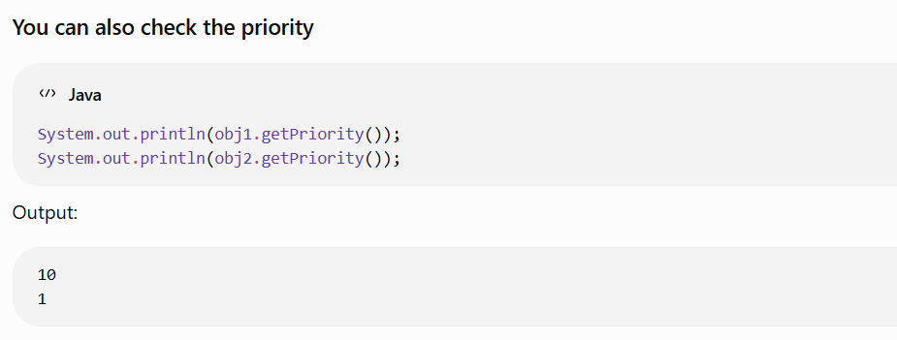

What is sleep() in Java?
sleep() is a method used to temporarily pause the execution of the currently running thread for a specified amount of time.
In simple words:
sleep() = "Pause this thread for some time."
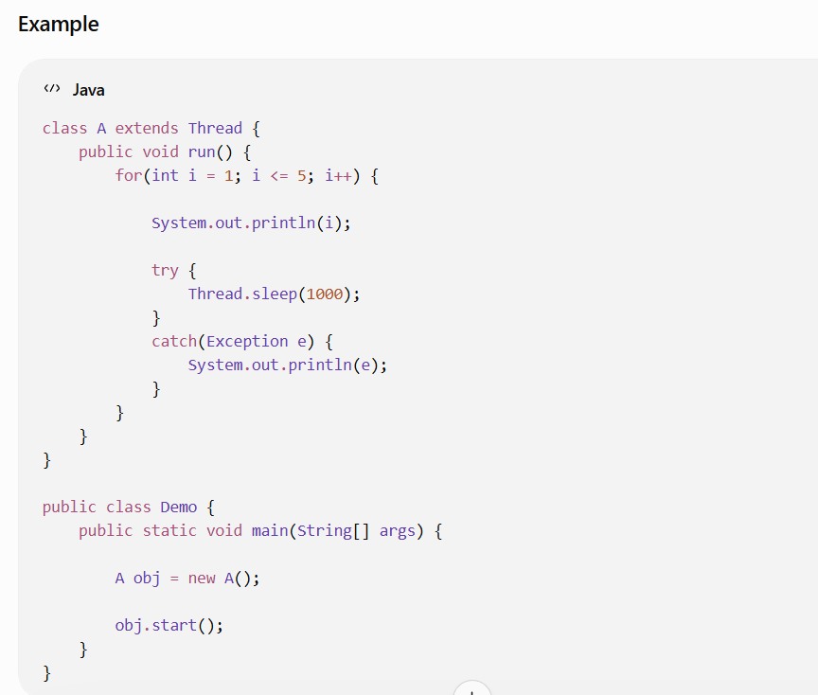
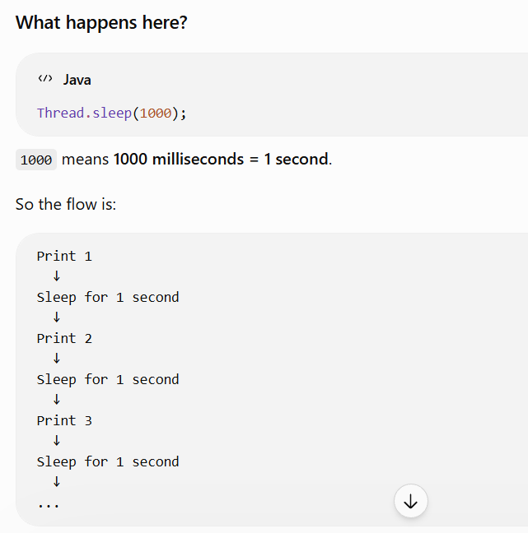

The catch is there because Thread.sleep() can throw an exception.
Let's understand it step by step.
1. Look at this line
Thread.sleep(1000);
Java says:
"I'm going to pause this thread for 1000 milliseconds, but this sleep operation can be interrupted."
If another thread interrupts the sleeping thread, Java can throw an InterruptedException.
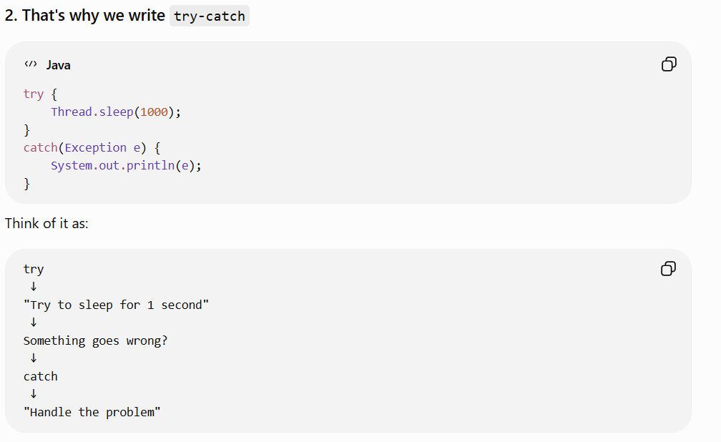
Catch : If an exception occurs, handle it here instead of letting the program terminate unexpectedly.

Thread vs Runnable in Java
Both are used to create threads, but they work differently.
1. Using Thread
You create a class that extends Thread:
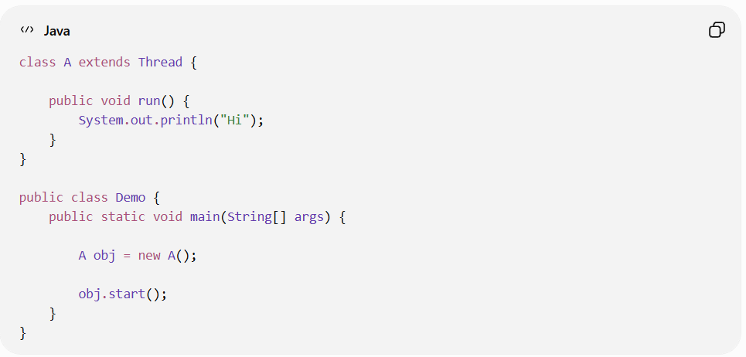
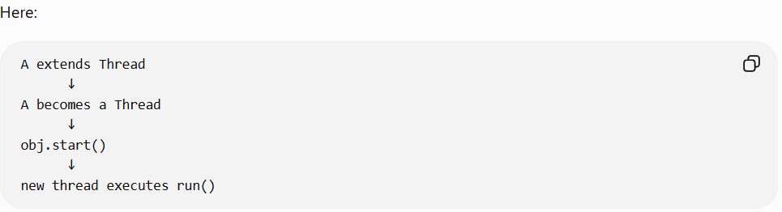
2. Using Runnable
Instead of extending Thread, you implement Runnable:
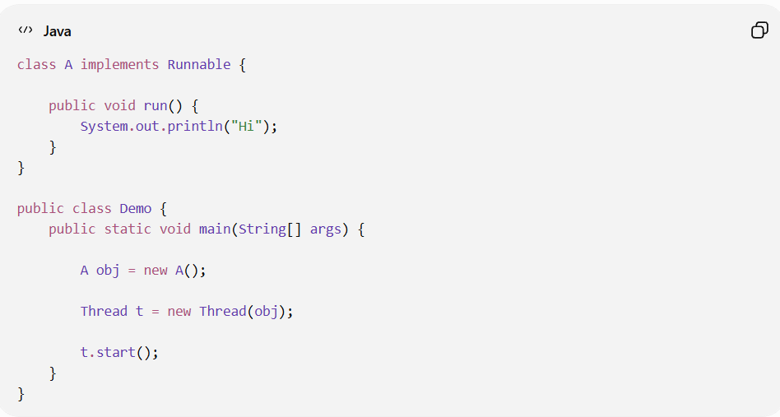
Now notice the difference.
A is not a Thread.
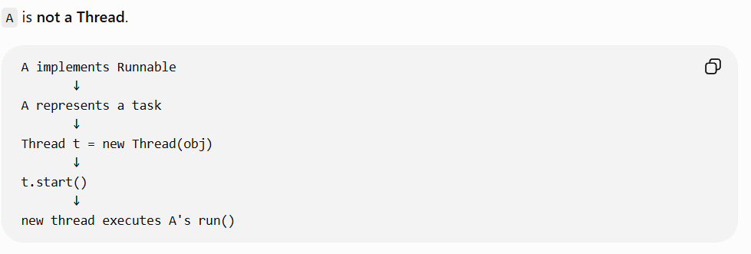
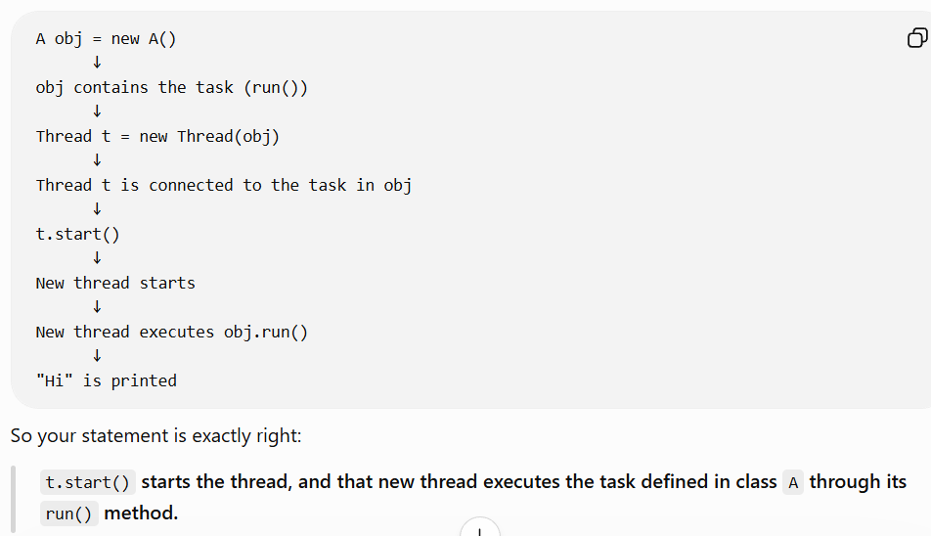
Thread
class A extends Thread
Here:
A = Thread + Task
The class itself becomes a thread.

Runnable
class A implements Runnable
Here:
A = Task
It is not a thread.
Then you give that task to a Thread:
Thread t = new Thread(obj);
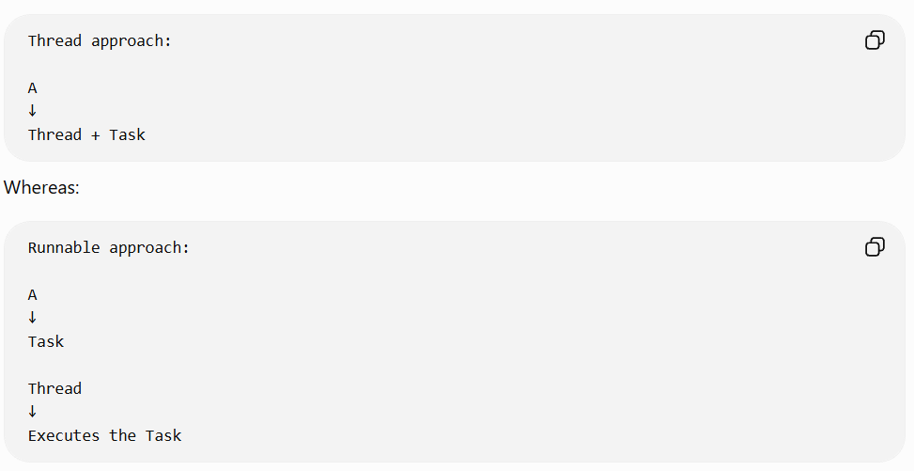
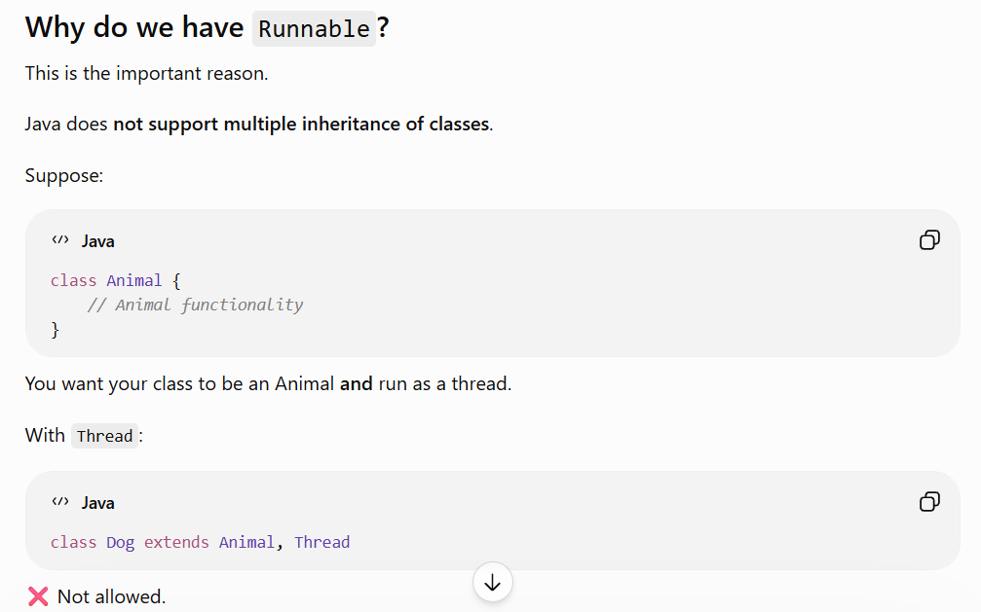
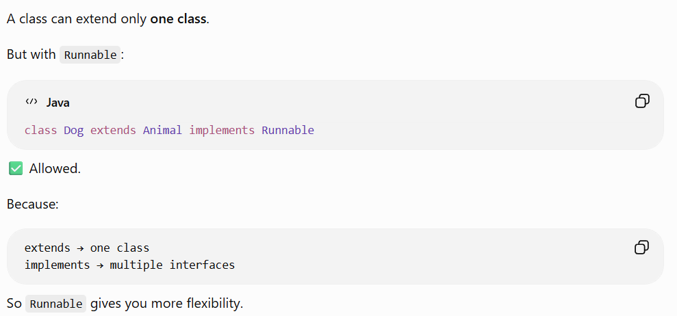
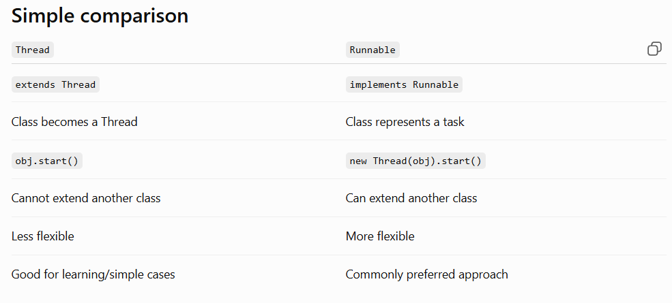
Race Condition in Java
A race condition occurs when multiple threads access and modify the same shared data at the same time, and the final result depends on which thread executes first.
Multiple threads + shared data + simultaneous modification = possible race condition.

Example:
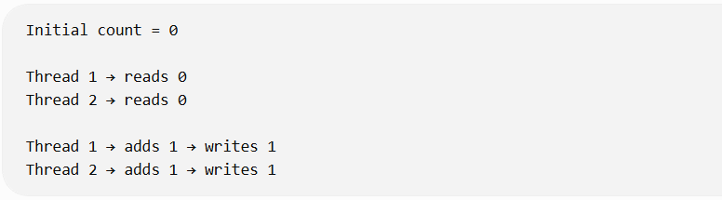
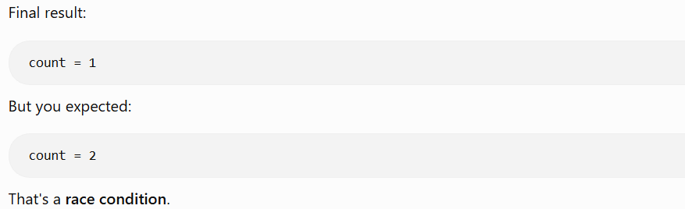
Why is it called a "race"?
Because the threads are essentially racing to access and modify the same data
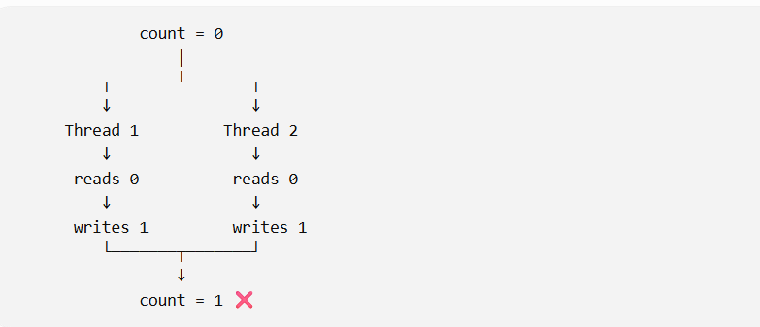
Real-world example
Imagine a bank account:
Balance = ₹10,000
Two withdrawal requests arrive at the same time:
Thread 1 → Withdraw ₹7,000
Thread 2 → Withdraw ₹5,000
Both threads might see:
Balance = ₹10,000
and both think the withdrawal is possible.
This can cause an incorrect balance.

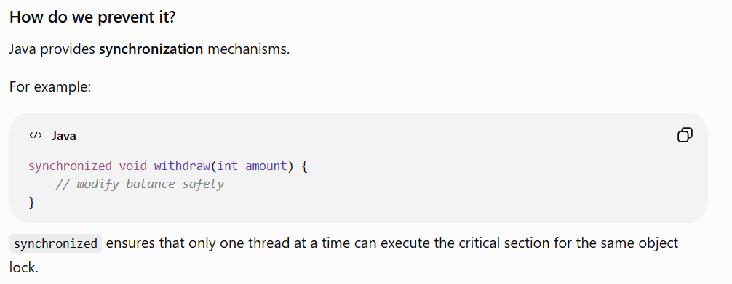

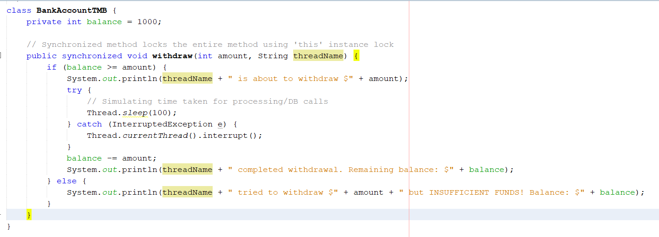
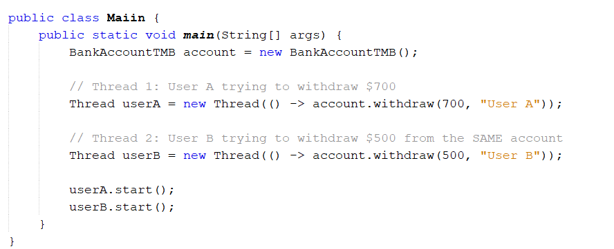
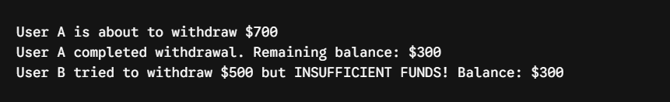

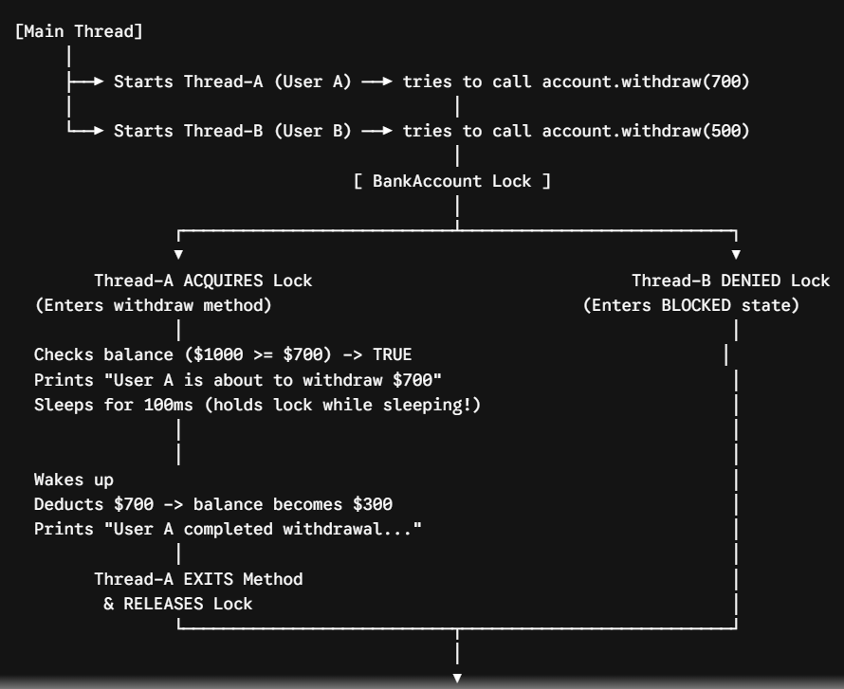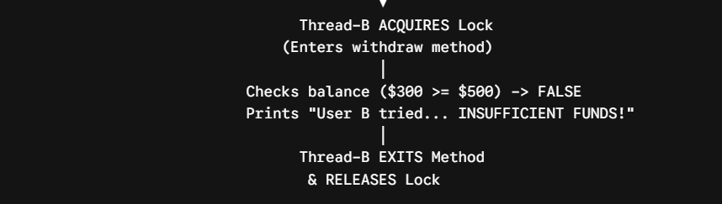
Another Case for Output:
User B is about to withdraw $500
User B completed withdrawal. Remaining balance: $500
User A tried to withdraw $700 but INSUFFICIENT FUNDS! Balance: $500
BUILD SUCCESSFUL (total time: 0 seconds)

Actually, Thread B (User B) executed first! Here is why:
1. Who executed first?
- User B started with the original $1000 balance.
- User B withdrew $500, leaving a remaining balance of $500 (1000 - 500 = 500).
- Then User A tried to withdraw $700, but failed because only $500 was left.
If Thread A had executed first, User A would have taken $700, leaving $300 behind.

2. Why did Thread B run first this time?
When you call .start() on two threads:
Java
userA.start();
userB.start();
Calling userA.start() first does not guarantee that User A wins the race to grab the lock!
- .start() simply tells the OS: "This thread is ready to run."
- The JVM and Operating System Thread Scheduler decide which thread actually gets CPU execution time first.
- It is completely normal for userB to request and grab the synchronized lock a fraction of a millisecond before userA, depending on OS scheduling.

The Big Takeaway
This output demonstrates the core nature of multithreading: thread scheduling is non-deterministic (unpredictable).
However, because your withdraw method was synchronized, the code remained thread-safe:
- The operations happened sequentially (B then A), never at the exact same time.
- The balance was never corrupted or overdrawn.
- The business logic (balance >= amount) produced a mathematically correct result

In Java, Thread State means the current stage/status of a thread during its life cycle.
Java provides 6 thread states through the Thread.State enum

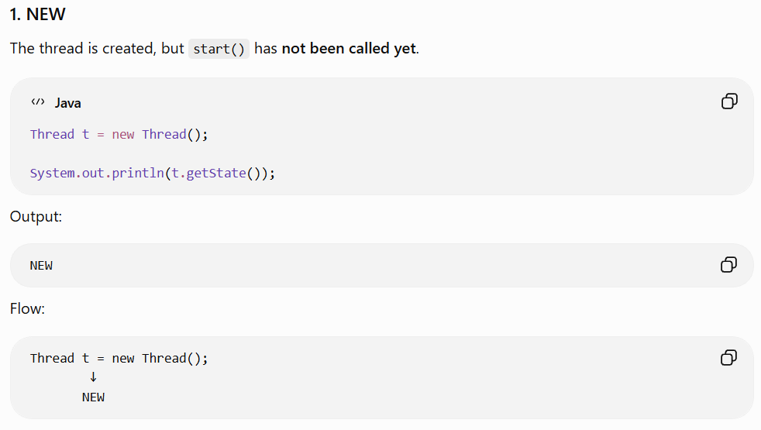
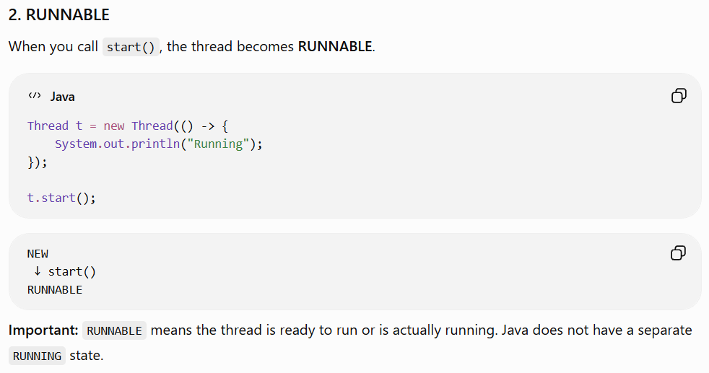
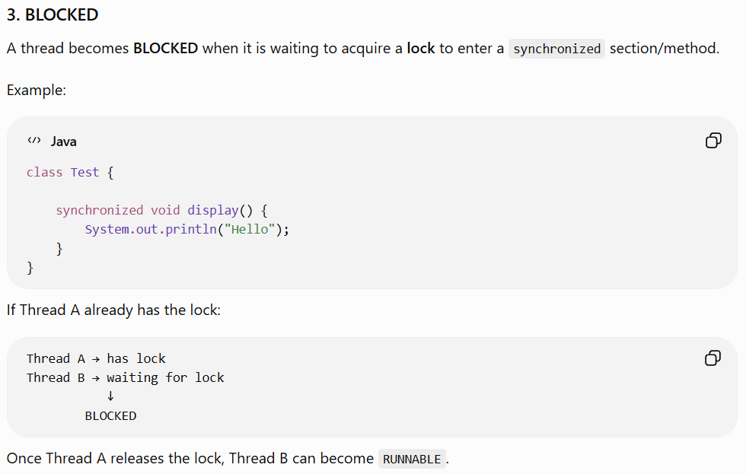

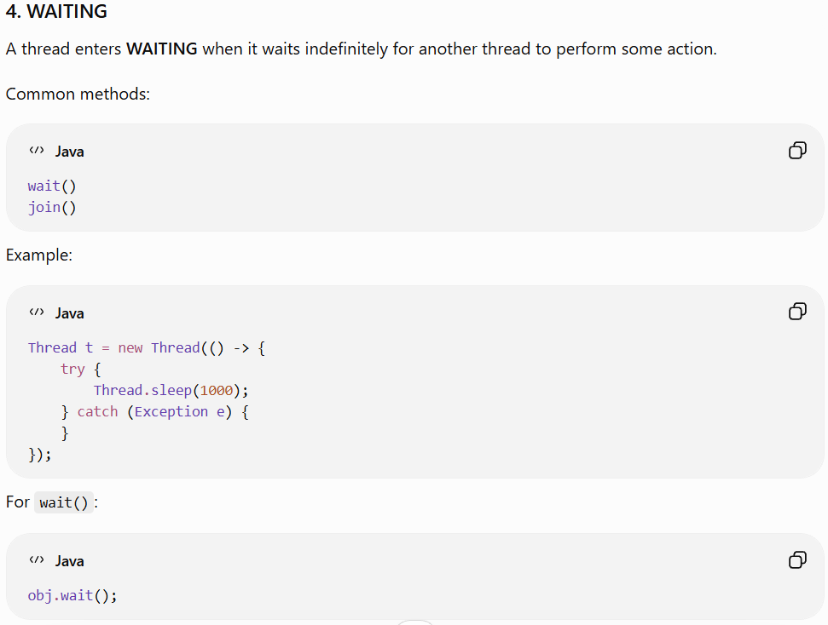
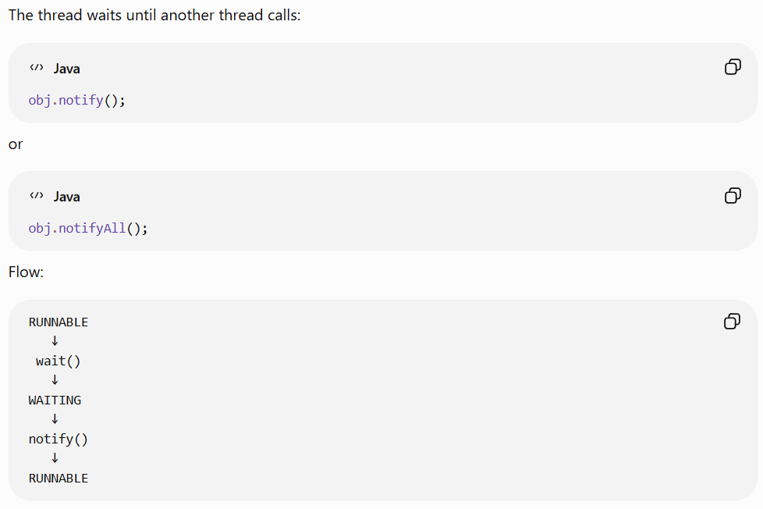
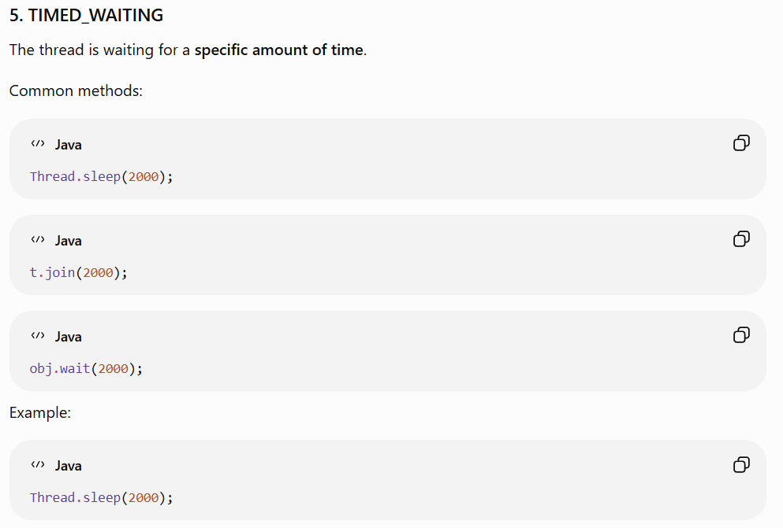
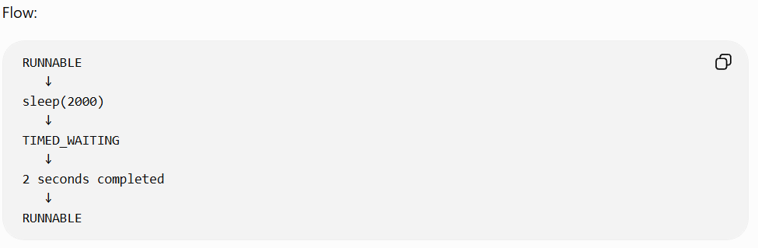
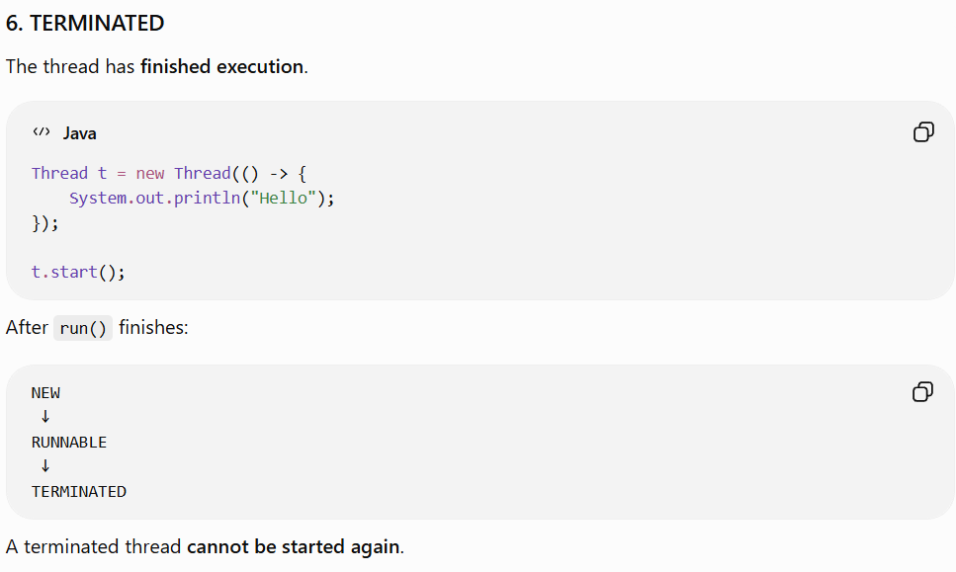
Complete Thread Life Cycle:
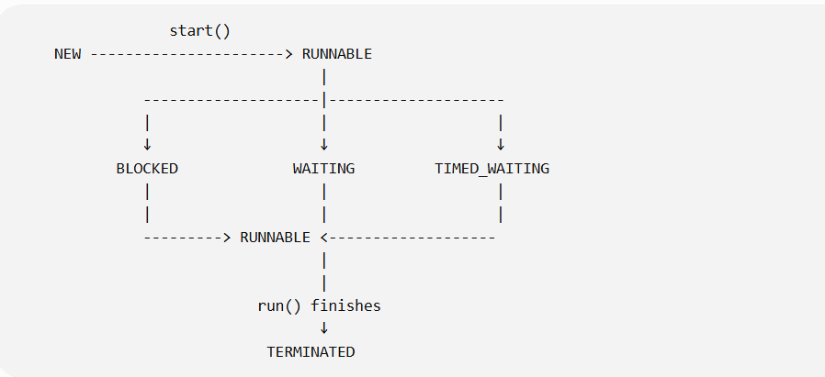
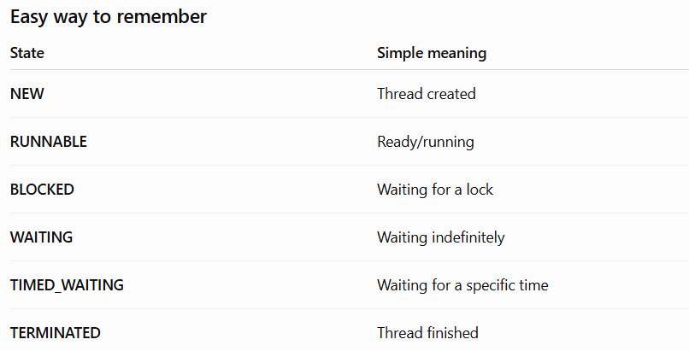
The Java Collections API is a framework in Java that provides a set of interfaces, classes, and algorithms to store, manage, and manipulate groups of objects efficiently.
It is part of the java.util package and was introduced in Java 2 (JDK 1.2).
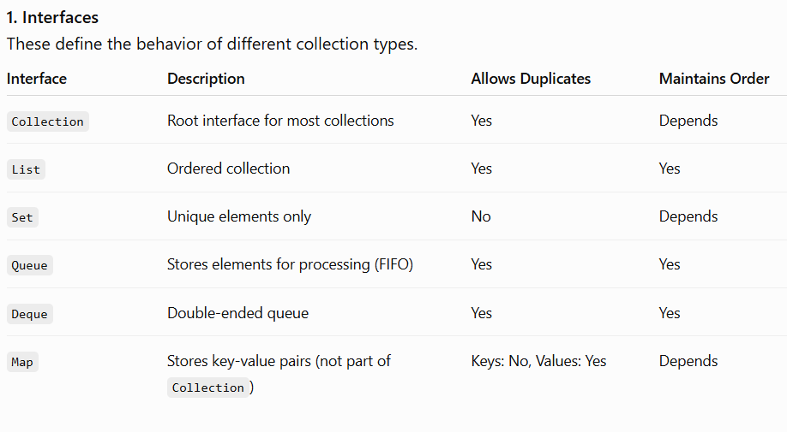
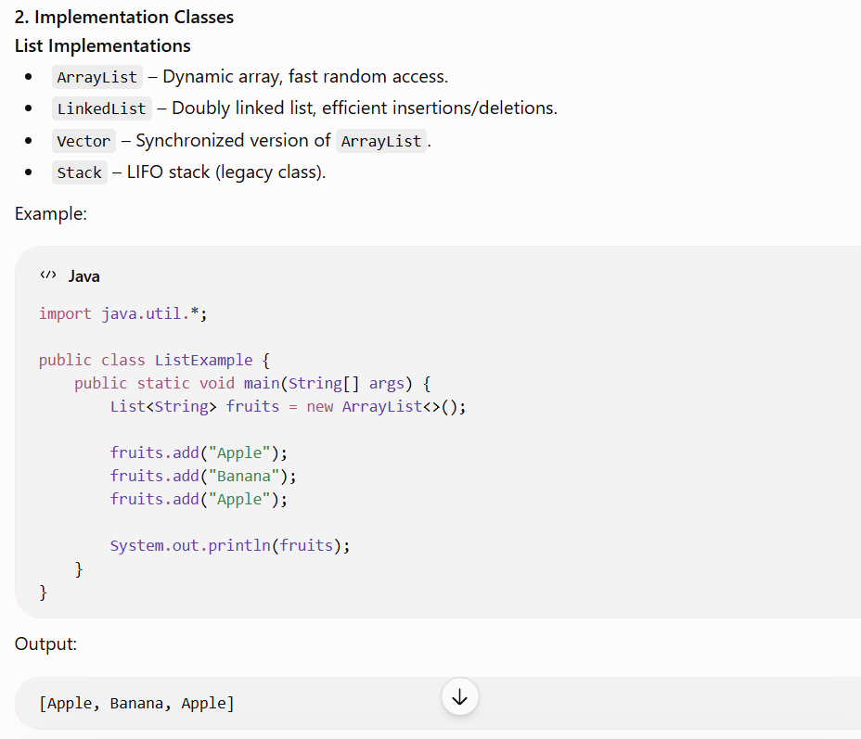

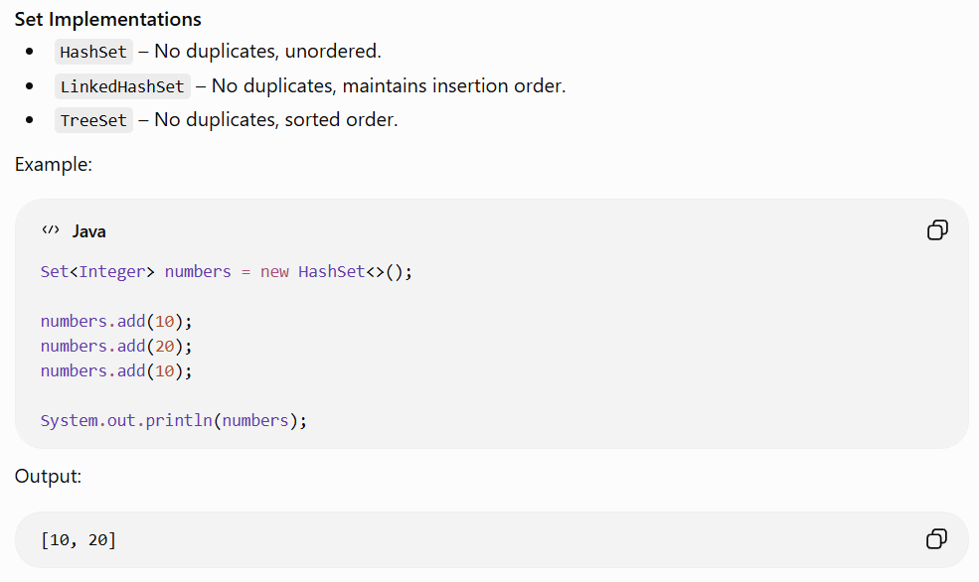
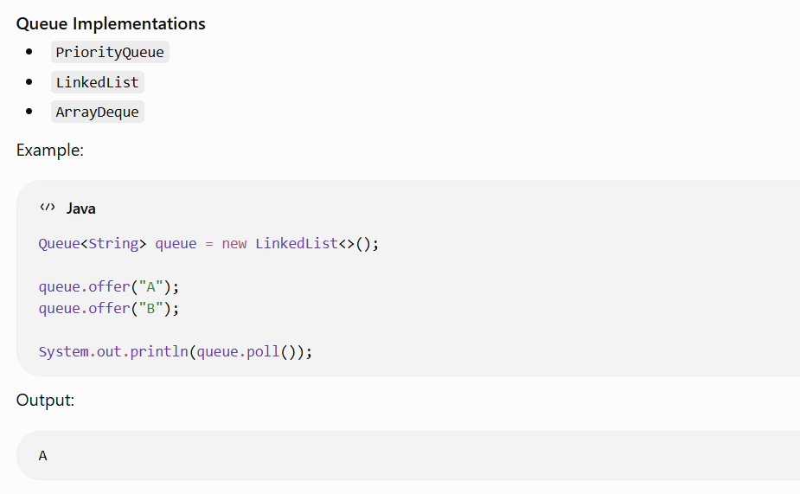
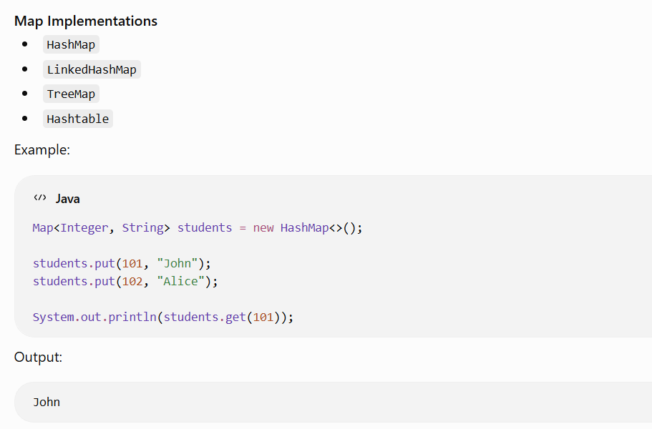
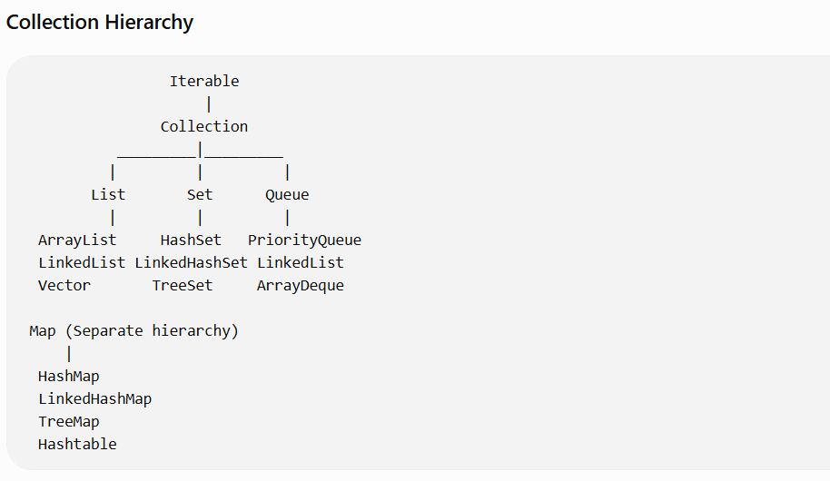
Map is part of the framework but not a subtype of Collection
Advantages of the Collections API
- Dynamic sizing (no fixed-size arrays).
- Reusable data structures (lists, sets, queues, maps).
- Built-in algorithms like sorting and searching via Collections.
- Generic support for type safety.
- Improved code readability and maintainability.
- Well-tested implementations optimized for common use cases.

What is ArrayList in Java?
Simple definition:
ArrayList is a class in Java that is used to store multiple objects/elements in a dynamically growing array.
It belongs to the Java Collections Framework and implements the List interface.
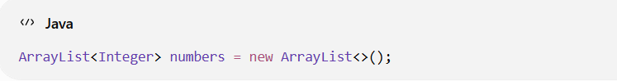
Here:
- ArrayList → Class
- numbers → Reference variable
- new ArrayList<>() → Creates an ArrayList object
- Integer → Type of elements we want to store
Why do we need ArrayList?
Normally, an array has a fixed size:
Int [] numbers = new int [3];
You can store only 3 elements.
[10] [20] [30]
If you want to add another element, you cannot simply increase the array's size.
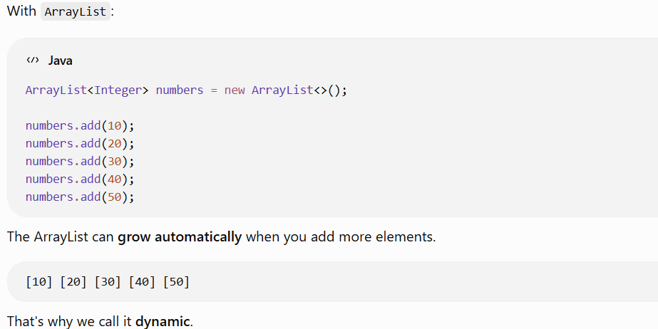
Important ArrayList methods:
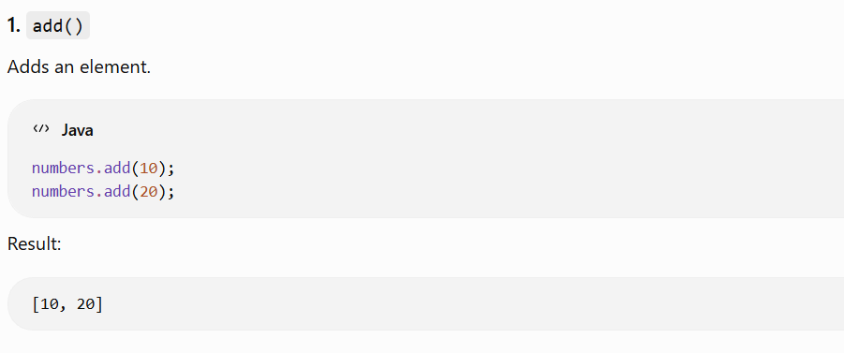
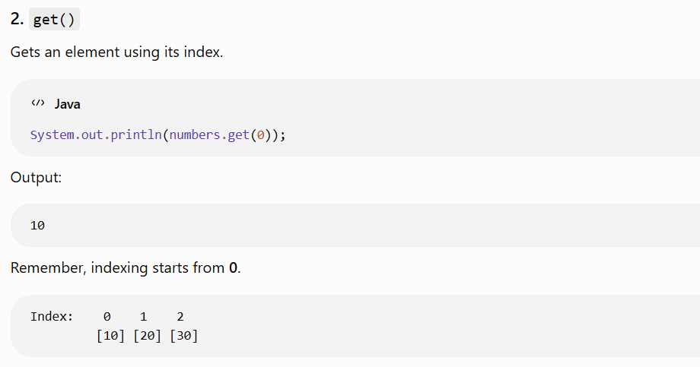
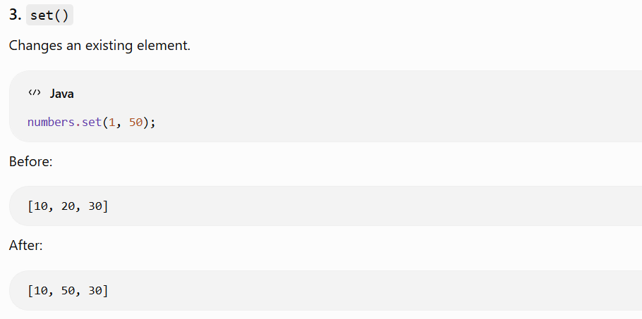
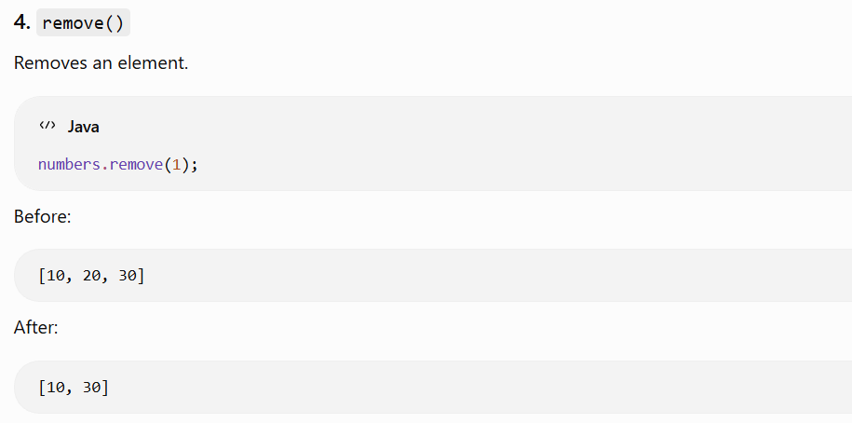
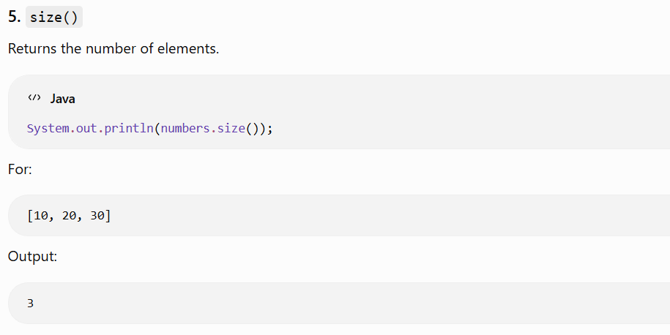
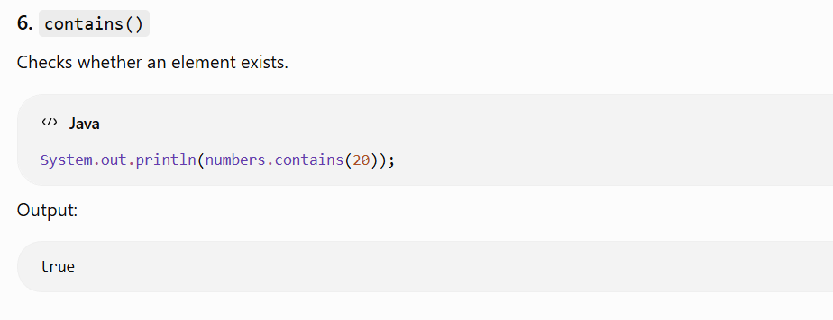

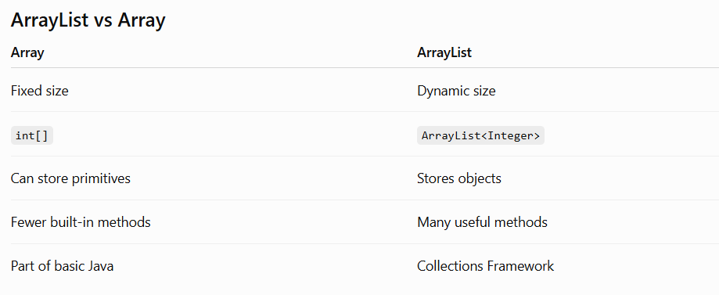
What is Set in Java?
Simple definition:
A Set is an interface in Java Collections that is used to store unique elements. It does not allow duplicate elements.
Set belongs to the Collections Framework.
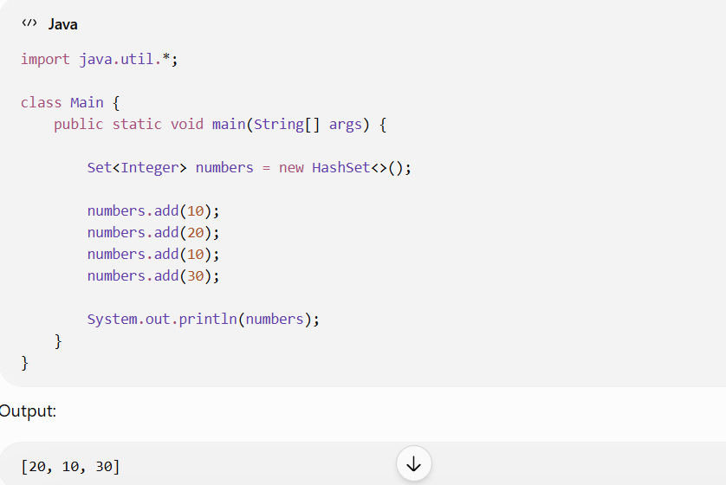
Why use Set?
Use a Set when you don't want duplicate values.
For example, suppose you have:
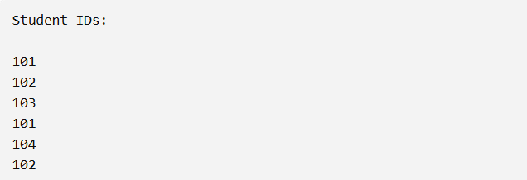
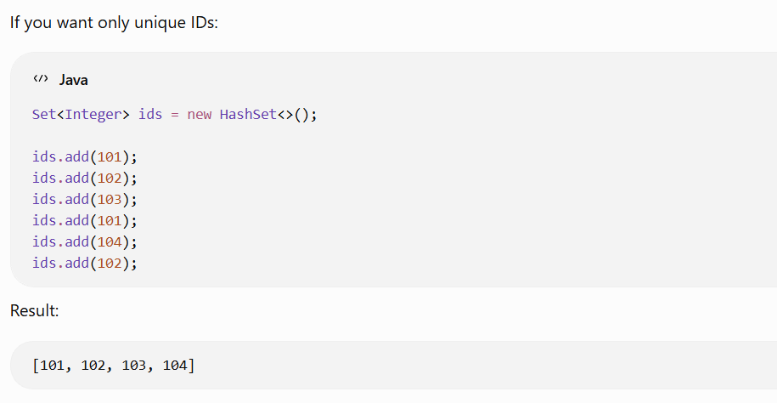
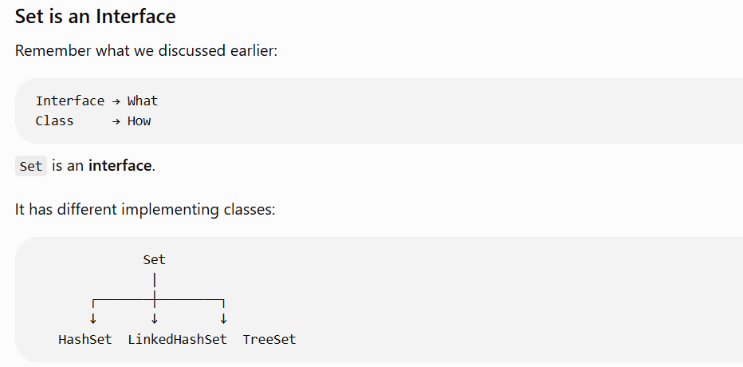
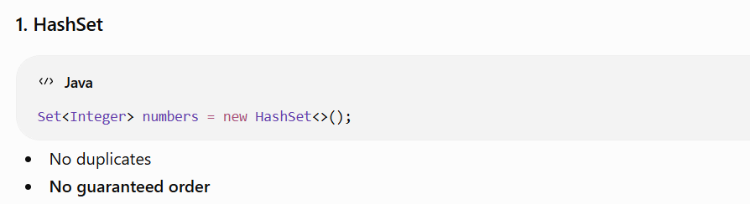
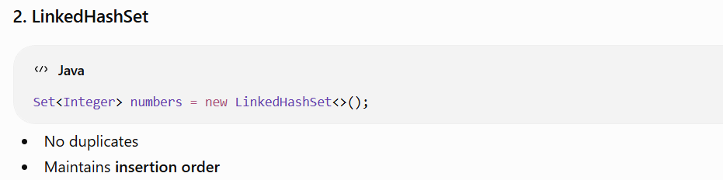
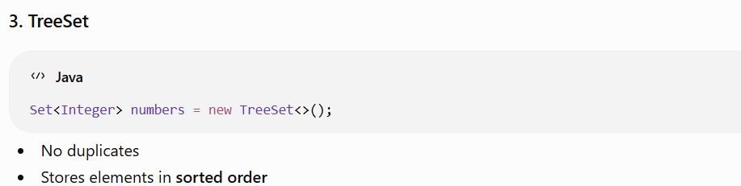
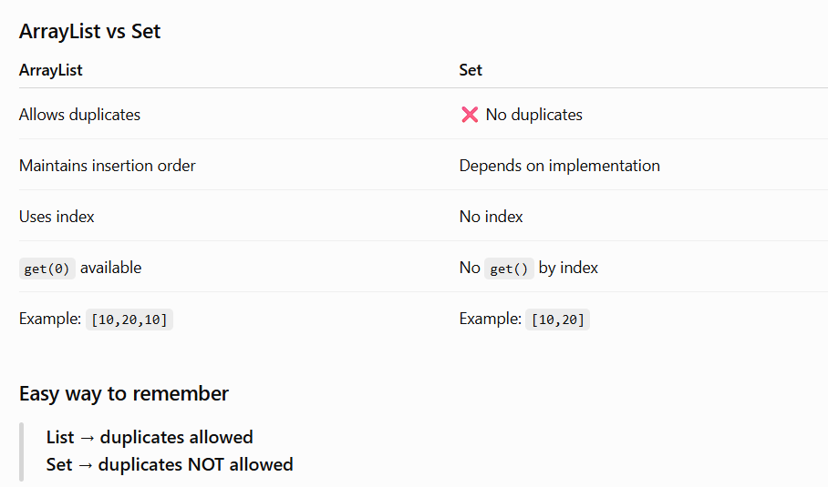
What is Map in Java?
Simple definition:
A Map is an interface in Java Collections used to store data in key-value pairs.
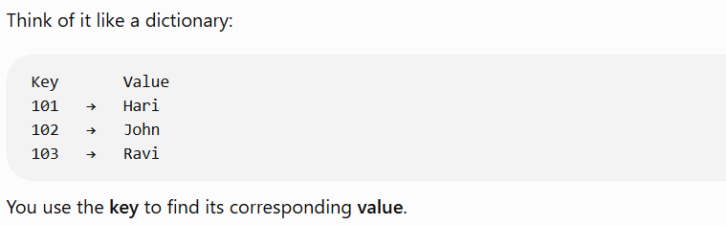
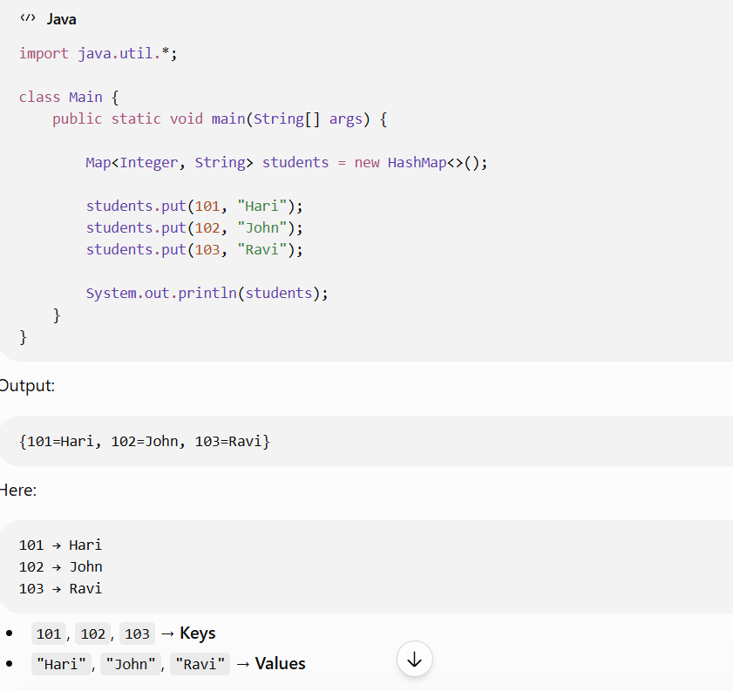
Why do we use Map?
Suppose you have student names and their marks:
Student ID → Marks
101 → 85
102 → 90
103 → 78
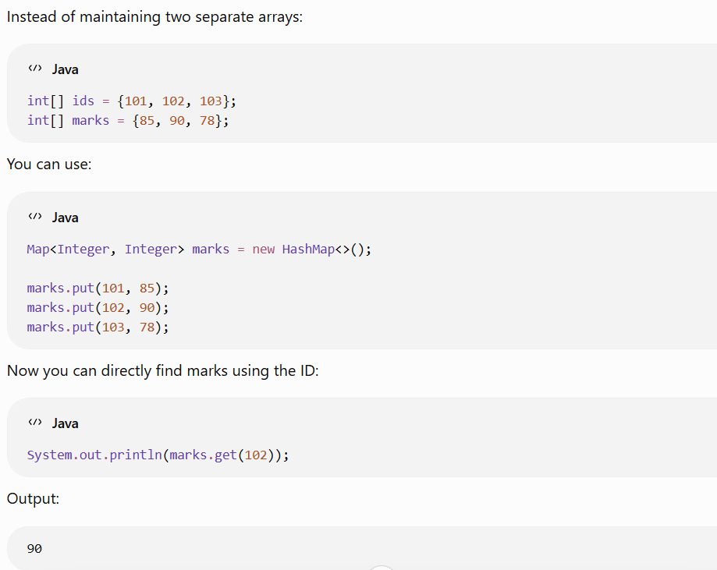
Important Map methods
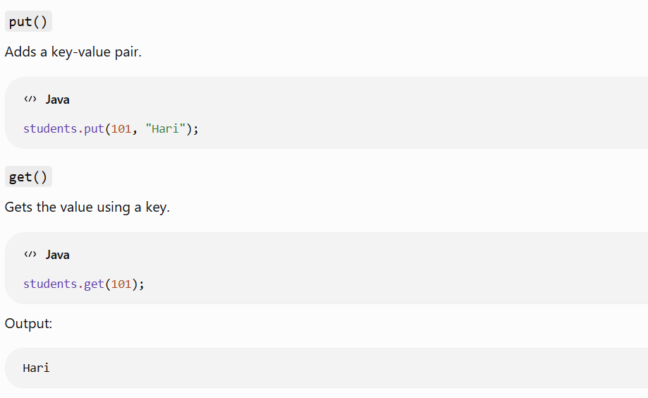
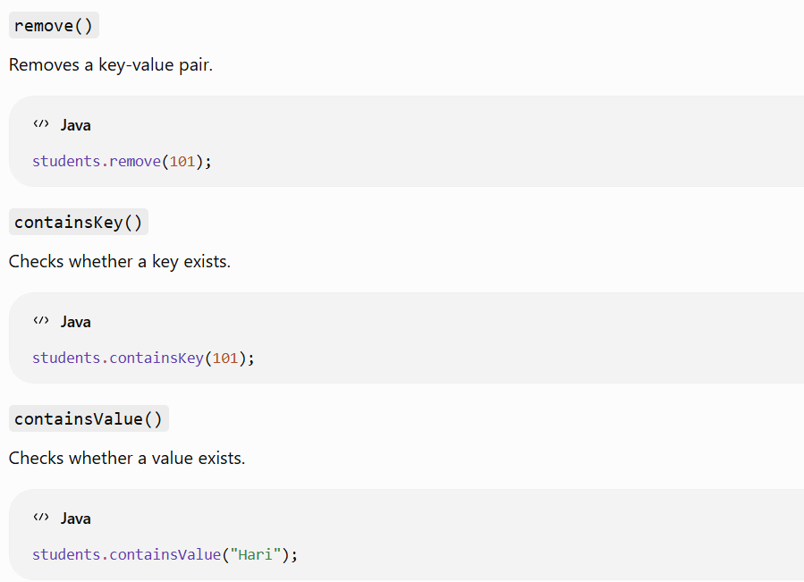
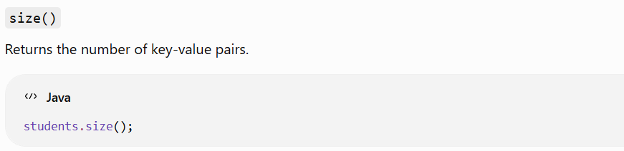
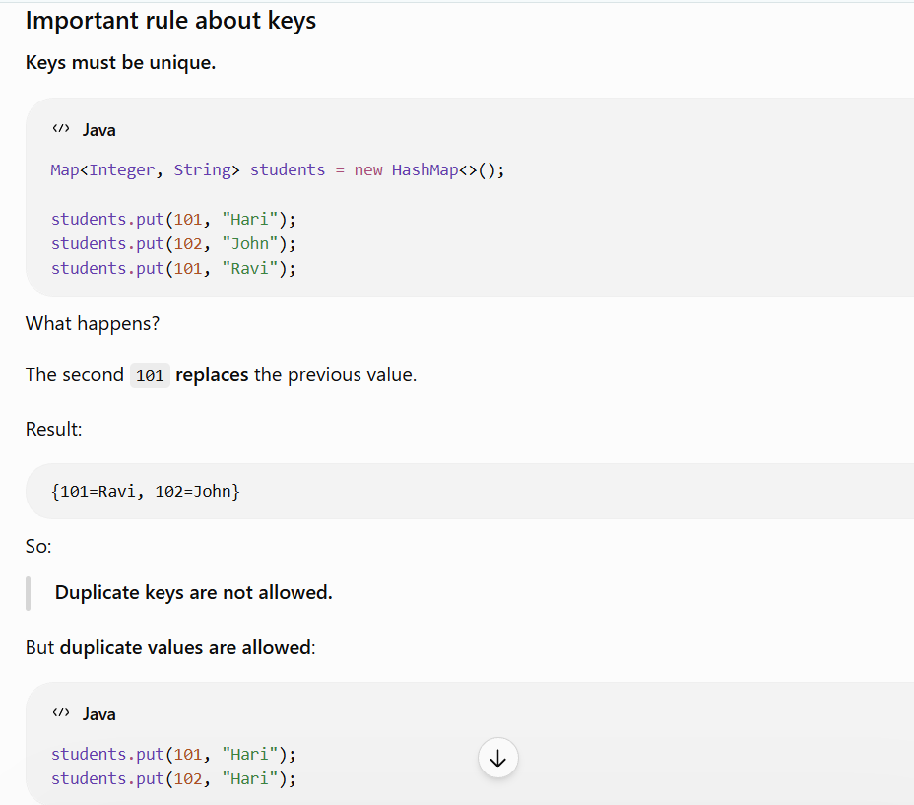
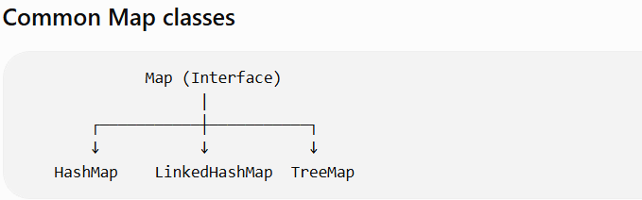
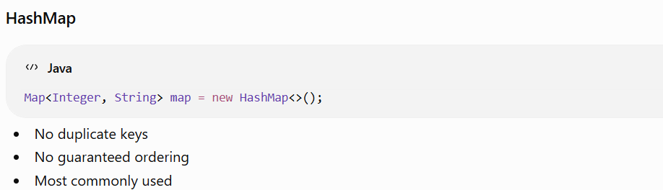
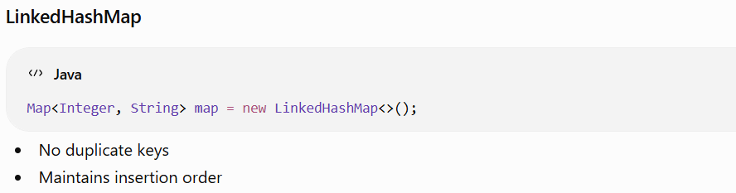
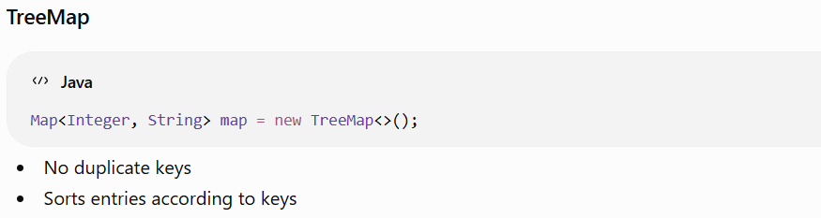
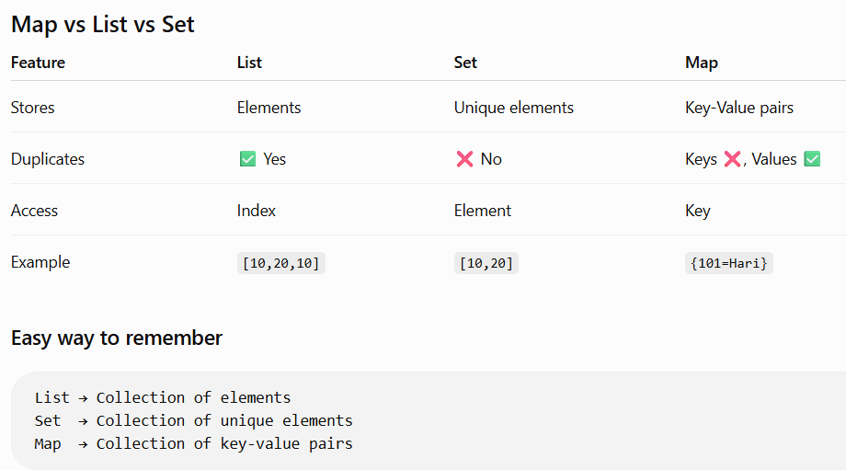
One important point: Map is part of the Java Collections Framework, but Map does not extend the Collection interface. It has its own separate hierarchy.

Comparable program:
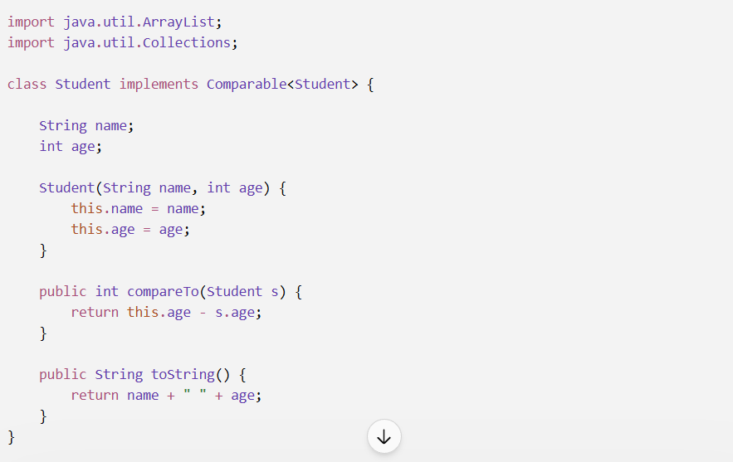
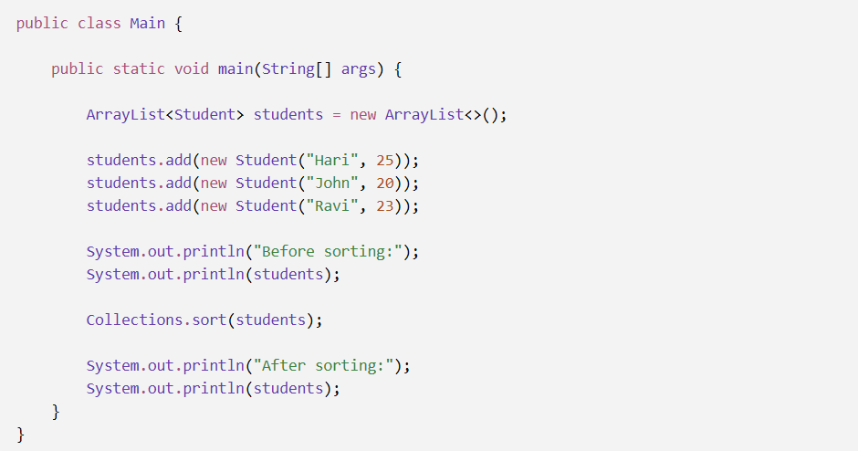
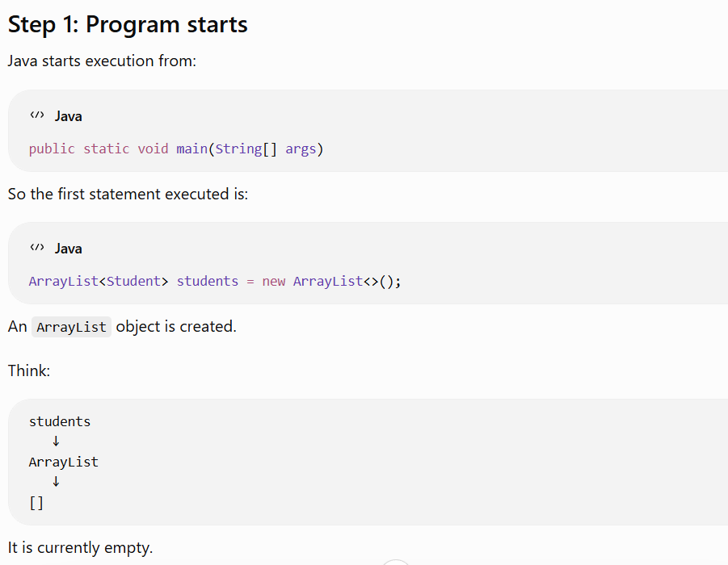

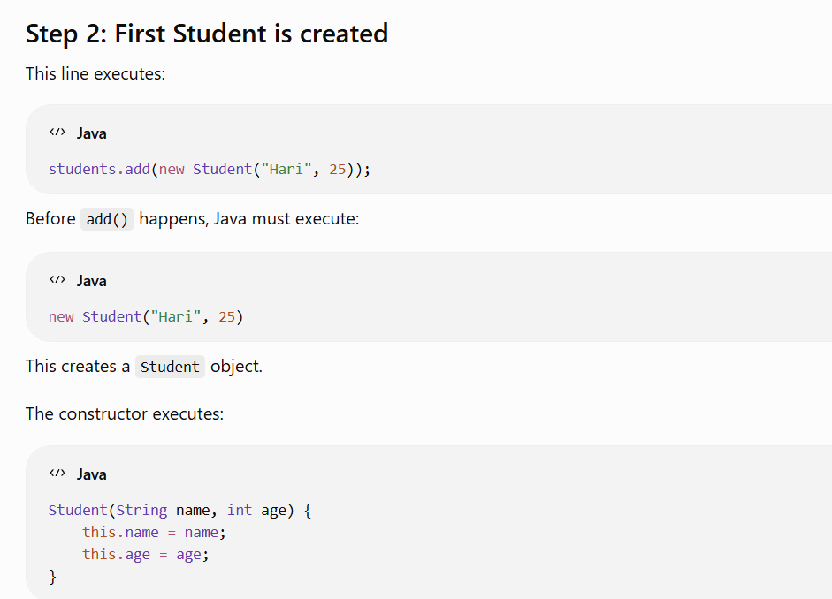
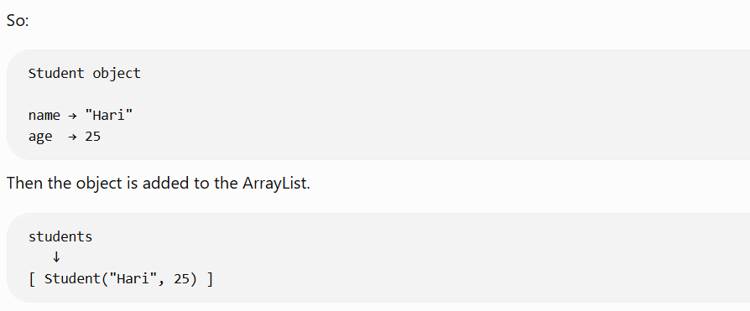
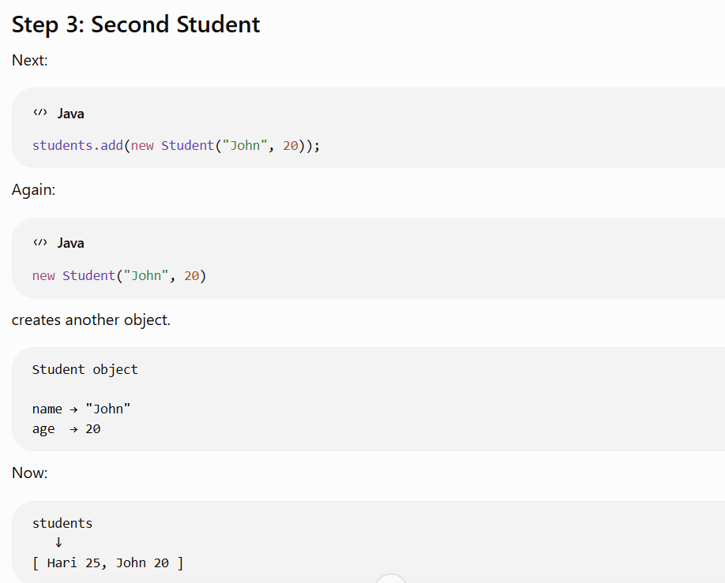
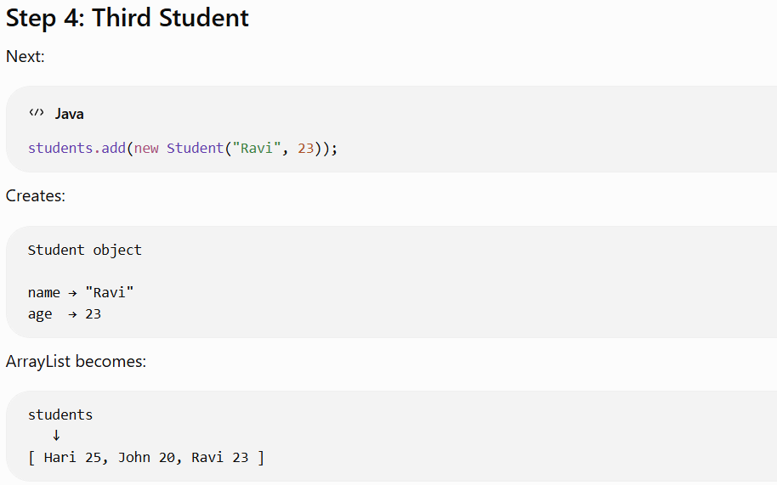
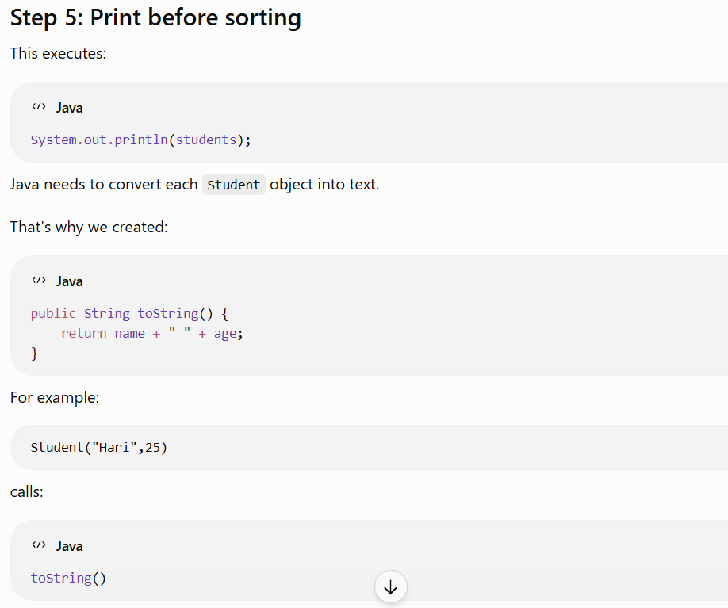
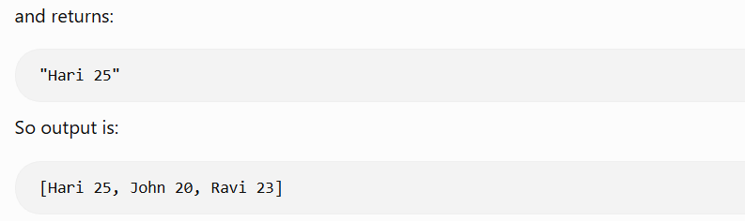
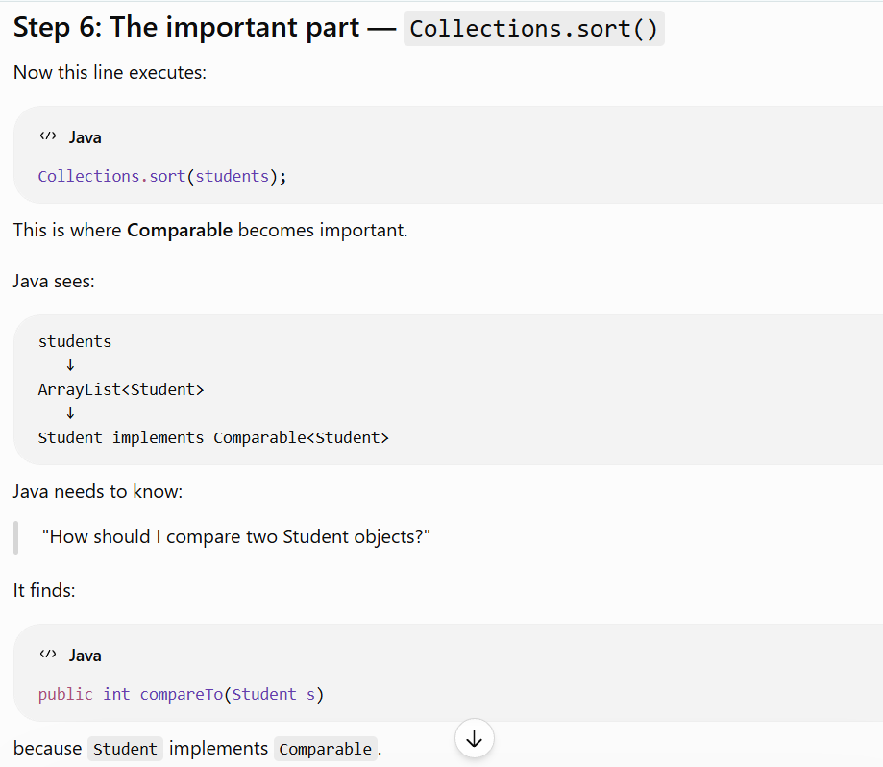

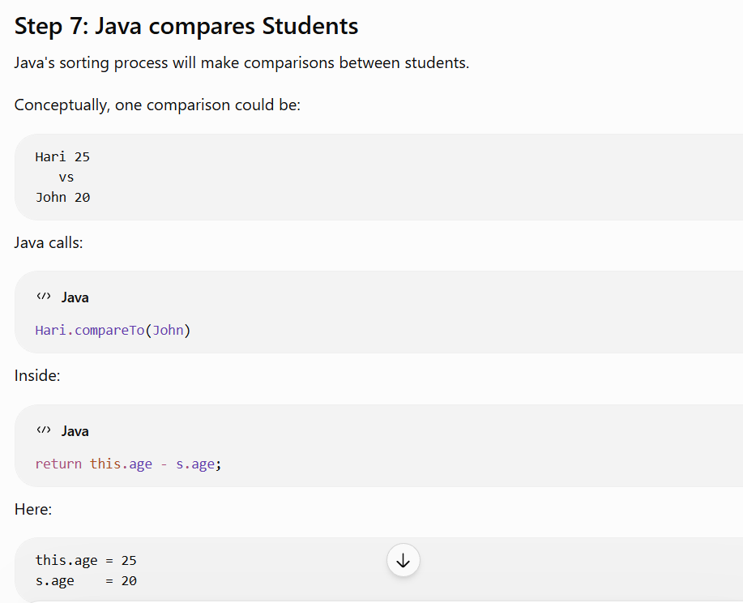
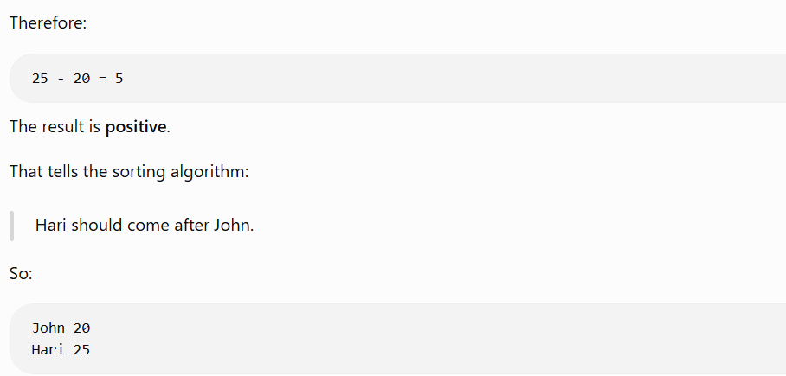
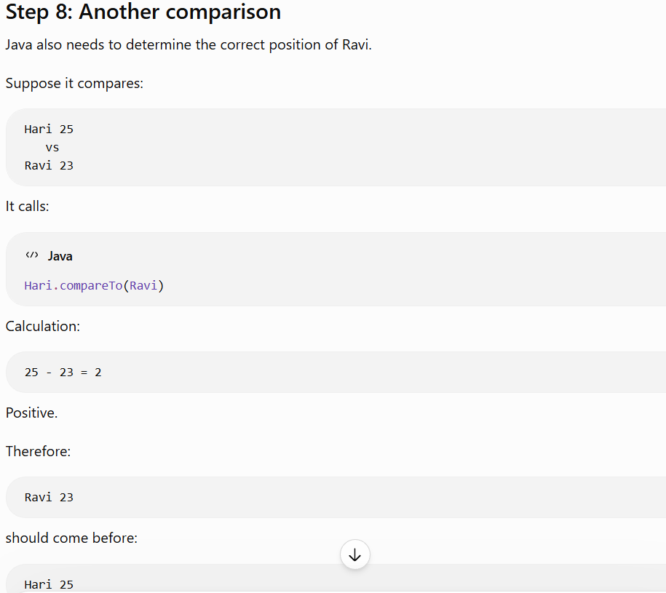

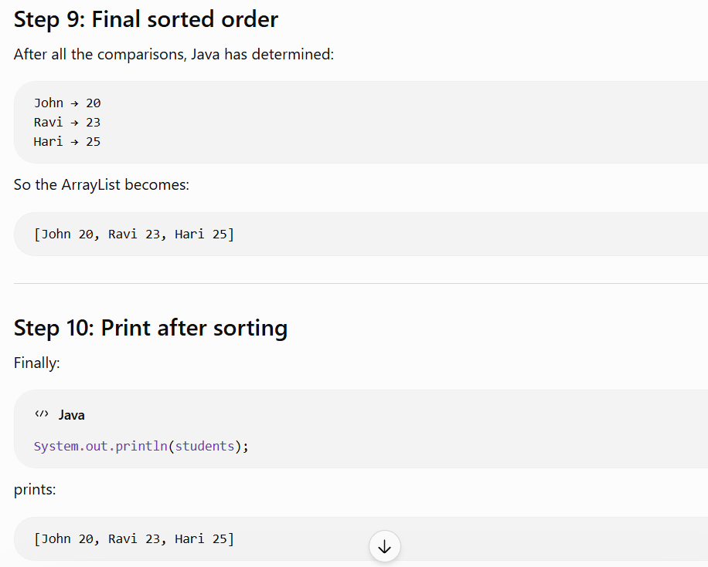
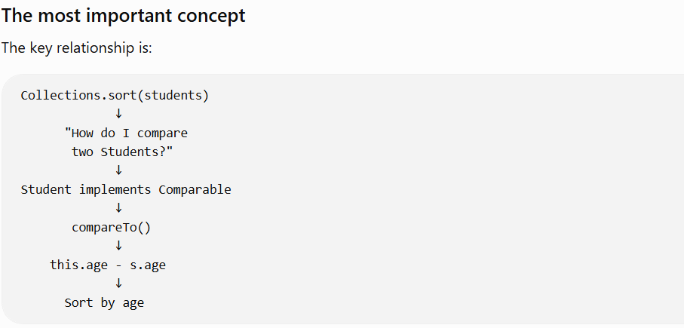

Comparator Program:
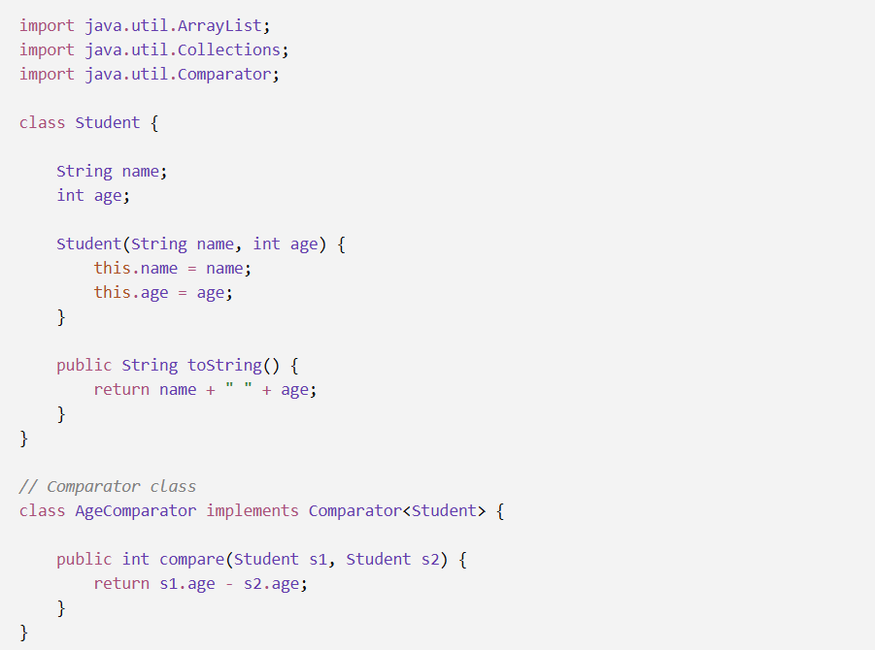
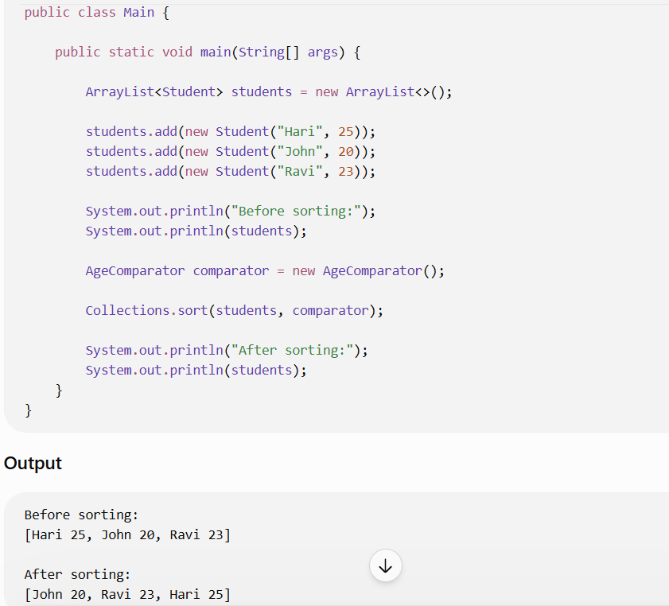

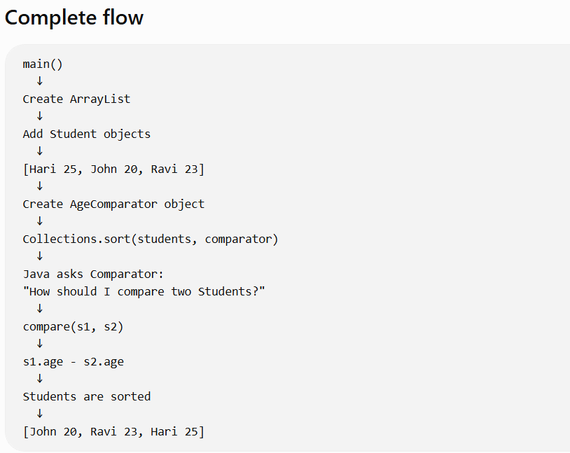
Now the important difference
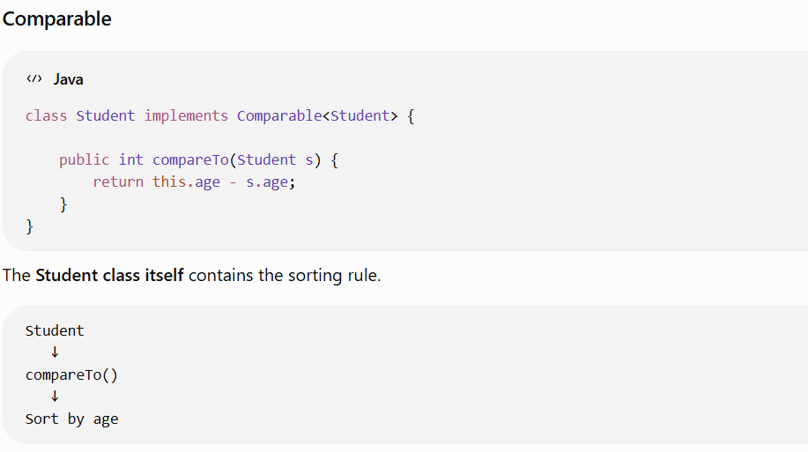
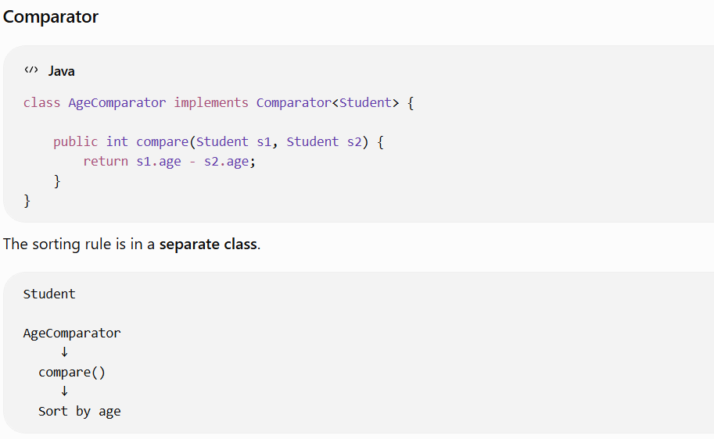
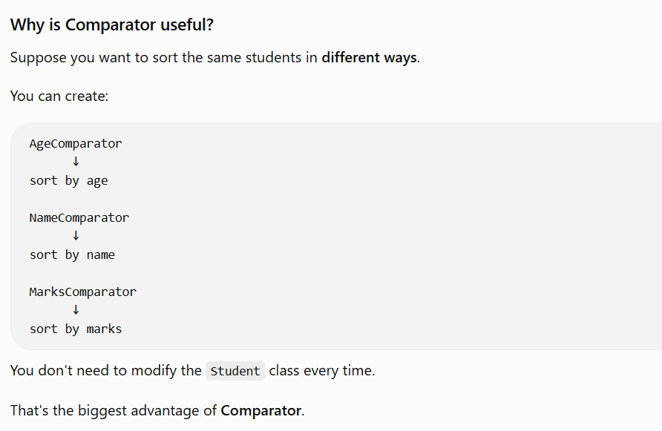

Stream API:
Stream API is a Java feature used to process collections of data in a declarative and readable way using operations such as filter(), map(), sorted(), and collect().
And remember the key difference:
Collection → stores data
Stream → processes data
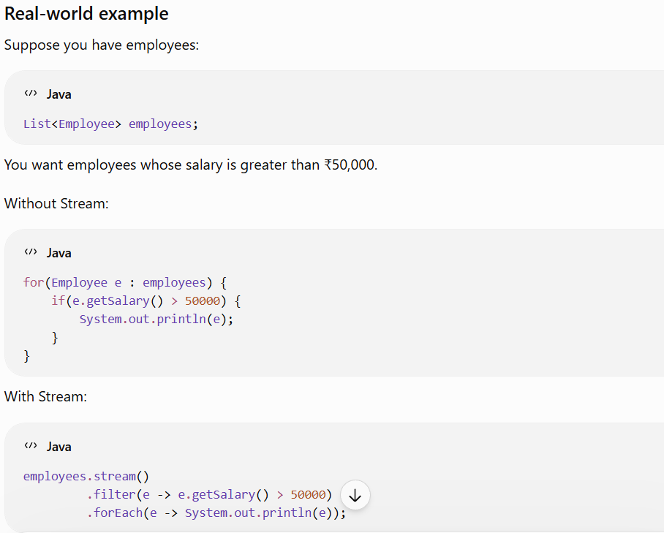
This becomes particularly useful when you need operations such as:
- filtering
- sorting
- transforming
- finding values
- counting
- grouping
- calculating sums/averages
- collecting results
- What is forEach() in Java?

- forEach() is a method used to perform an action on every element of a collection or stream.
- Simple definition
- forEach() executes a given piece of code once for every element.
